
Computing Department
Project ID : UQU-CS—
….2025-2026

Safe chain

An Intelligent Food Safety Monitoring System Using IoT
Authors:
Shatha Mohammed Al-Montashery | 444007872
Wajdan Atiyeh Al-Zahrani | 444004760
Reema Al-Rashdi | 444004209
Raghad Hassan Al-Masaari | 444001447
Aryam Aqeel Al_zubaidi | 444002164

Supervisors:
Dr. Ali Abdulaziz Al-Zubaidi
aakzubaidi@uqu.edu.sa

Dept. of Computing
College of Engineering and Computing at ALQunfudhah
Umm Al-Qura University, KSA

CONTACT INFORMATION
This project report is submitted to the Department of computer science at Umm Al-Qura University in partial fulfillment of the bachelor's degree in computer science requirements.

Author(s):

Name | ID | E-mail
Shatha Mohammed Al-Montashery | 444007872 | s444007872@uqu.edu.sa
Wajdan Atiyeh Al-Zahrani | 444004760 | s444004760@uqu.edu.sa
Reema Al-Rashdi | 444004209 | s444004209@uqu.edu.sa
Raghad Hassan Al-Masari | 444001447 | s444001447@uqu.edu.sa
Aryam aqeel Al_zubaidi | 444002164 | s444002164@uqu.edu.sa

INTELLECTUAL PROPERTY RIGHT DECLARATION
This work, done under the supervision of Dr. Ali Abdulaziz Al-Zubaidi with the title " Safe chain" carried out to meet parts of the requirements of a Bachelor of Science in Computer Science, is the sole property of Umm Al-Qura University and the respective supervisor are protected under the intellectual property rights laws and conventions. It can only be considered or used for purposes like an extension for further enhancement, a product development, commercial or organisational usage adoption, etc., with the university's permission and the respective supervisor.

Date : 25/12/2025
Author(s):
Name | ID
Shatha Mohammed Al-Montashery | 444007872
Wajdan Atiyeh Al-Zahrani | 444004760
Reema Al-Rashdi | 444004209
Raghad Hassan Al-Masari | 444001447
Aryam aqeel Al_zubaidi | 444002164

Signature: ______________
Signature: ______________
Signature: ______________
Signature: ______________
Signature: ______________

Supervisor
Dr. Ali Abdulaziz Al-Zubaidi

ANTI-PLAGIARISM DECLARATION
This is to declare that the above publication, produced under the supervision of Dr. Ali Abdulaziz Al-Zubaidi and having the title "Safe Chain" is the sole contribution of the author(s), and no part hereof has been reproduced illegally (cut and paste), which can be considered plagiarism. All referenced parts have been used to argue the idea and have been cited properly. I/we will be responsible and liable for any consequence if a violation of this declaration is proven.

Date :25/12/2025
Author(s):
Name | ID
Shatha Mohammed Al-Montashery | 444007872
Wajdan Atiyeh Al-Zahrani | 444004760
Reema Al-Rashdi | 444004209
Raghad Hassan Al-Masari | 444001447
Aryam aqeel Al_zubaidi | 444002164

Signature: ______________
Signature: ______________
Signature: ______________
Signature: ______________
Signature: ______________

Supervisor
Dr. Ali Abdulaziz Al-Zubaidi

ACKNOWLEDGMENT

The authors at the beginning of this work express their sincere gratitude and thanks to the Almighty for the blessing of good luck and patience, giving them the opportunity to complete this effort.
They also extend their sincere appreciation and gratitude to their generous parents for their unlimited support, patience and endurance throughout this journey, asking the Almighty to provide them with health and strength to continue their precious support in the coming stages.
They would like to thank and appreciate the project supervisor Dr. Ali Abdulaziz Al-Zubaidi for his continuous support, valuable guidance, and constructive feedback, which was an invaluable help at all stages of the design and development of the Safe Chain system.
They also express their gratitude to all faculty members and colleagues, who contributed their insightful opinions and valuable suggestions, which effectively helped to refine the system structure, support design decisions, and formulate the technical requirements contained in this chapter. Their support and role has been pivotal in enhancing the quality, clarity and applicability of the proposed design.

ABSTRACT

This project, called "Safe Chain," aims to develop an intelligent Internet of Things (IoT)-based system for monitoring and ensuring food safety during transport and storage. The proposed system integrates multiple environmental sensors to measure temperature, humidity, gas emissions, and the condition of truck doors, providing real-time data to a central platform or mobile application.
The system uses a Raspberry Pi device as the main controller, collecting sensor data and transmitting it to a cloud database for display and analysis. Through a user-friendly dashboard, users can monitor live readings, receive instant alerts when conditions exceed predefined safety thresholds, and view historical reports summarizing key environmental trends.
The primary objective of Safe Chain is to reduce food spoilage, enhance transparency in the cold chain, and support food safety and security by enabling immediate intervention when abnormal conditions occur. By offering a low-cost, easy-to-use, and scalable solution, the system addresses key shortcomings of existing commercial systems, making it suitable for food transport companies, restaurants, and regulatory bodies.

Table of Content
CONTACT INFORMATION 2
INTELLECTUAL PROPERTY RIGHT DECLARATION 3
ANTI-PLAGIARISM DECLARATION 4
ACKNOWLEDGMENT 5
ABSTRACT 6
Table of Content 7
List of figures 12
List of TABLES 15
List Abbreviations or symbols 17
Chapter1: Introduction 19
1.1 Introduction 20
1.2 The research problem 20
1.3 The purpose of the project 21
1.3.1 Main Objective of the Project 21
1.3.2 Beneficiaries and Users 22
1.3.3 How the Project Helps Beneficiaries 22
1.4 Purpose of this Document 23
1.4.1 Reason for Creation: 23
1.4.2 Contents: 23
1.4.3 Audience: 23
1.4.4 Usage: 24
1.5 Existing System 24
1.5.1 Cooltrax-cold chain management and control system 24
1.5.2 DicksonOne-cloud-based environmental monitoring system 27
• Data Encryption in Transi 30
• compliance with international standards 31
1.5.3 TempTale GEO Ultra-cold 33
1.5.4 Sonicu-cold chain monitoring system 37
1.5.4.5 Weaknesses 39
1.5.5 shortcomings of the current systems versus the advantages of the proposed project 40
1.5.6 COMPARISON table between current systems and the proposed project 42
1.6 Methodology 45
1.6.1 Selected Methodology: Scrum (Agile) 45
1.6.2 Objectives of Using Scrum 46
1.6.3 Comparison with Other Methodologies 46
1.7 Project Plan 47
1.7.1 Project Timeline Summary 47
1.7.2 Gantt Char Project 48
1.7.3 Conclusion 48
1.8 Summary 48
Chapter2: SYSTEM ANALYSIS 49
2.1 Introduction 50
2.2 Stakeholders 50
2.2.1 Food transport and distribution companies: 50
2.2.2 Restaurants and food storage facilities: 50
2.2.3 Regulatory Authorities: 50
2.2.4 Consumers: 51
2.3 Requirements Elicitation and Analysis Methodology 51
2.3.1 Interviews: 51
2.3.2 Questionnaires: 54
2.4 Functional Requirements 64
2.4.1 User Login (FR_001): 64
2.4.2 Sensor Data Monitoring (FR_002): 66
2.4.3 Instant Alerts System (FR_003): 66
2.4.4 Records and Reports Management (FR_004): 68
2.4.5 New User Registration Requirement (FR_005) 69
2.4.6 Password Reset Requirement (FR_006) 71
2.4.7IoT Device Requirements 72
2.4.8 Web & Mobile App Requirements 77
2.4.9 Account–Device Binding Requirements 88
2.4.10 Post-Login Data Fetch Requirements 91
2.5 Dependencies 94
2.5.1 Functional dependencies 94
2.6 Non- Functional Requirements 95
2.6.1 Security 95
2.6.2 Privacy 95
2.6.3 Performance and Reliability Requirements 96
2.6.4 Usability and Compatibility Requirements 96
2.6.5 Logging & Auditing Requirements 97
2.6.6 Maintainability Requirements 97
2.6.7 Error Handling Requirements 98
2.6.8 Data Integrity Requirements 98
2.6.9 Energy Efficiency Requirements (Important for IoT Device) 98
2.7 Data Flow Diagram 99
2.8 Requirements Modelling UML 108
2.8.1 Use Case Diagram 108
2.8.2 Sequence Diagram 111
2.8.3 Activity Diagram 120
2.8.4 Class Diagram 124
2.8.5 Entity-relationship diagram 129
2.9 Summary 130
Chapter3:DESIGN CONSIDERATIONS 131
3.1 INTRODUCTION 132
3.2 ARCHITECTURAL STRATEGY 132
3.2.1 PRESENTATION LAYER (USER INTERFACE LAYER) 132
3.2.2 BUSINESS LOGIC LAYER (PROCESSING AND NOTIFICATIONS) 132
3.2.3 DATA LAYER (STORAGE AND SYNCHRONIZATION) 133
3.3 Development Requirements 133
3.3.1 Hardware Requirements 133
3.3.2 Software Requirements 134
3.4 Food Transport Temperatures 135
3.4.1 Refrigerated and Chilled Foods 135
3.4.2 Non-Refrigerated and Non-Frozen Foods 139
3.4.3 Recommended Relative Humidity (RH) for Food Transportation 148
3.4.4 Food Safety and Refrigerator Cooling Guidelines [18] 149
3.4.5 Natural and Critical Concentrations of Gases and Dust. 150
3.4.6 Natural and Critical Ratios for Monitored Factors in Pharmaceutical Transport. 152
3.5 Graphical User Interface Design and Wireframe 153
3.6 Summary 154
Chapter 4: System Implementation 155
4.1 Introduction 156
4.2 Development Environment 156
4.3 Hardware Components 158
4.4 Hardware Implementation 160
4.4.1 Connection Diagram 160
4.5 Database Implementation 161
4.5.1 Initialization Script 161
4.5.2 Connection Pool 162
4.5.3 MySQL 162
4.5.3.1 Connection to MySQL 163
4.5.3.2 Tables in MySQL 164
4.6 System Interface Screenshots 169
4.6.6 User management 171
4.6.7 Assign Trucks 172
4.7 Conclusion 179
Chapter 5: System Testing and Conclusion 180
5.1 Introduction 181
5.2 Challenges and learning experiences 181
5.3 Testing 182
5.3.1 Functional Testing 182
5.3.2 User Interface (UI) and Usability Testing 187
5.3.3 Design Testing 187
5.3.4 Operational Testing 190
5.4 System Testing 193
5.5 Unit Testing 195
5.6 Conclusion 195
5.7 Future work 196
5.8 SUMMARY 197
Reference: 198

List of figures
Figure 1 Cooltrax-cold chain management and control system 25
Figure 2 DicksonOne-cloud-based environmental monitoring 29
Figure 3 interactive web in DicksonOne 30
Figure 4 Device TempTale GEO Ultra 34
Figure 5 Cloud Platform TempTale GEO Ultra-cold 35
Figure 6 SoniCloud monitoring 39
Figure 7 Scrum Methodology 47
Figure 8 Gantt chart 49
Figure 9 stakeholders in SafeChain 51
Figure 10 context diagram of the "Safe Chain System" 100
Figure 11 Data Flow Diagram - Level 0 100
Figure 12 Data Flow Diagram - Level 1 (p1) Access and user management 101
Figure.13 Data Flow Diagram - Level 1 (p2) Real-time Monitoring and Alerts 101
Figure 14 Data Flow Diagram - Level 1 (p3) Reports and Records 102
Figure 15 Data Flow Diagram - Level 1 (p4) Device management and IoT requirements 102
Figure 16 Data Flow Diagram - Level 2 (p1.1) User verification and login 103
Figure 17 Data Flow Diagram - Level 2 (p1.2) Accounts and Roles Management 103
Figure 18 Data Flow Diagram - Level 2 (p 1.3) Checking roles and permissions 104
Figure 19 Data Flow Diagram - Level 2 (p2.1) Receiving and processing IoT data 104
Figure 20 Data Flow Diagram - Level 2 (p2.2)Analysis and comparison of alarm generation 105
Figure 21 Data Flow Diagram - Level 2 (p2.3) Alerts and notifications management 105
Figure 22 Data Flow Diagram - Level 2 (p2.4) Managing safety limits 106
Figure 23 Data Flow Diagram - Level 2 (p 3.1) Search Request Processing and Filtering 106
Figure 24 Data Flow Diagram - Level 2 (p 3.2) Fetch Alert Records 107
Figure 25 Data Flow Diagram - Level 2 (p 3.3) The generation of reports and the export of data 107
Figure 26 Data Flow Diagram - Level 2 (p4.1) Managing safety threshold 108
Figure 27 Data Flow Diagram - Level 2 (p4.2) Managing the connection/disconnection 108
Figure 28 Data Flow Diagram - Level 2 (p4.3) Review the device’s connection status 109
Figure 29 use case diagrams - Access and user management 109
Figure 30 use case diagrams - Live monitoring and alerts 110
Figure 31 use case diagrams - Device management and IoT requirements 110
Figure 32 use case diagrams - Records and Inquiry Reports 111
Figure 33 Sequence Diagram-Login 112
Figure 34 Sequence Diagram-Create an account 113
Figure 35 Sequence Diagram-Generating instant alerts 114
Figure 36 Sequence Diagram-Security Service 115
Figure 37 Sequence Diagram-Create reports 116
Figure 38 Sequence Diagram-logout page 117
Figure 39 Sequence Diagram-Administrator control 118
Figure 40 s Sequence Diagram-ensor data service 119
Figure 41 Sequence Diagram-Password Reset 120
Figure 42 Activity Diagram - Login 121
Figure 43 Activity Diagram - Generate Custom Report 122
Figure 44 Activity Diagram - Sensor Data Lifecycle (Iot) 123
Figure 45 Activity Diagram - Password Reset 124
Figure 46 Class diagram - all System 125
Figure 47 Class diagram - Truck system and devices 126
Figure 48 Class diagram - Sensor and reading system 127
Figure 49 Class Diagram – Shipments and Reporting System 128
Figure 50 Class Diagram –Alerts and notifications system 129
Figure 51 ER Diagram 130
Figure 52 Safe Chain Graphic User Interface 155
Figure 53 Flutter 158
Figure 54 Fast Api 158
Figure 55 Wi-Fi Communication 158
Figure 56 4G LTE Communication 158
Figure 57 LoRaWAN 158
Figure 58 MySQL 158
Figure 59 Prometheus (Monitoring) 159
Figure 60 Grafana (Visualization) 159
Figure 61 IDE Visual Studio Code 159
Figure 62 Raspberry pi 4 160
Figure 63 SHT31 Temp & Humid 160
Figure 64 Gas sensor Mq-135 160
Figure 65 Gas sensor Mq-9 160
Figure 66 Neo-6M GPS Module 160
Figure 67 Magnetic Reed Switch 160
Figure 68 Complete hardware assembly of the SafeChain IoT device 162
Figure 69 Database Engine Configuration (SQLAlchemy) 164
Figure 70 Tables in MySQL 165
Figure 71 Table users in MySQL 165
Figure 72 Table trucks in MySQL 166
Figure 73 Table user_trucks in MySQL 166
Figure 74 Table groups in MySQL 166
Figure 75 Table products in MySQL 167
Figure 76 Table Trips in MySQL 167
Figure 77 Table trip_counter in MySQL 167
Figure 78 Table reports in MySQL 168
Figure 79 Table alerts in MySQL 168
Figure 80 Table sensors in MySQL 169
Figure 81 Table security_limits in MySQL 169
Figure 82 Table updates in MySQL 169
Figure 83 Login Screen 170
Figure 84 User Registration Screen 170
Figure 85 OTP Verification Screen 171
Figure 86 Password Reset Screen 171
Figure 87 Admin Screen 172
Figure 88 USER MANAGEMENT 172
Figure 89 Assign Trucks 173
Figure 90 Admin Alerts Screen 173
Figure 91 Sensors Check Screen 174
Figure 92 Updates Screen 174
Figure 93 Admin Reports Screen 175
Figure 94 User Screen 175
Figure 95 User Alerts log Screen 176
Figure 96 User Reports Log Screen 176
Figure 97 Real-Time Truck Status Screen 177
Figure 98 Profile Sittings Screen 177
Figure 99 Settings Menu Screen (Admin View) 178
Figure 100 Product Type Selection Screen 178
Figure 101 Safety Thresholds Configuration Screen 179
Figure 102 Settings Menu Screen (User View) 179

List of TABLES
Table 1 Technical Comparison Table of Cold Chain Monitoring System 43
Table 2:Comparison with Other Methodologies 48
Table 3 Project Timeline 48
Table 4 Functional Requirement – User Login 66
Table 5 Functional Requirement – Sensor Data Monitoring 67
Table 6 Functional Requirement – Instant Alerts System 68
Table 7 Functional Requirement – Records and Reports Management 69
Table 8 Functional Requirement – New User Registration Requirement 70
Table 9 Functional Requirement – Password Reset Requirement 72
Table 10 Functional Requirement – IoT Device Requirements 73
Table 11 Functional Requirement – Data Buffering 74
Table 12 Functional Requirement – Data Transmission to the Cloud 76
Table 13 Functional Requirement – GPS Tracking 77
Table 14 Functional Requirement – Login/Logout 78
Table 15 Functional Requirement – Dashboard 80
Table 16 Functional Requirement – Real-time monitoring 81
Table 17 Functional Requirement – Threshold settings management 82
Table 18 Functional Requirement – Alert log 83
Table 19 Functional Requirement – Report generation 84
Table 20 Functional Requirement – Instant notifications 86
Table 21 Functional Requirement – Historical data filtering 87
Table 22 Functional Requirement – User and role management 88
Table 23 Functional Requirement – Device pairing 89
Table 24 Functional Requirement – Device status verification 90
Table 25 Functional Requirement – Device unpairing 91
Table 26 Functional Requirement – Automatic data fetch 92
Table 27 Functional Requirement – Live data update 93
Table 28 Functional Requirement – Account-specific alerts 94
Table 29 Fresh Vegetables 136
Table 30 Fresh Fruits 137
Table 31 Chilled Dairy Products and Their Derivatives 139
Table 32 Chilled Meats and Their Derivatives 139
Table 33 Infant Foods 140
Table 34 Meats and Their Derivatives 141
Table 35 Dairy Products and Their Derivatives 142
Table 36 Fruits, Vegetables, and Their Derivative 143
Table 37 Vegetable Oils, Fats, and Their Derivatives 144
Table 38 Cereals, Legumes, Nuts, and Their Derivatives 144
Table 39 Water and Beverages 146
Table 40 Other Miscellaneous Products 147
Table 41 Recommended Relative Humidity (RH) for Food Transportation 149
Table 42 Food Safety and Refrigerator Cooling Guidelines 150
Table 43 Natural and Critical Concentrations of Gases and Dust 151
Table 44 Natural and Critical Ratios for Monitored Factors in Pharmaceutical Transport. 153
Table 49 Comparison of Database Technologies and Justification for Selection 163
Table 45 FUNCTIONAL TESTING 183
Table 46 Design Testing 188
Table 47 Operational Testing 191
Table 50 Functional, Performance and Security Testing 194
Table 51 Performance Testing 195
Table 52 Security Testing 195
Table 53 Unit Testing Coverage for Modules/Files 196

List Abbreviations or symbols
Abbreviation | Full Term | Category
Organizations & Standards
FAO | Food and Agriculture Organization | Organization
WHO | World Health Organization | Organization
HACCP | Hazard Analysis and Critical Control Points | Standard
NIST | National Institute of Standards and Technology | Standard
FDA | Food and Drug Administration | Standard
GxP | Good Practice (pharmaceutical/food guidelines) | Standard
CFR | Code of Federal Regulations | Standard
ISO | International Organization for Standardization | Standard
KPI | Key Performance Indicator | Standard
IoT & Hardware
IoT | Internet of Things | IoT
GPS | Global Positioning System | IoT
GNSS | Global Navigation Satellite System | IoT
GPIO | General Purpose Input/Output | IoT
GSM | Global System for Mobile Communications | IoT
RTD | Resistance Temperature Detector | IoT
MEMS | Micro-Electro-Mechanical Systems | IoT
NDIR | Non-Dispersive Infrared (sensor) | IoT
RH | Relative Humidity | IoT
LTE | Long-Term Evolution (4G network) | IoT
DC | Direct Current | IoT
AC | Alternating Current | IoT
Networking & Protocols
MQTT | Message Queuing Telemetry Transport | Protocol
HTTPS | Hypertext Transfer Protocol Secure | Protocol
LoRaWAN | Long Range Wide Area Network | Protocol
SMS | Short Message Service | Protocol
OTP | One-Time Password | Protocol
SMTP | Simple Mail Transfer Protocol | Protocol
Security
SSL | Secure Sockets Layer | Security
TLS | Transport Layer Security | Security
AES | Advanced Encryption Standard | Security
RBAC | Role-Based Access Control | Security
2FA | Two-Factor Authentication | Security
Software & Development
API | Application Programming Interface | Software
IDE | Integrated Development Environment | Software
HTML | Hyper Text Markup Language | Software
CSS | Cascading Style Sheets | Software
SQL | Structured Query Language | Software
NoSQL | Non-Relational Database | Software
CSV | Comma-Separated Values | Software
QR | Quick Response (code) | Software
UI | User Interface | Software
System Analysis & Modelling
UML | Unified Modelling Language | Modelling
DFD | Data Flow Diagram | Modelling
ER | Entity Relationship | Modelling
ERP | Enterprise Resource Planning | Systems
TMS | Transport Management System | Systems

Chapter1: Introduction

1.1 Introduction
This project aims to develop a system based on the Internet of Things (IoT) to monitor and track food safety during transportation and storage.
The system measures key factors such as temperature, humidity, and gas emissions inside the trucks, and then sends the data instantly to a simple platform or application to track it.
This project belongs to the field of Information Technology and the Internet of things with direct application in the food, transport and distribution sector.
The importance of the project lies in its role in ensuring the quality and safety of food, reducing spoilage and losses during transportation and storage, which supports food security and increases consumer confidence in food products.
In addition, the system also monitors truck location and door status to enhance security and prevent external contamination.

1.2 The research problem
A Hungarian study published in the journal Foods in 2024 found that up to 30% to 50% of perishable food transported without proper temperature control can arrive at its destination spoiled or lost [1]. Upon further analysis of the underlying causes, one of the most critical issues identified in the food transportation chain is the failure to maintain proper temperature control, which significantly accelerates food spoilage.
Additionally, the lack of transparency in shipment tracking poses a major challenge, as many transportation systems lack accurate and real-time data regarding temperature and truck location. This makes it difficult to take timely action to prevent food deterioration.
Inspired by Islamic principles that emphasize the preservation of blessings and the responsible use of resources, this project aims to mitigate food waste through the development of an intelligent monitoring device equipped with five sensors: a temperature sensor, a humidity sensor, a door sensor, a gas sensor, and a geolocation sensor.
The device is installed in transportation trucks and is also utilized for monitoring storage facilities to ensure accurate supervision of environmental conditions. The system provides real-time tracking of location and internal parameters, thereby enhancing food preservation during transportation and storage and reducing overall losses.

1.3 The purpose of the project
This project aims to develop a smart experimental system based on (IoT) technologies to monitor and track food safety during storage or transportation. The goal is to ensure food product quality, reduce the likelihood of spoilage, and support food security.

1.3.1 Main Objective of the Project
1.3.1.1 a prototype that enables reading of basic data such as temperature, humidity, and gas emissions
• Temperature and humidity are among the most critical factors affecting food quality. According to the Food and Agriculture Organization (FAO), about 70% of refrigerated food spoilage is caused by uncontrolled fluctuations in temperature and humidity[2].
• The emission of gases such as ammonia (NH3) and hydrogen sulfide (H2S) serves as an early indicator of meat and dairy product spoilage.
• Therefore, this prototype provides a practical tool for monitoring these indicators .
1.3.1.2 Transmit data in real-time to a simple platform or application for visualization
• Real- Develop time monitoring reduces delays in problem detection.
• Studies in the field of cold chain monitoring show that delays in detecting temperature deviations may lead to losses of up to 35% of transported food products[4][5].
• Sending data directly to a platform or mobile application enhances responsiveness and immediate problem-solving.
1.3.1.3 Generate instant alerts when thresholds are exceeded
• Early alerts help in making timely decisions before losses occur.
• A study published in the Journal of Food Protection indicated that instant alert systems contributed to reducing refrigerated food losses by about 25%[4].
• This feature makes the system practical and economically valuable.
1.3.1.4 Test the system on a small-scale model to validate effectiveness
• Small-scale testing reduces risks and reveals errors before large-scale implementation.
• Prototypes are an essential step in developing any system, as they allow verification of hardware and software performance in a controlled environment.
• This increases the likelihood of success when scaling the project in the future.

1.3.2 Beneficiaries and Users
The system targets many users and participants in transportation, storage and control of food. These beneficiaries range from private companies to consumers who indirectly benefit from safer food products. The system is designed to improve monitoring efficiency, enhance food safety standards, and reduce food waste.
1.3.2.1 Food transport and distribution companies
• These companies face significant losses due to food spoilage during transportation.
• According to the World Bank, nearly 30% of food products worldwide are lost due to weak transport and storage systems[5].
• The proposed system helps these companies reduce losses through continuous monitoring.
1.3.2.2 Restaurants and food storage facilities
• Restaurants rely heavily on fresh ingredients, and their quality is directly tied to temperature and humidity conditions.
• Health reports indicate that one-third of food poisoning cases each year are linked to poor storage practices.
• By using the system, they can monitor inventory and protect customers from foodborne risks.

1.3.2.3 Regulatory authorities such as the Food and Drug Authority
• These authorities need accurate data to evaluate companies’ compliance with health standards.
• Traditional systems often rely on periodic manual inspections, while this system provides real-time and reliable data.
• This enhances regulatory efficiency and makes monitoring more proactive.

1.3.2.4 Consumers indirectly, by gaining access to safe products
• Consumers are the ultimate beneficiaries.
• The World Health Organization (WHO) reports that 600 million people fall ill every year due to contaminated food.
• Smart monitoring systems reduce the likelihood of unsafe products reaching consumers.

1.3.3 How the Project Helps Beneficiaries
1.3.3.1 Enable companies to monitor storage and transport conditions accurately and reduce losses
• The system provides companies with real-time intervention capability, which helps minimize financial losses caused by food spoilage.
1.3.3.2 Provide regulatory authorities with real-time and reliable data to support effective oversight
• Real-time data increases transparency and enhances authorities’ ability to make swift, informed decisions.
1.3.3.3 Enhance consumer confidence in the quality and safety of food products
• Smart monitoring systems build customer trust and provide companies with a competitive advantage in the market.
1.3.3.4 Support the community by reducing food waste and strengthening food security
• Reducing food waste directly contributes to global food security.
• According to the United Nations, about 14% of food is lost between harvest and retail, and this system can help reduce that percentage.

1.4 Purpose of this Document

1.4.1 Reason for Creation:
This document exists to outline the objectives, scope, and expected results of the smart food monitoring and tracking system project. It defines the purpose of the project and explains its importance in improving food quality, reducing waste, and supporting food safety.

1.4.2 Contents:
It contains details about the project goals, system functionalities, expected outcomes, and benefits. It also describes the technical and practical aspects of the prototype, as well as the target problems it aims to solve.

1.4.3 Audience:
The intended audience includes supervisors, academic instructors, project developers, stakeholders in the food supply chain, and regulatory authorities interested in food quality and safety.

1.4.4 Usage:
This document should be used as a reference throughout the project lifecycle. It guides the development process, supports evaluation and assessment, and provides a clear framework for understanding the project’s objectives, benefits, and applications.

1.5 Existing System
Currently, there are several systems and applications for monitoring food during transportation and storage, including intelligent refrigeration systems and heat and humidity sensors used in some major companies.

1.5.1 Cooltrax-cold chain management and control system

1.5.1.1 General description and mode of action
Cooltrax is an integrated system focused on monitoring refrigerated transport conditions and real-time Cold Chain Management. It offers a “Fresh InTransit " solution that allows monitoring trucks and refrigerated containers during their movement through wireless sensors connected to a communication module (Gateway) connected to a GPS tracking system. The system collects accurate temperature data inside the truck or container and sends it to the Cooltrax cloud servers. Users can follow the status of shipments moment by moment via a web dashboard or through phone applications. In addition, the system enables the creation of automated reports that support compliance with food safety standards such as HACCP and international regulations (As shown in Figure 1, which illustrates the application logo).

Figure 1 Cooltrax-cold chain management and control system

1.5.1.2 Basic Techniques and Components
- Wireless Temperature Sensors:
Installed inside the refrigerated truck or container to measure and record temperature data precisely. Multiple sensors may be used to cover all internal areas and detect uneven cooling.
- Gateway (Communication Module):
Collects data from sensors and pairs it with GPS signals. It timestamps the data and transmits it to the cloud via Wi-Fi or 4G networks.
- GPS Tracking System:
Provides real-time location information of the vehicle. Combining temperature data with GPS coordinates helps identify where and when a temperature deviation occurs.
- Cloud Platform (Cooltrax Cloud):
Responsible for receiving, analyzing, and securely storing all collected data. It provides dashboards, alerts, and downloadable reports.
- Dashboard and Mobile Applications:
Offers visualized graphs, historical data, and color-coded alerts. The dashboard helps users easily interpret trends and respond quickly to abnormalities.
- ERP/TMS Integration:
Allows Cooltrax to synchronize with Enterprise Resource Planning or Transport Management Systems for broader logistics control and operational automation.

1.5.1.3 Common areas of use
The Cooltrax cold chain management and control system operates through an integrated process that ensures continuous monitoring and precise control of temperature-sensitive goods throughout the supply chain.
The system workflow can be summarized as follows:
- Installation of Devices: Wireless temperature sensors and GPS-enabled tracking modules are installed inside refrigerated trucks, containers, or storage units to monitor environmental conditions in real time.
- Configuration of Parameters: Users define acceptable thresholds for each variable (such as minimum and maximum temperature levels) according to the type of product being transported or stored.
- Data Collection and Transmission: The sensors continuously measure temperature and humidity levels. These readings are transmitted via the communication gateway to the Cooltrax cloud platform using Wi-Fi or 4G networks.
- Data Visualization and Monitoring: The collected data is displayed instantly on the Cooltrax dashboard and mobile applications. Users can view live readings, analyze graphical trends, and detect irregular patterns in the system performance.
- Alert Management: If any value exceeds the pre-set limits, the system automatically generates instant alerts via e-mail or SMS, allowing users to respond quickly to prevent product spoilage or safety violations.
- Data Storage and Analysis: All collected data is securely stored in the Cooltrax cloud database. Authorized users can access historical records, generate analytical reports, and review environmental trends to ensure long-term compliance and quality control.

1.5.1.4 Strengths
- Integration of Environmental and Location DataCooltrax combines GPS and temperature readings, providing both “where” and “what happened.”
This allows rapid root-cause analysis (e.g., identifying that a rise in temperature occurred at a specific stop) and increases transparency and trust with customers and authorities.
- Global Real-Time Monitoring: Through its cloud-based infrastructure, users can access shipment data anytime and anywhere.
This enables centralized monitoring and quick responses to abnormalities in large-scale logistics.
- Automated Compliance Reporting: Generates HACCP-ready reports automatically, saving time on manual documentation and ensuring continuous compliance with international standards.
- Instant Multi-Channel Alerts: When temperature thresholds are exceeded, the system sends immediate alerts via email or SMS, shortening response times and preventing product loss.
- Interoperability with Other Systems: The system integrates with ERP or TMS software, ensuring smooth data sharing and improving operational efficiency.
- Customer Confidence: By providing transparent and verified data on shipment conditions, Cooltrax helps companies build long-term credibility and enhance client satisfaction.

1.5.1.5 Weaknesses
- Limited Scope (Temperature Focus Only):
Cooltrax only monitors temperature and does not detect other spoilage indicators such as humidity or gases (NH₃, CO₂, H₂S). This limitation reduces its ability to identify early stages of food spoilage.
- High Initial and Operating Costs: The system’s use of GPS, cloud subscriptions, and advanced sensors makes it costly for small and medium enterprises.
- Dependence on Network Coverage: Requires strong and continuous internet connectivity (Wi-Fi or cellular). In remote or cross-border areas, data loss may occur, reducing reliability.
- Operational Complexity for Small Businesses: Its advanced functions (like ERP integration) may be unnecessary or difficult to manage for small operators.
- Low Flexibility in Customization: Companies may find it difficult to adapt the system’s setup or interface for specific needs since it is built for large-scale operations.

1.5.1.6 Brief Analysis
Cooltrax is one of the most recognized systems in refrigerated transport monitoring, integrating temperature and GPS tracking for precise visibility and control.
It is ideal for large enterprises that require compliance, reliability, and international-level performance.

1.5.2 DicksonOne-cloud-based environmental monitoring system

1.5.2.1 General description and mode of action
DicksonOne is an integrated cloud-based system used to monitor environmental conditions (especially temperature and humidity) in sensitive environments such as hospitals, laboratories, food warehouses, and pharmaceutical industries. Based on data loggers connected to the internet via Wi-Fi or Ethernet, these devices continuously collect data and send it to a centralized cloud platform. Through this platform, users can view real-time readings, retrieve historical data, and adjust the settings of alerts and reports. The system also provides multi-user access, which allows administrative and technical teams to work simultaneously (As shown in Figure 2, which illustrates the application logo).
.
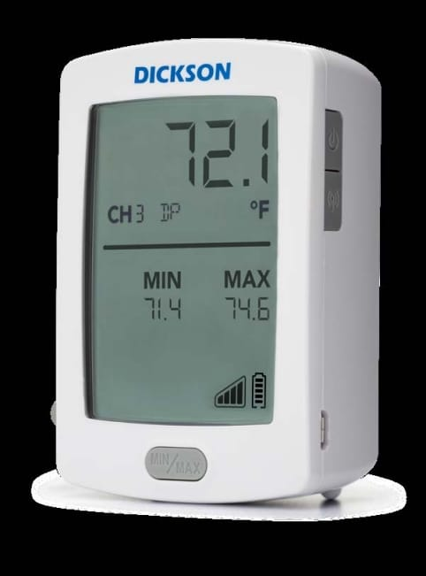
Figure 2 DicksonOne-cloud-based environmental monitoring

1.5.2.2 Basic techniques and components
- Sensors:
Sensors are the key element of the system, continuously measuring environmental values such as temperature and humidity. DicksonOne sensors are characterized by high accuracy and the possibility of calibration according to international standards such as NIST or ISO/IEC 17025 to ensure the reliability of readings.
- Data Loggers:
These devices are used to receive and temporarily store sensor data before sending it to the cloud system. They have a backup internal memory to store data when the internet connection is interrupted, in addition to an internal battery that ensures continued operation in the event of a power outage.
- Network Connectivity
The system supports several connection methods to facilitate connecting devices to the cloud:
- Wi-Fi for indoor environments.
- Ethernet for fixed networks, which is highly reliable.
- LoRaWAN for remote places or those with limited coverage.
- Bluetooth in some devices for quick setup purposes.
This flexibility in communication makes the system applicable in different environments, both small and distributed over several sites.
- Cloud Platform
The cloud platform is the central heart of the system. It stores all the data sent from the sensors, from which the analysis, monitoring, and alarm management processes are managed. Users can access it via an
- interactive web interface (Web Dashboard)
without the need to install any local software. There are also companion applications for smartphones that provide a simplified view of data and instant alerts, but they are not the platform itself (As shown Figure 3 , interactive web interface)
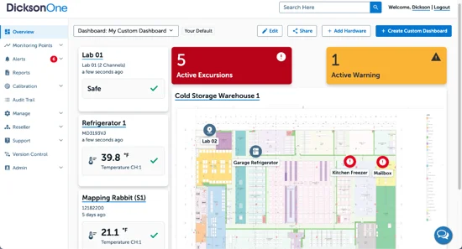
Figure 3 interactive web in DicksonOne

- Alert System
DicksonOne allows you to create custom alerts for each environmental variable. When the temperature or humidity exceeds the set values, the system sends instant notifications via e-mail, text messages, or phone notifications. This feature reduces the likelihood of damage to products or loss of samples due to sudden environmental changes.
- Reporting and Analysis
The system enables the creation of periodic or on-demand reports that include historical data, graphs, and time trends. Reports can also be exported in multiple formats (PDF, Excel) to meet the requirements of internal audits or regulatory authorities.

1.5.2.3 common Areas of Use
- Sensors and recording devices are installed in the required locations such as cold rooms or laboratories.
- Sets the allowable thresholds for each variable (e.g. maximum and minimum temperature).
- Recording devices periodically send data to the cloud platform via the internet.
- The readings in the dashboard are displayed instantaneously and can be tracked graphically.
- If any value exceeds the specified limits, the system issues instant alerts.
- The data is stored in a secure cloud database that allows historical records to be consulted when needed.

1.5.2.4 System Integration in Dickson Security One:
The DicksonOne system emphasizes the importance of security and controlled system integration due to the sensitivity of the data it handles, including medical and food-related information. The system is designed following a multi-layer security approach (Defense in Depth) to protect data during transmission, storage, and access. Additionally, it provides limited but structured methods to integrate with external systems.
- Data Encryption in Transit
All data transmitted from sensors to the cloud platform is encrypted using SSL/TLS protocols. This prevents unauthorized interception and ensures secure communication across the network.
- Data Encryption at Rest
Data stored on DicksonOne cloud servers is encrypted with strong algorithms such as AES-256. Even in the event of unauthorized physical access to servers, data cannot be read without encryption keys.
- User Access Control
The system uses role-based access control (RBAC), assigning each user permissions according to their role. Passwords are encrypted and cannot be viewed by any user.
- Audit Trail
All user activities, including logins, data modifications, and system changes, are automatically logged. These records are immutable and support security audits and investigations.
- Regulatory Compliance
DicksonOne complies with standards such as FDA 21 CFR Part 11 and GxP, ensuring data integrity and suitability for pharmaceutical and food industries.
- Data Backup and Recovery
Automatic backups are performed across multiple geographic locations (redundant data centers), allowing seamless data recovery in case of server failures.
- Secure Authentication
The system supports two-factor authentication (2FA) and strong password policies, including complexity requirements and periodic updates.
- Security Monitoring
Continuous monitoring detects abnormal activities, such as failed logins or unexpected configuration changes, ensuring proactive threat management.

1.5.2.5 Strengths
- integrated cloud system
The fact that the system is cloud-based means that the user can access data from anywhere and at any time, without the need for local storage or maintenance of internal servers.
- high flexibility of communication
The system supports more than one communication protocol (Wi-Fi, Ethernet, LoRaWAN), which makes it applicable in different environments in terms of infrastructure.
- instant monitoring and smart alerts
The system is characterized by its ability to send instant notifications when any deviation in the readings occurs, which ensures a quick response and minimizes losses.
- compliance with international standards
The system is compliant with FDA 21 CFR Part 11 data integrity requirements, making it suitable for controlled medical and industrial facilities.
- scalability
The system can be started using a limited number of devices and later expanded to several sites or branches without the need for radical changes in the architecture.
- advanced reporting and analysis
It provides sophisticated graphical analysis tools that help track environmental performance and detect long-term trends or recurring problems.
- security and user management
The system has a tiered permissions system that determines who can access data or modify settings, with an Audit Trail to track any changes.
- backup storage and data loss protection
The data is kept in cloud servers with periodic backups, as well as local memory inside the devices that protects against information loss when the connection is interrupted.

1.5.2.6 Weaknesses and challenges
- Full dependence on internet connection
The system is based on data transfer to the cloud, which means that any interruption in the internet may delay updates or alerts. Although some devices have local memory, an immediate alert may not be sent until the connection is returned.
- subscription and hardware cost
High-resolution hardware and cloud service licenses require a relatively high physical cost, which can be a burden for small or budget-limited projects.
- cyber security challenges
The fact that the system is connected to the cloud makes it vulnerable – like any other networked system – to possible cyber-attacks if it is not adequately secured. This requires constant security updates, and the application of strict access policies.
- the need for periodic calibration of sensors
Over time, the sensors may lose their accuracy due to environmental factors, which requires regular calibration to ensure the reliability of the recorded data.
- alarm delay in some cases
When setting sampling intervals (Sampling Interval) over long time intervals, a noticeable delay may occur between the actual occurrence of the change in values and the reception of the alarm in the system.
- complexity of setup in large networks
If the system is applied to multiple installations or different geographical locations, careful management of settings and distribution of permissions may be required to avoid data conflicts or operational errors.
- challenges in integration with other systems
Despite the existence of a software interface (API), the system faces limitations that limit the flexibility of integration, such as limited access to some types of data, the absence of real-time integration, the absence of Webhooks, as well as the absence of support for standard industrial protocols such as Modbus and MQTT, which makes it difficult to integrate the system in advanced industrial environments.

1.5.2.7 Brief summary of the DicksonOne system
The DicksonOne system is a reliable cloud solution for monitoring temperature and humidity in sensitive environments such as hospitals, laboratories and the pharmaceutical industry. It features accurate measurement, instant alerts, and accessibility from anywhere. But the system is focused only on limited environmental factors, and is completely dependent on the internet connection, which can cause a delay in alerts when interrupted. Subscription and hardware costs may also be high for some. Integration with industrial plant management systems is limited due to the lack of support for common industrial protocols, which limit the capabilities of automatic control

1.5.3 TempTale GEO Ultra-cold

1.5.3.1 General description and mode of action
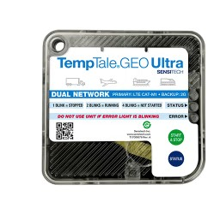
TempTale GEO Ultra is an integrated real-time Cold Chain Monitoring and management system, widely used in the food and pharmaceutical industries. Developed by Sensitech, it combines advanced sensors, GPS tracking technology and a global network connection (GSM/4G LTE), allowing users to track their shipments during transportation anywhere in the world. The system works via smart data recorders placed with products inside trucks or refrigerated containers, these devices collect accurate data about temperature, humidity and geographical location, and then send it instantly to a centralized cloud platform. This platform enables users to track shipments moment by moment and receive instant notifications in case of exceeding the allowed limits or any malfunction during the trip.

Figure 4 Device TempTale GEO Ultra

1.5.3.2 Basic techniques and components
- Sensors
The TempTale GEO Ultra system relies on advanced temperature and humidity sensors capable of measuring from −80°C to +70°C with high accuracy. These sensors continuously collect data about the environment surrounding the shipment. The sensors are factory-calibrated and designed to maintain precision over long operational periods, ensuring that any temperature deviation is quickly detected during transport.
- Data Loggers
Each shipment includes a smart data logger that records the sensor readings in real time. The device features an internal memory for data storage when there is no network connection, and an internal alkaline battery that allows continuous operation for several weeks. Once the connection is restored, all stored data is automatically uploaded to the cloud platform.
- Network Connectivity
The device transmits data through global cellular networks, using:
a. GSM (2G) for basic coverage in most regions.
b. 4G LTE for high-speed data transmission and global roaming.
The system can automatically switch between available networks depending on signal strength. Each device contains a multi-network SIM card, ensuring stable and continuous communication during international shipments.
- Cloud Platform
All collected data is sent to the ColdStream Cloud Platform, which acts as the system’s central management interface.
The platform stores, analyzes, and displays data through an interactive web dashboard accessible from any browser, as well as through mobile applications (iOS and Android) for real-time tracking. The platform also provides smart analytics to predict potential risks and generate detailed compliance reports.
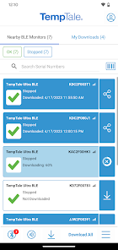 | 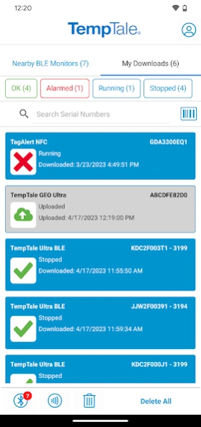 | 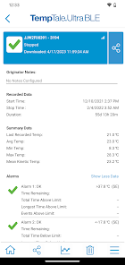
Figure 5 Cloud Platform TempTale GEO Ultra-cold
- Alert System
TempTale GEO Ultra provides multi-channel alerts that notify users instantly when temperature or humidity readings exceed preset thresholds. Notifications can be received through email, SMS, or mobile app alerts, allowing quick corrective action to prevent product damage during transport.

1.5.3.3 Common areas of use
TempTale GEO Ultra is mainly used in the transportation of heat-sensitive products, such as medicines, vaccines, and fresh food products. Major logistics companies rely on it to ensure the safety of their products during global distribution, especially when dealing with long distances or shipments need very precise conditions. It is also used in the agricultural and food industries to track products from farms to stores, enhancing transparency in the supply chain.

1.5.3.4 Security and System Integration in TempTale GEO Ultra
- Data Encryption in Transit
All transmitted data is protected using SSL/TLS encryption, ensuring that the information cannot be intercepted or altered during transmission.

- Data Encryption at Rest
Data stored on the ColdStream servers is encrypted using AES-256 algorithms, protecting sensitive information even if physical access to servers occurs.
- Data Backup and Recovery
The platform performs automatic backups in multiple geographic locations to ensure data availability and recovery in case of failure or data loss.

1.5.3.5 Strengths
- Real-Time Global Monitoring
The integration of GPS, GSM, and 4G enables continuous global tracking of temperature, humidity, and location in real time.
- Smart Multi-Channel Alerts
Provides instant notifications via email, SMS, or app, allowing rapid intervention before damage occurs.
- Reliable Data Storage and Reporting
Automatic cloud storage and FDA-compliant reports simplify auditing and reduce manual documentation.
- Scalability and Multi-Shipment Management
Supports monitoring hundreds of shipments simultaneously, suitable for global logistics companies.

1.5.3.6 Weaknesses
- High Cost
Device and cloud subscription fees are expensive, limiting access to the system for small and medium-sized enterprises.
- Reliance on Cellular Networks
It relies entirely on GSM/4G connectivity, which can cause data delays or gaps in remote areas with poor coverage.
This means that the device requires cellular network coverage in the area where it is charging to choose whether to transmit temperature, humidity, and geographic location information in real-time.
If charging is scheduled in areas where cellular coverage is not available (such as certain mileage zones or during air travel), the data is temporarily allocated, and the device automatically stores the data until indoor coverage is restored, then sends it all at once to the cloud client.
This heavy reliance on cellular networks is a weakness due to poor coverage or network connectivity, which can lead to:
Delayed data or alerts.
- Temporary effectiveness with in-flight charging.
- Possibility of losing some readers if the project fails.
- Therefore, system performance and monitoring continuity depend on the extent of the communications network in the areas where the shipment is being processed.
- Limited Environmental Range
Measures only temperature and humidity, without detecting other important indicators such as gas emissions or vibrations.
- Device Size and Placement
Some models are relatively large, which may be unsuitable for small parcels or sensitive shipments.
- Limited System Customization
Customization or integration with third-party systems requires contacting the manufacturer, which increases cost and time.

1.5.3.7 Brief analysis
TempTale GEO Ultra is one of the most powerful commercial systems in tracking refrigerated shipments globally and is an ideal option for large companies with huge budgets and dealing with large-scale distribution. However, it mainly focuses on temperature, humidity and geographical location, and does not touch on other factors such as gases (NH3, CO2, H2S) that are an early indicator of food spoilage. In addition, the high cost makes this system unsuitable for small and medium-sized businesses. Here your proposed project has the advantage of being low-cost, more flexible, combining heat, humidity and gas monitoring with real-time notifications via a simple application, which makes it a practical and effective solution for a wider segment of users.

1.5.4 Sonicu-cold chain monitoring system

1.5.4.1 General description and mode of action
The SoniShield Duo by Sonicu is an advanced wireless environmental monitoring system designed to accurately measure, record, and analyze critical environmental parameters in real time.
The system operates through two NIST-certified digital sensors connected to the main monitoring unit, continuously collecting data on temperature, humidity, air flow, and door activity.
This data is temporarily stored in the device’s internal memory and then automatically transmitted via wireless network to the SoniCloud platform, which performs analysis, report generation, and real-time alerting when any threshold is exceeded.
The system also supports integration with other facility management or monitoring systems (e.g., hospital or laboratory networks) using standard communication protocols such as HTTPS and MQTT.
This enables seamless data exchange between devices and platforms, allowing unified environmental monitoring across multiple locations.
Thus, SoniShield Duo functions as part of an interconnected digital ecosystem, enhancing both operational efficiency and monitoring accuracy.
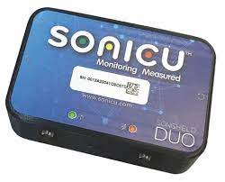
Figure 6 SoniCloud monitoring

1.5.4.2 Basic techniques and components
- Sensors
High-accuracy NIST-certified digital sensors for temperature and humidity with fast response and long-term stability.
- Connectivity Module:
Supports Wi-Fi, Ethernet, or LoRa with strong data encryption to ensure security during transmission.
- Storage and Power:
Built-in memory for local data storage during network outages, and an internal backup battery for uninterrupted operation.
- Cloud Platform:
SoniCloud handles data processing, storage, analytics, and visualization through a user-friendly online dashboard.
- Software Integration:
Offers limited integration with other systems through restricted APIs; software customization or adding new sensors is not allowed.
Allows real-time and historical data access, customizable alerts (email, SMS, or push), and report generation.

1.5.4.3 Common areas of use
The SoniShield Duo is used across multiple sectors that require precise environmental monitoring, including:
- Hospitals, operating rooms, and medical laboratories.
- Pharmacies, drug storage facilities, and cold chain warehouses.
- Restaurants, industrial kitchens, and food logistics.
- Museums and archives for sensitive material preservation.
- Research centers and university laboratories.

1.5.4.4 Strengths
- High Measurement Accuracy: NIST-certified sensors provide reliable and precise environmental readings suitable for sensitive conditions.
- Operational Continuity: Backup battery and internal memory ensure data collection even during power or network failures.
- Integrated Cloud Platform: SoniCloud offers real-time data tracking, automatic analysis, and regulatory-compliant reporting.
- Multi-Channel Alerts: Supports alerts via email, SMS, phone calls, or push notifications, minimizing response time in emergencies.
- System Integration: Compatible with enterprise-level facility systems using modern communication protocols, enabling smooth interoperability.
- User-Friendly Interface: Provides quick data access and analysis tools for technicians and administrators without requiring deep technical expertise.

1.5.4.5 Weaknesses
- Lack of Gas Detection: Does not include gas sensors (e.g., NH₃, H₂S), which are important for detecting food spoilage.
- High Cloud Dependency: Relies heavily on the SoniCloud server connection; data delays may occur if internet access is unstable.
- High Cost: Designed primarily for healthcare and laboratory environments, making it more expensive than simpler or open-source solutions.
- Limited Customization: The system is closed-source, preventing modifications or the addition of new hardware modules.
- Restricted External Integration: Although it supports certain protocols, full interoperability with other systems requires vendor support.

1.5.4.6 Brief analysis
The SoniShield Duo demonstrates several valuable design principles that can be applied to the SafeChain project, as it ensures reliable operation with continuous monitoring even during outages, provides a secure cloud-based system for data collection and analysis, and utilizes smart multi-channel alert management to maintain efficiency and safety.

1.5.5 shortcomings of the current systems versus the advantages of the proposed project

1.5.5.1 Integration Interfaces (API and Webhooks)
Application Programming Interface : is a digital contract that allows other systems to request data or trigger specific functions from the proposed system when needed.
Model: Request / Pull
Function: Allows external systems (such as analytics or monitoring software) to fetch historical or real-time data on demand.
Example: “Retrieve all active temperature readings from sensor X.”
Advantage: Essential for enabling wide integration and providing centralized control of data by the client.
Webhooks: Webhooks are automated triggers that enable the system to push information directly to an external platform when specific events occur.
Model: Push / Notification
Function: When a temperature threshold is exceeded, the system automatically sends an instant alert message to the client without requiring a manual data request.
Advantage: Eliminates the need for repeated queries and makes the system more efficient, as the client receives updates in real time only when necessary.
This integration mechanism enhances the proposed system’s responsiveness and connectivity, ensuring seamless communication between devices and external platforms.

1.5.5.2 cost factor
The problem: most of the current systems are expensive, both in terms of the price of devices and monthly subscription fees to cloud platforms, making them difficult to access for companies with limited budgets or in developing countries.
The solution in our project: providing a low-cost solution based on available commercial sensors and open source platforms, which reduces the overall cost and makes the system available to a wider segment of users.

1.5.5.3 comprehensiveness of follow-up
The problem: most systems are limited to monitoring only temperature and humidity, while some systems such as TempTale GEO Ultra add geo-tracking, which makes their ability to detect problems early limited.
The solution in our project: the system integrates a wide range of sensors that cover several basic aspects of cold chain monitoring, namely:
Sensors for temperature and humidity: to strictly follow the storage and transportation conditions.
Door sensor: to detect any unauthorized opening of the door, which contributes to the Prevention of theft or the ingress of external pollutants such as dust or unclean air.
Geographic tracking (GPS): to track the location of the truck in real time and document its route.
Gas sensors (NH3, CO2, H2S): for early detection of food spoilage by monitoring the emission of biogas.
This integration makes the system more comprehensive and integrated compared to commercial systems, gives it a predictive and proactive ability to protect food products and ensure their safety during transportation and storage.

1.5.5.4 ease of Use and integration
Problem: many systems are oriented to large companies and require special training or technical experience for operation and management. Also, some of them mainly rely on email or periodic reports for alerting.
The solution in our project: to present a simple and easy-to-use application that works on smartphones or the web, with instant alerts sent via notifications, making the response faster and more practical.

1.5.5.5 contribute to food security and reducing losses
The problem: trading systems are often focused on achieving compliance and increasing the profits of large companies.
The solution in our project focuses on serving the wider community by reducing food waste, enhancing food security, and increasing consumer confidence n products.

1.5.5.6 conclusion
It can be said that our project not only aims to imitate existing systems, but also seeks to fill their gaps by providing an integrated solution that combines: low cost, comprehensiveness of measurements (temperature, humidity, door, tracking, gases), ease of Use, and future flexibility, making it a more effective and sustainable option for different categories of users.
- 1.5.6 COMPARISON table between current systems and the proposed project

Table 1 Technical Comparison Table of Cold Chain Monitoring System
Technology | Cooltrax | DicksonOne | TempTale GEO Ultra | Sonicu | SafeChain
Sensors | Long-range Bluetooth micro-sensors + thermistor and RTD for temperature + capacitive sensors for humidity + magnetic reed switch for door + GPS for tracking | RTD for temperature + digital IC sensors + fast-response thermistor + thermocouple for wide temperature ranges + capacitive sensors for humidity + piezoresistive MEMS sensors for pressure + NDIR sensor for infrared detection |  | RTD (e.g., Pt100) for high-accuracy temperature + capacitive humidity sensors + condenser/electroacoustic microphone + capacitive pressure sensors with flexible plate + hot-wire anemometer measuring airflow cooling + magnetic reed switch for door | The system uses carefully selected sensors to balance accuracy, cost, and reliability. SHT31 is used for precise temperature and humidity measurement due to its stability and accuracy. MQ-135 and MQ-9 sensors are used for gas detection because they can detect a wide range of harmful gases at low cost. A magnetic reed switch is used for door monitoring due to its simplicity and low power consumption. The NEO-M8N GPS module is used for real-time tracking due to its high accuracy and reliability.
Controllers | Cooltrax Telematics Unit includes a microcontroller for data processing and system control + dual-mode cellular/satellite modem + GPS module for location tracking | DicksonOne Data Logger includes a powerful microprocessor for local data processing and analysis + Wi-Fi/Ethernet module for network or cloud transmission + non-volatile memory to retain data during power loss | TempTale Ultra/Geo (Embedded CPU) records sensitive shipment data like temperature and humidity independently + low-power microcontroller for long battery operation + secure flash memory for protected data storage | SoniLink Hub/Duo Gateway includes a processor for receiving and initially processing sensor data + multi-mode communication module (RF/Wi-Fi/Cellular) for flexible connectivity | The Raspberry Pi is used as the main controller because it provides high processing capability, supports multiple interfaces (GPIO, I²C, UART), and enables easy integration with sensors and cloud systems. It is suitable for handling real-time data processing and running IoT applications efficiently.
Location Technology | Built-in GPS | Not available | Built-in GPS with 5-10 meter accuracy | Not available | The NEO-M8N GPS module is selected for its high positioning accuracy (5–10 meters), fast signal acquisition, and reliable performance in transportation environments.
Network Type | Cellular networks (GSM/3G/4G) + Wi-Fi | Wi-Fi / Ethernet | Cellular networks (GSM/4G LTE) with international roaming + multi-carrier SIM cards | Cellular networks / Wi-Fi / Radio communication | A hybrid network approach is used to ensure continuous connectivity. Wi-Fi is used in urban environments for fast and cost-effective communication, 4G LTE is used during transportation for real-time data transmission, and LoRaWAN is used in remote areas due to its long-range communication and low power efficiency.
Communication Protocols | 4G+  Wi-Fi | Ethernet+  LoRaWAN  Wi-Fi | GSM(2G)+  LTE(LTE4 Cat-M1) | Wi-Fi + Ethernet  + LoRa+4G +HTTPS+MQTT | MQTT is used for efficient and lightweight data transmission between devices and servers, while HTTPS is used to ensure secure communication. LoRaWAN protocol is used for long-range communication in remote environments with minimal power consumption.
Database | Cloud database  Time-Series/  NoSQL+GPS | SQL database in the cloud | Distributed cloud database  Time-Series/SQL | Cloud database  Time-Series | The system uses XAMPP as a structured (SQL-based) database for storing static and structured data, such as user and system records. In addition, Prometheus is used as a time-series database to efficiently store and analyze real-time sensor data such as temperature, humidity, and environmental changes.
Power Source | Uses rechargeable batteries or external power. It can also work wirelessly without a fixed power source, making it suitable for transportation and mobile applications. It supports long-range wireless communication such as LoRa and ZigBee, and can operate for long periods without maintenance. | Operates on main AC power. If electricity fails, it automatically switches to rechargeable battery mode. It can be reused many times, making it ideal for labs and industrial environments | Works on a built-in non-rechargeable battery (single-use). After usage, data is retrieved externally and analyzed. | Operates on both AC and DC power sources. Has an automatic system that switches to battery mode in case of power outage, allowing up to 24 hours of data logging. | The system operates using rechargeable batteries or external DC/USB power, providing flexibility for both mobile and fixed deployments. A power management system is implemented to ensure energy efficiency and protect against overcharging and power loss.
Measured Parameters | Measures temperature , humidity, and door status (open/closed). Includes GPS for location tracking, and data is sent to the cloud platform for analysis. | Measures temperature using RTD sensors with accuracy and humidity with RH accuracy. It can also record environmental conditions and upload data to cloud platforms for monitoring. | Measures temperature using RTD sensors and humidity. Also provides GPS location tracking for shipments. | Measures temperature and humidity, optionally includes GPS for location tracking. Provides stable and accurate readings for short-range sensors. | Measures  temperature, humidity, gas levels, door status, and location to ensure complete monitoring of environmental conditions and shipment safety.
Supported Metrics | Temperature only | Temperature and humidity | Temperature and humidity | Temperature, humidity, air flow, and door status | Temperature, humidity, gas detection, door status, and GPS location tracking.

Observation:
It should be noted that the current comparison reflects the basic characteristics of the most common systems, however, some companies may introduce upgraded versions or models that include additional advantages such as wider measurements or advanced technical integrations. These versions are usually aimed at groups with special needs and come at a higher cost compared to the basic platforms.

1.6 Methodology
1.6.1 Selected Methodology: Scrum (Agile)
The project will adopt the Scrum (Agile) methodology, which is one of the most widely used iterative and incremental software development approaches. It emphasizes flexibility, continuous improvement, and delivering functional prototypes in short cycles (sprints).
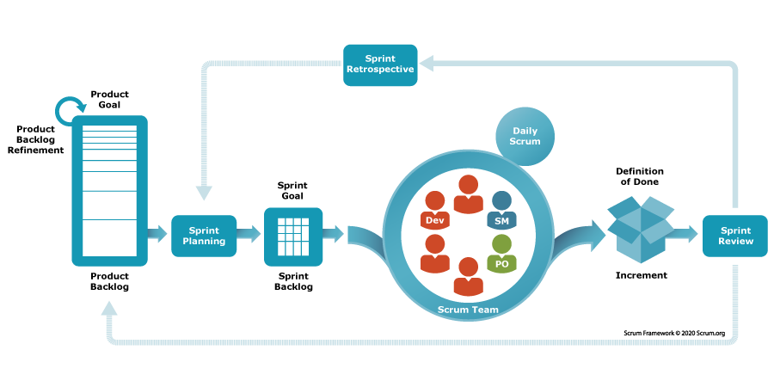
Figure 7 Scrum Methodology

1.6.2 Objectives of Using Scrum
- To ensure that the system is developed iteratively, minimizing risks.
- To guarantee that user requirements (food companies, restaurants, regulators) are continuously considered and validated.
- To allow prototyping and testing of sensors, mobile application, and cloud integration at each sprint stage.
- To achieve a balance between time, cost, and quality while maintaining transparency and traceability of progress.

1.6.3 Comparison with Other Methodologies
Methodology | Strengths | Weaknesses | Suitability for This Project
Waterfall | Clear stages, structured, good for fixed requirements | Rigid, hard to adapt if requirements change, testing comes late | Not suitable because IoT projects need frequent testing and adjustments
Agile (Scrum) | Flexible, iterative, frequent feedback, supports hardware+software integration | Requires active collaboration and discipline | Most suitable because the project involves experimental prototypes, feedback, and gradual improvements
Table 2:Comparison with Other Methodologies

1.7 Project Plan
The Safe chain project is aimed at developing an intelligent food safety monitoring system using IoT sensors, cloud integration, and mobile applications. The project will be executed over 10 months (40 weeks), divided into 20 sprints of 2 weeks each. Each sprint delivers a functional increment that can be tested and validated.
The plan is structured into six main phases, each addressing critical components of the system: hardware (sensors + Raspberry Pi), software (Dashboard prototype and mobile app), and Database integration.

1.7.1 Project Timeline Summary
Phase | Sprint(s) | Month | Deliverable
Preparation & Setup | 1–2 | 1 | Initial setup + sensor prototype
Basic Monitoring System | 3–6 | 2–3 | Dashboard prototype
Cloud Integration & Alerts | 7–10 | 4–5 | Database-connected system with alerts
Mobile App Development | 11–14 | 6–7 | Mobile app prototype
System Enhancement & Analytics | 15–18 | 8–9 | Enhanced monitoring system
Testing, Security & Final Delivery | 19–20 | 10 | Fully tested and deployed system
Table 3 Project Timeline

1.7.2 Gantt Char Project
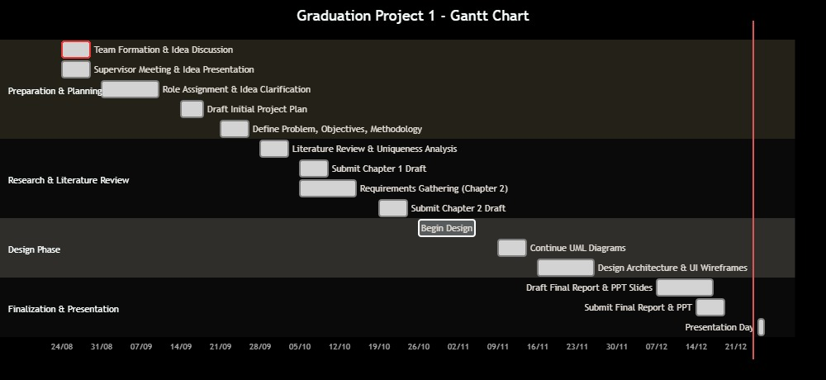
Figure 8 Gantt chart

1.7.3 Conclusion
In summary, this chapter has outlined a comprehensive and robust roadmap for the development of the Safe chain project. The selection of the Scrum (Agile) methodology is a strategic decision, directly aligned with the project's inherent complexities involving hardware-software integration, evolving requirements, and the need for continuous stakeholder feedback. The detailed project plan, segmented into six distinct phases and twenty sprints, provides a clear, iterative, and manageable pathway from initial concept to final deployment. This structured yet flexible approach ensures that the project minimizes risks through incremental prototyping, validates functionality at every stage, and remains adaptable to changes and unforeseen challenges. By adhering to this plan, the project is well-positioned to deliver a fully tested, secure, and effective intelligent food safety monitoring system that meets its core objectives and provides a solid foundation for future enhancements.

1.8 Summary
In this chapter, the idea of the project, its goals and importance in monitoring food safety during transportation and storage were presented, while clarifying the research problem related to the impact of food on environmental factors inside trucks. The purpose of the project and its detailed objectives were also determined, the beneficiary categories and the expected benefits of the system were reviewed. An overview of the current systems used in food control was also presented, with their advantages and disadvantages, and what distinguishes our project from them. Finally, the methodology followed in the development of the project and its implementation time plan were briefly presen

Chapter2: SYSTEM ANALYSIS

2.1 Introduction
This chapter provides a comprehensive analysis of the system's functional and non-functional requirements. It outlines the features and functionalities of the application and presents the technical specifications needed for development

2.2 Stakeholders
The SafeChain project includes a group of stakeholders who benefit from its results. They were identified as follows
(As show Figer 9):
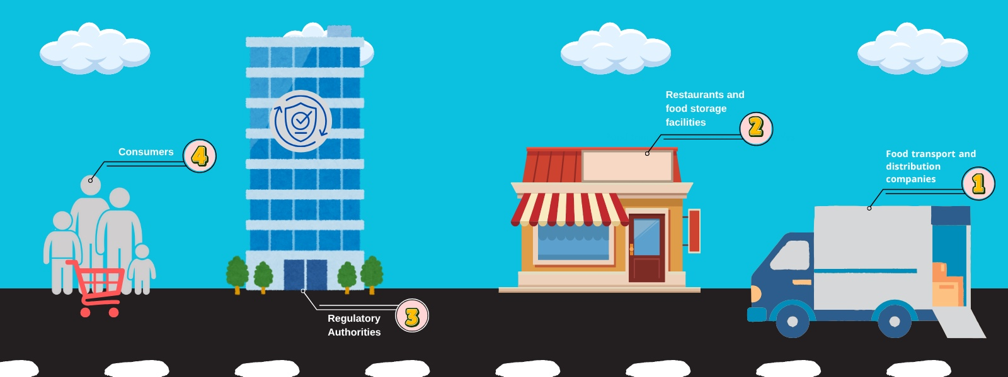
Figure 9 stakeholders in SafeChain

2.2.1 Food transport and distribution companies:
They are one of the most important stakeholders because they will actually use the system to monitor trucks while transporting food. The project helps them reduce damage and waste and improve operational efficiency.

2.2.2 Restaurants and food storage facilities:
They are interested in the system to follow the condition of stored food and ensure their quality. The system provides them with immediate reports and alerts that help maintain the safety of products.

2.2.3 Regulatory Authorities:
They take advantage of the system to follow up on companies' commitment to food safety standards through immediate and accurate data, which improves the quality of censorship.

2.2.4 Consumers:
They are the primary beneficiaries with a clear interest because they are the final beneficiary of the system, as the project guarantees them safe and sound food products.

2.3 Requirements Elicitation and Analysis Methodology
To ensure that the SafeChain system is built that meets the actual needs of its core users, the requirements collection process is designed based on direct interaction with the stakeholders that most influence the functionality of the system. A set of tools was used to collect and analyze the requirements, each tool was oriented towards a specific segment of stakeholders identified in Section 2.2 to get the most out of it

2.3.1 Interviews:
Interviews are the main qualitative tool used to collect detailed requirements for the SafeChain system. The main objective of these interviews was to delve deeper into understanding the current workflow and cold chain challenges, identify pain points, and derive operational requirements that represent an actual need for the user.

2.3.1.1 Interview Details:
An organized consulting interview was conducted with an expert in the field of transport and logistics, Mr. Mohammed Salim, who holds the position of (Business Development Supervisor) at Al Wefaq National Transport Company. The conversation focused on the challenges of preserving and transporting food and the requirements of the control system for refrigerated trucks.

2.3.1.2 Key operational challenges identified:
The interview was conducted as a structured consultation with the expert, Mr. Mohammed Salim. The questions were designed to cover key operational challenges, monitoring data, system reliability, and future constraints. The detailed questions and answers are provided belowCooling readiness: it must be ensured that the cooling box is sealed and its temperature is ready to the desired degree before loading.

2.3.1.2.1 What are the biggest challenges you face in the food preservation and transport process?
- The main challenges of preservation and transport are:
- 1. Driver control: How to manage the driver and their driving style.
- 2. Readiness for refrigeration: The refrigerated container must be airtight, and the temperature must be at the required level before loading begins.
- 3. Damage to the refrigeration unit: The biggest problem is loading frozen food that is still fresh (not frozen), which causes excessive strain and damages the refrigeration unit.
- 4. Loading time: The loading process must be quick to prevent the product from losing its temperature.
- 5. Monitoring: A digital thermometer must be installed in front of the driver to provide accurate and immediate temperature readings.
        - What data do you consider essential for monitoring and tracking in the truck?
The indispensable data points are: temperature and humidity. In addition, the driver's behavior and door openings (the number of times the door is opened and closed) must be monitored.
        - What means of alert do you prefer when a malfunction occurs?
The indispensable data points are: temperature and humidity. In addition, the driver's behavior and door openings (the number of times the door is opened and closed) must be monitored.
        - How important is it for the system to provide periodic reports? And what type are they?
Regular reports are essential. Daily or weekly reports are preferable for monitoring food quality and condition. The importance of a data logger, which accurately records the date and temperature of the trip, should also be noted as a reliable reference.
        - What usage platforms do you find suitable for accessing system data?
The system should be available on two platforms: a mobile application (for out-of-office and anywhere else), and a website (for use during working hours from a laptop or desktop).
        - What is the critical importance of preserving historical data records?
Saving data is very important and necessary, especially for reference in certain cases such as: customer complaints, accidents, or if there is damage to the goods, or in cases of theft.
        - In the event of an internet outage or poor coverage, do you need a solution that ensures the system's operation and continuous monitoring?
Yes, there should be a backup solution to ensure the system works in case the truck is in a weak coverage area or there is a network outage.
        - Do you need an alternative power source for monitoring sensors or tracking devices?
Yes, this is absolutely essential. There must be an alternative power source (for the sensor, GPS, or data logger) in case the truck battery or alternator fails.
        - What are your requirements regarding data security and protection?
Security and protection are absolutely essential for data retrieval in cases of damage or theft.
        - What features does your current system already cover?
The current system already covers most of the features you mentioned, especially regarding driver behavior (monitoring hard braking, accelerator pedaling, not wearing a seatbelt, talking on the phone without a headset).
        - What is the biggest future challenge for optimizing and developing this system?
The biggest challenge they face is the cost of cloud storage, as they sometimes need to keep data for long periods (a month or two) to deal with unexpected problems, and storage costs can be expensive.

2.3.1.3 Basic requirements for the system:
A set of functional and non-functional requirements and limitations necessary for the design of the proposed system were derived, namely:
- Necessary monitoring data: the speaker stressed the importance of monitoring the following continuously:
- Temperature and humidity.
- Opening doors (the number of times they open and close).
- Driver behavior.
- Location and speed via GPS system.
- User interfaces and alerts:
- The system should preferably be available via a mobile app (for follow-up outside the office) and a website (for office use).
- The need for a digital meter (digital thermometer) in front of the driver to monitor the temperature immediately.
- It is preferable to receive instant alerts when a malfunction occurs via text messages (SMS), Whatsapp, email, or an alarm from the application.
- Daily/weekly reports are very necessary to follow the status of food.
- Reliability and data management:
- The system should save previous records for reference (in cases of customer complaints, damage, theft).
- The system must include a data logger device that accurately records the date and temperature of the flight.
- High security and protection of stored data should be provided.
- Infrastructure requirements and restrictions (Non-Functional Constraints):
- Operation when the internet is interrupted: there must be an alternative solution to ensure the operation of the system in the event of an internet outage or poor coverage.
- Alternative power source: another source of electricity must be available (for the sensor, GPS, or data logger) in case the battery or Dynamo in the truck breaks down.
- The cost of cloud storage: the biggest challenge to optimize the system idea is the cost of cloud storage (Cloud), as they require data retention for long periods (one or two months)

2.3.2 Questionnaires:
Questionnaires are an essential and complementary quantitative tool for in-depth interviews. This tool was used to assess the general needs and feature priorities of a wider cross-section of stakeholders, providing statistically Measurable data on the extent to which users accept and prefer the proposed features in the SafeChain system.

2.3.2.1 Analysis of results:
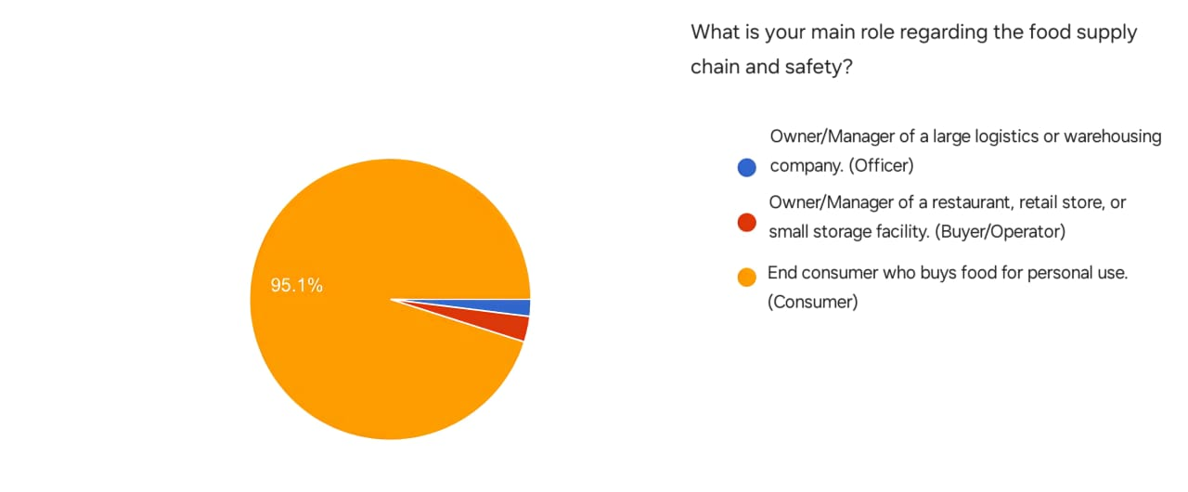
Figure10 Distribution of the main roles of the survey participants
This figure shows the main role of participants in the supply chain and food safety. The results show that the vast majority of participants, at 95.1%, are end consumers who buy food for personal use, while managers or owners of restaurants and small shops made up a limited percentage, and the percentage of managers of large logistics or warehousing companies was the lowest among the participants.
These results indicate that the questionnaire sample is predominantly consumer-oriented, reflecting the interest of individuals as end consumers in food safety issues more than actors at other stages of
the supply chain.
Interpretation: According to the results, 95.1% of the participants are end-consumers, making them the primary beneficiaries of this system. Consequently, our system will focus on simplicity and the ease of reading final indicators for non-specialized users, ensuring that information is accurately communicated to every user.

.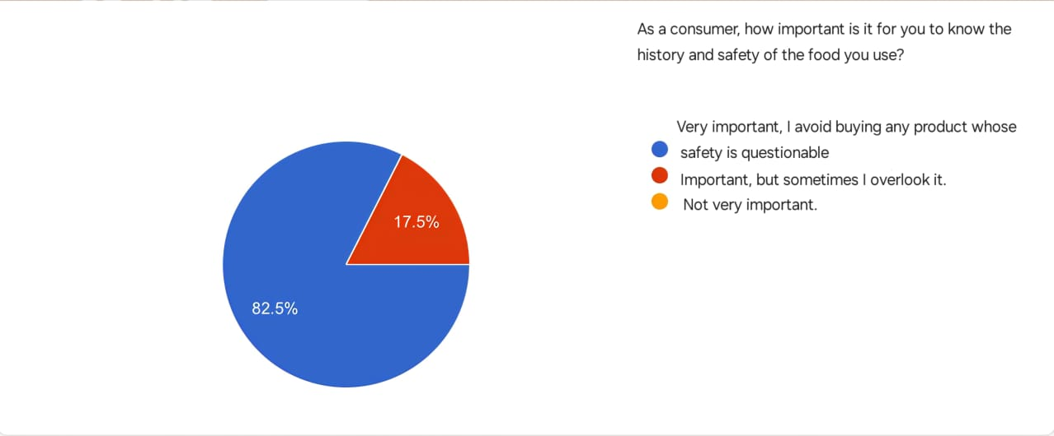

Figure 11 The influence of quality and safety factors on the consumer's choice of product

This figure shows how important it is for consumers to know the history and safety of the food they use. It turns out that 82.5% of respondents consider this very important and avoid buying any product whose safety is in doubt, while only 17.5% consider it important but may sometimes overlook it, while no one seemed unimportant.
These results indicate that the majority of consumers pay great attention to safety and quality aspects before making a purchase decision.
Interpretation: The results show that 82.5% of end-consumers consider knowing the history and safety of food to be extremely important. Accordingly, we found an urgent need for our system, as consumers will refrain from purchasing any product if they doubt its safety, which negatively impacts manufacturers and distributors.

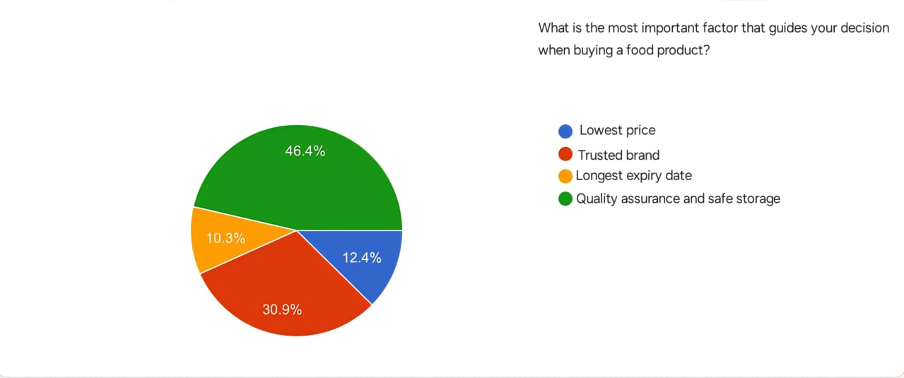
Figure 12 The most important factors that guide the consumer's decision when buying food
This figure shows the factors that most influence the decision of consumers when buying food products. The survey showed that the factor of quality assurance and safe storage came in first place with 46.4%, followed by the trusted brand with 30.9%, then the low price with 12.4%, and finally the longest shelf life with 10.3%.
The results show that consumers prefer quality and safety over price or shelf life, reflecting a growing awareness of the importance of food safety.
Interpretation: Based on the results showing that 46.4% of end-consumers prioritize product quality and safe storage, we conclude that consumers possess sufficient awareness to choose a product regardless of its brand or price, as long as storage safety is guaranteed. Therefore, we chose to equip our system with high-precision sensors to monitor storage conditions in real-time, fulfilling the consumers' primary demand.

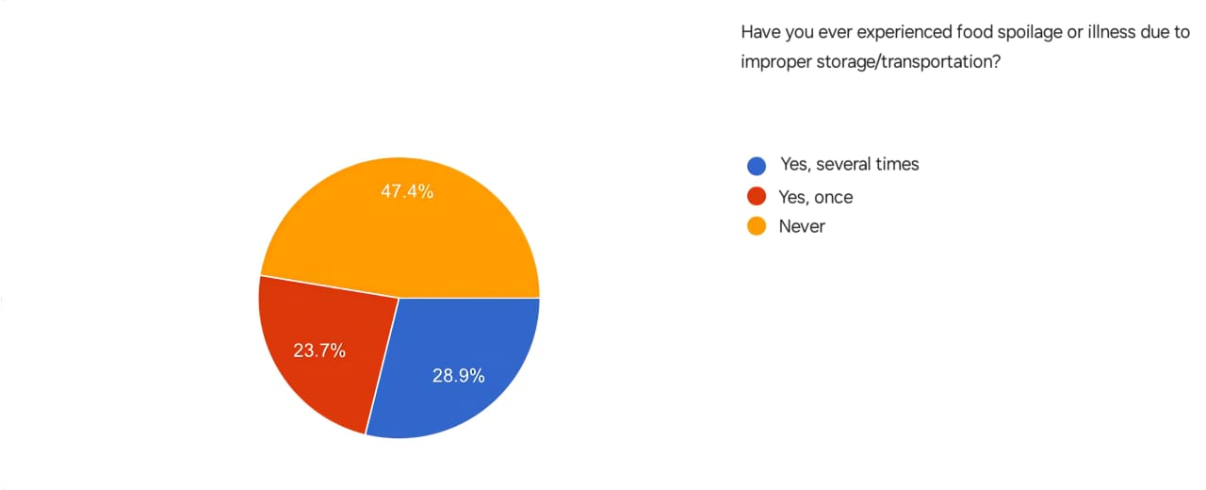

Figure 13 Statistics on food spoilage / diseases caused by poor storage

This figure shows the extent to which consumers are exposed to food spoilage or disease as a result of poor storage or transportation. The survey showed that 28.9% of respondents have experienced this several times, while 23.7% of them have encountered this problem only once, while 47.4% have never experienced it.
Interpretation: The results indicate that 28.9% of end-consumers have experienced food spoilage multiple times, while 23.7% have experienced it once. From this, we conclude that 52.6% of consumers have already been affected by food spoilage, proving the dire need for our system to provide an additional layer of protection currently lacking in existing supply chains.

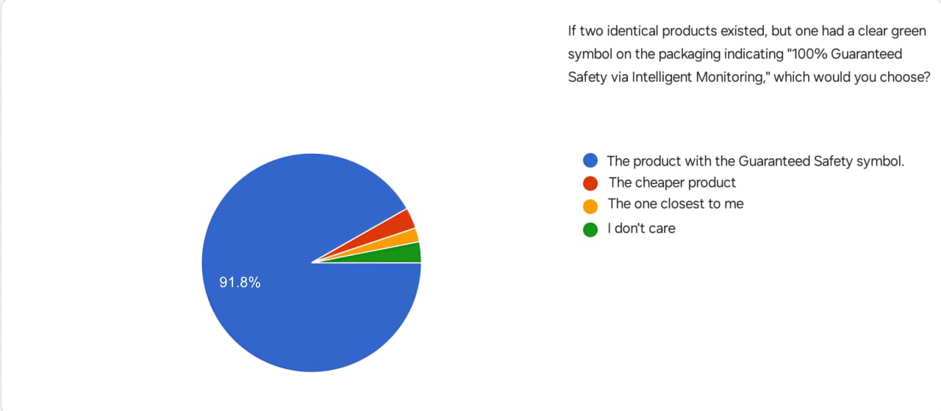

Figure 14 The extent to which the safety guarantee affects the consumer's purchase decision

This figure shows the preferences of consumers when choosing between two identical products, one of which has a green symbol indicating "100% safety guarantee via smart monitoring". The survey showed that 91.8% of respondents prefer the product with the warranty code, while 4% chose the cheapest product, 2% the closest one, and 2.2% do not care about the difference.
The results show that consumers attach great importance to safety and quality factors when buying, reflecting a strong confidence in products that clearly highlight safety standards.
Interpretation: Since 91.8% of end-consumers prefer products carrying a safety guarantee label, we decided that the final output of the system—in cooperation and agreement with the companies—will be a distinctive label. This label will be placed on products and shelves to indicate safe transport, enabling consumers to make confident and secure purchasing decisions.

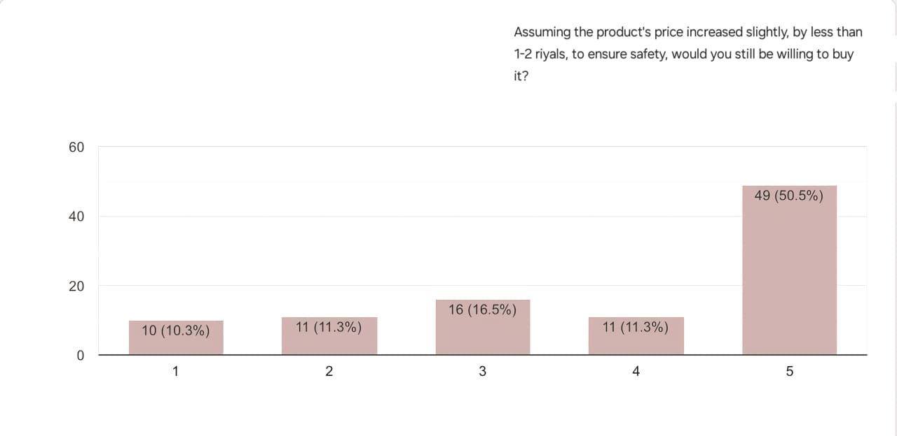

Figure 15 The extent to which the consumer is willing to pay for ensuring the safety of the product.

This figure shows the extent to which consumers are willing to buy the product if its price rises slightly (from 1 to 2 riyals) in exchange for ensuring its safety. The results showed that 50.5% of the participants showed a strong willingness to buy despite the price increase, while 16.5% showed an average degree of acceptance, and the rejection or hesitation rates were 10.3%, 11.3% and 11.3%, respectively.
The results show that the majority of consumers are willing to pay a little extra for a food safety guarantee, which confirms the importance of the safety factor in purchasing decisions.

Interpretation: The results show that 50.5% of end-consumers are willing to pay an additional amount for product quality. This proves that consumers are ready to support the technologies used in our system, allowing companies to recover system costs through a slight and acceptable increase in product price.
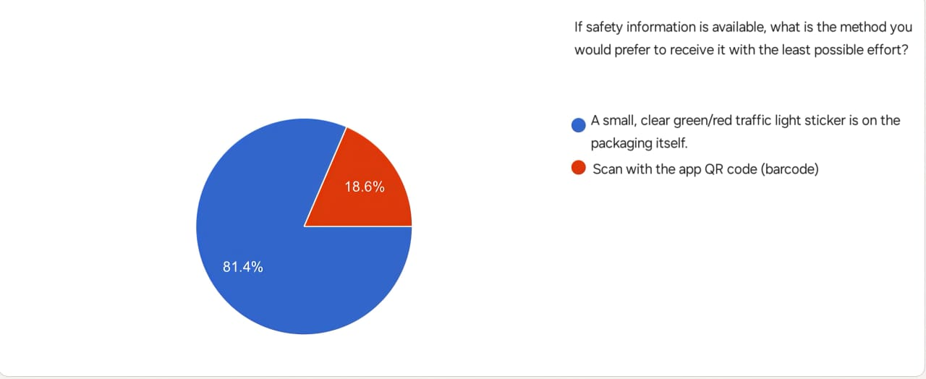
Figure 16 The consumer's preferred way to obtain product safety information
This figure shows the preferred way for consumers to receive safety information for food products. The survey showed that 81.4% of respondents prefer a simple and clear label on the package with a color code (green/red) indicating the level of security, while only 18.6% prefer to use a QR code to access information.
The results indicate that consumers prefer easy and straightforward ways of viewing safety information without the need to use additional applications or tools.
Interpretation: According to the findings, 81.4% of end-consumers prefer a physical label on the packaging over a QR code. Consequently, we decided to focus on a color-coded label placed on products and shelves. This will significantly assist the consumer and provide a faster benefit than a QR code, which some—especially the elderly—might find complex or inconvenient.
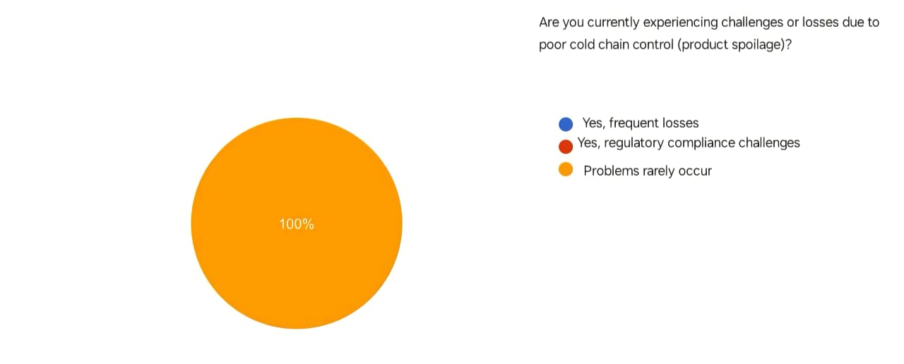
Figure 17: How frequent are problems with cold chain control
This figure shows the extent to which participants suffer from challenges or losses resulting from poor control of the cold chain of food products. The results showed that 100% of all participants reported that problems rarely occur, which indicates that their food preservation and storage processes are running very efficiently and do not face significant challenges related to product corruption.
Interpretation: The results show that 100% of operators found that transport and storage issues rarely occur. We conclude that this rarity is due to strict manual monitoring by human personnel. Accordingly, our system aims to reduce human effort through full automation, ensuring loss prevention without relying on sudden human error that may go undetected in its early stages.

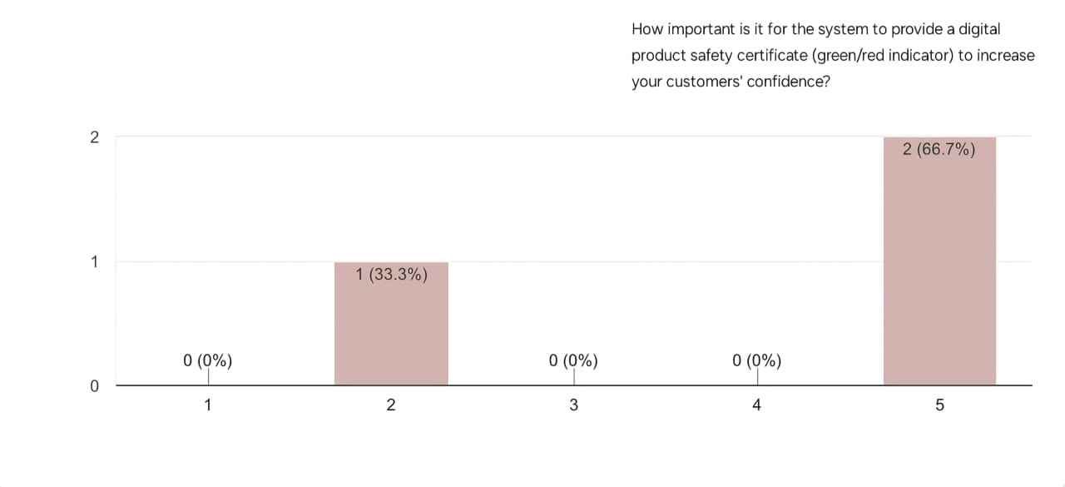
Figure 18: How frequent are problems with cold chain control
This figure shows how important it is for the system to provide a digital certificate of Product Safety that includes a color indicator (green/red) to enhance customer confidence. The results indicate that 66.7% of the participants consider this to be of very high importance, while 33.3% expressed that it is of relatively low importance, while none of the participants expressed a neutral position.
These results indicate that the majority of participants recognize the importance of digital visual indicators in enhancing consumer confidence in Product Safety and quality.

Interpretation:
The results illustrate the frequency of problems related to cold chain control among operators. The findings indicate that a significant proportion of participants experience cold chain issues frequently, highlighting existing challenges in maintaining proper temperature control during storage and transportation. This emphasizes the need for effective monitoring and control systems to detect deviations promptly and reduce potential risks to product safety and quality.

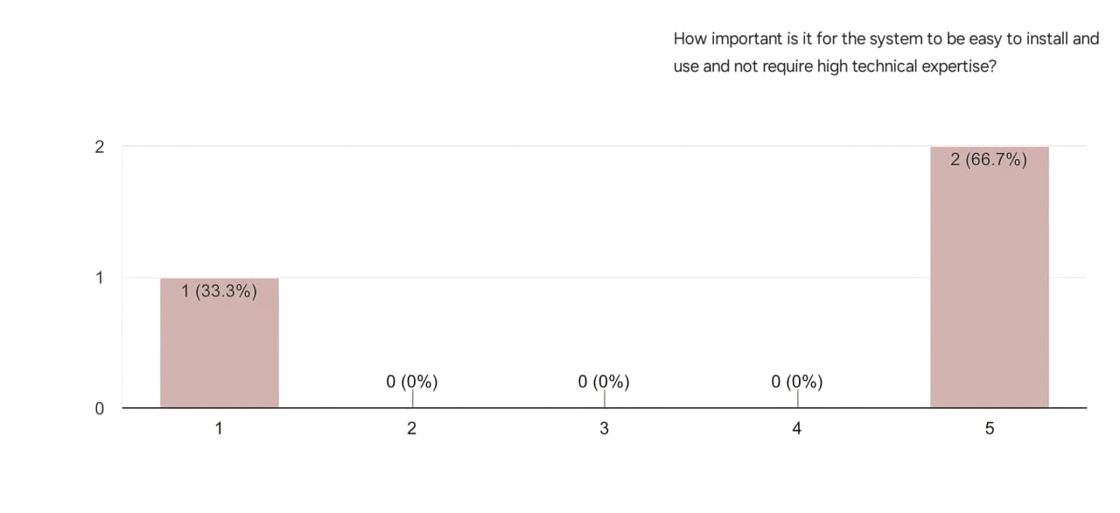
Figure 19 How important is the ease of installation and use of the system without the need for high technical expertise

This figure shows how important the ease of installation and use of the proposed system for operators is. The results showed that 66.7% of the participants expressed the highest importance (Grade 5) for the ease of the system and its lack of high technical expertise, while 33.3% of the participants indicated less importance (Grade 1). These results clearly indicate that the overwhelming majority of operators attach the utmost importance to the flexibility and ease of handling of the system as a key factor for its adoption.
Interpretation: The results show that 66.7% of operators consider ease of installation and system usage without high technical expertise to be very important. This indicates that operators prefer practical and simple systems that do not require specialized technical skills. Consequently, our system was designed with an intuitive interface and a simple installation process to ensure ease of use by non-technical personnel.

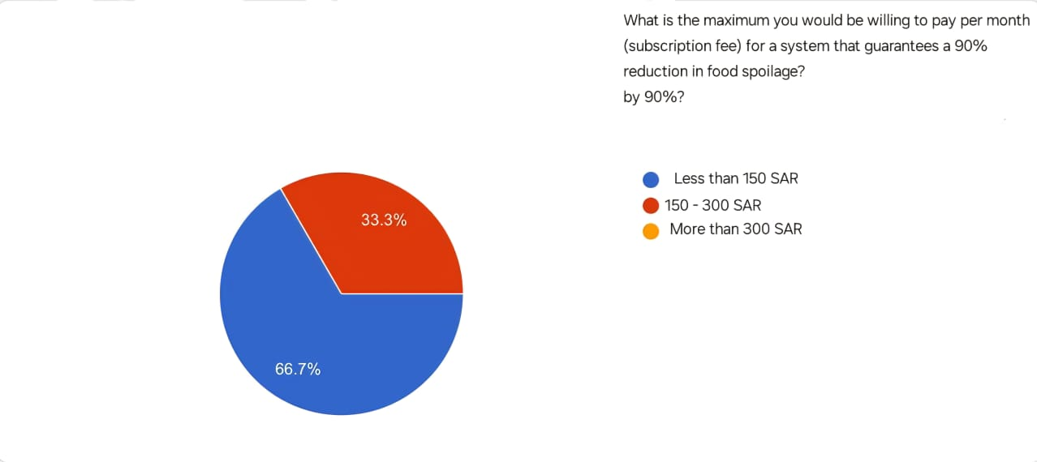

Figure 20 How important is the ease of installation and use of the system without the need for high technical expertise

This figure shows how much participants are willing to pay per month for a system that ensures a 90% reduction in food spoilage. The results showed that 66.7% of the participants prefer to pay less than 150 Saudi riyals per month, while 33.3% expressed their willingness to pay an amount between 150 and 300 riyals. These results indicate the tendency of the majority of participants to adopt effective solutions to reduce food spoilage, provided that they are low-cost and economically suitable.
Interpretation: The results indicate that 66.7% of operators are willing to pay less than 150 Saudi Riyals per month, while 33.3% are willing to pay between 150 and 300 Saudi Riyals. This demonstrates that cost is a critical factor in system adoption. Accordingly, our system focuses on providing an affordable subscription model that delivers essential monitoring features without imposing high financial burdens on companies.

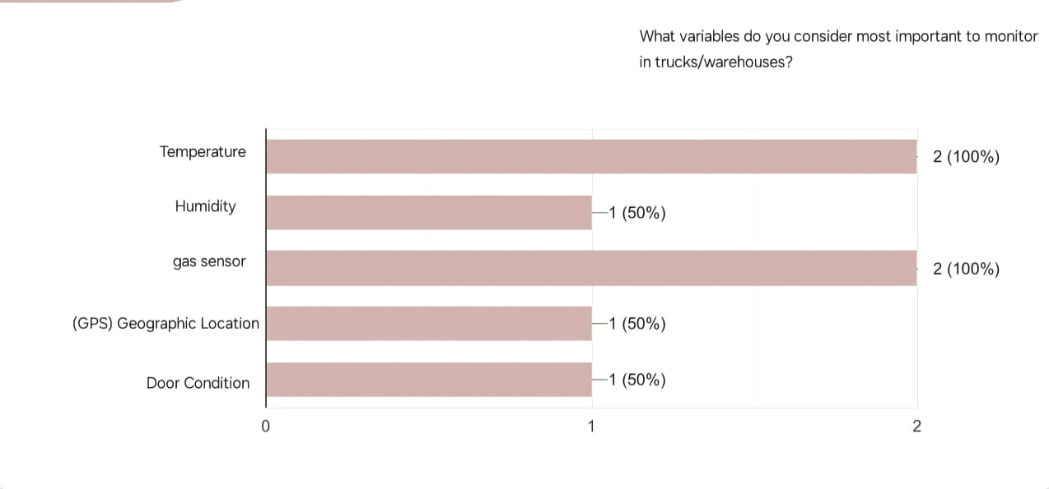
Figure 21 The most important variables that the operational entities deem necessary for monitoring in trucks/warehouses
This figure shows which variables participants consider the most important for observation inside trucks or warehouses. The results indicate that 100% of the participants stressed the importance of monitoring both temperature and gas sensors, while 50% of them felt that monitoring humidity, geographical location (GPS) and the condition of the doors are also important elements to follow. These results highlight the participants ' awareness of the importance of controlling key environmental factors to ensure food safety during transportation and storage, in particular temperature and gases that may directly affect product quality.
Interpretation: The results show that 100% of operators consider temperature and gas monitoring essential, while 50% also consider humidity, GPS location, and door status to be important. This confirms that operators are aware of the key factors affecting food safety. Therefore, our system prioritizes high-precision temperature and gas sensors while supporting additional monitoring variables to ensure comprehensive protection during storage and transportation.
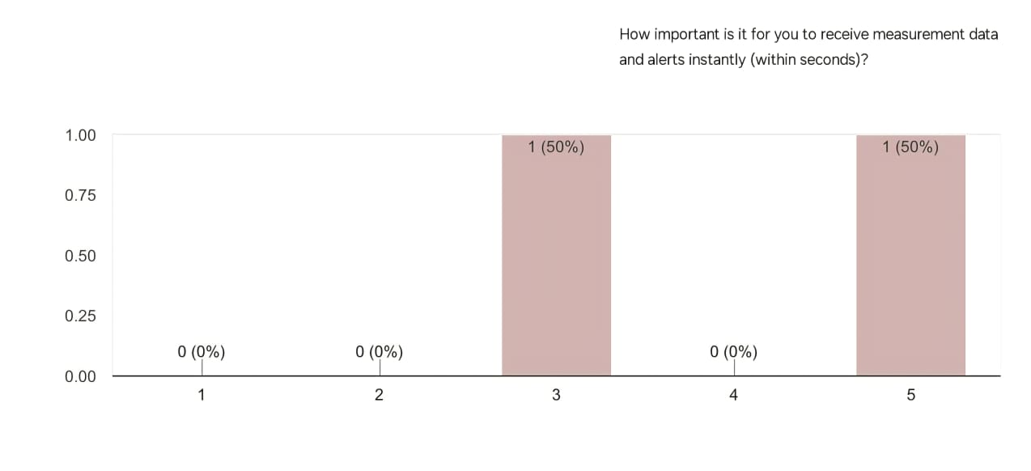
Figure 22 How important it is to receive measurement data and alerts instantly (within seconds).
This figure shows how important it is to receive measurement data and alerts instantly (within seconds). The results showed that 50% of the participants considered the immediate response to be very important, while another 50% considered it to be of medium importance. These results indicate that there is a general agreement on the importance of the speed of the system in sending alerts and data, because of its essential role in avoiding errors and taking preventive measures in a timely manner.
Interpretation: The results indicate that operators place high importance on receiving measurement data and alerts instantly. This highlights the need for rapid response to abnormal conditions. Consequently, our system was designed to provide real-time data transmission and immediate alerts to allow timely intervention and prevent potential losses.

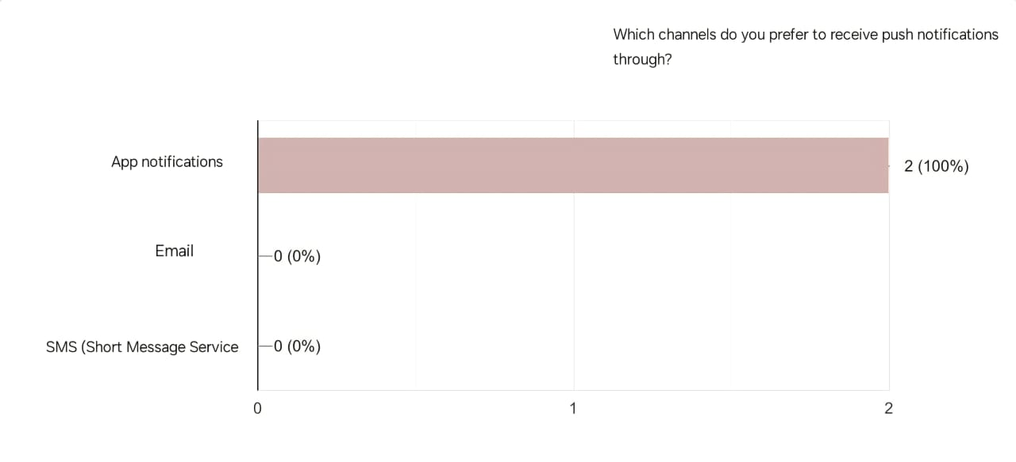
Figure 23 Preferred channels for operators to receive System Notifications
This figure shows the preferences of participants about the channel for receiving push notifications related to the status of the system and monitoring. The results showed an absolute preference for app notifications by 100%, while no participants chose to receive notifications via email or SMS. This result indicates that participants prefer to receive immediate and direct alerts within the application environment of the system, which indicates that they rely on the system to follow up on logistics operations in real-time, and that application notifications are the most effective tool to ensure quick access to information and take the necessary action in a timely manner.
Interpretation: The findings show that 100% of operators prefer receiving system notifications through application notifications rather than email or SMS. This indicates a preference for fast and direct communication. Accordingly, our system relies on in-application notifications to ensure that alerts are received and acted upon without delay.

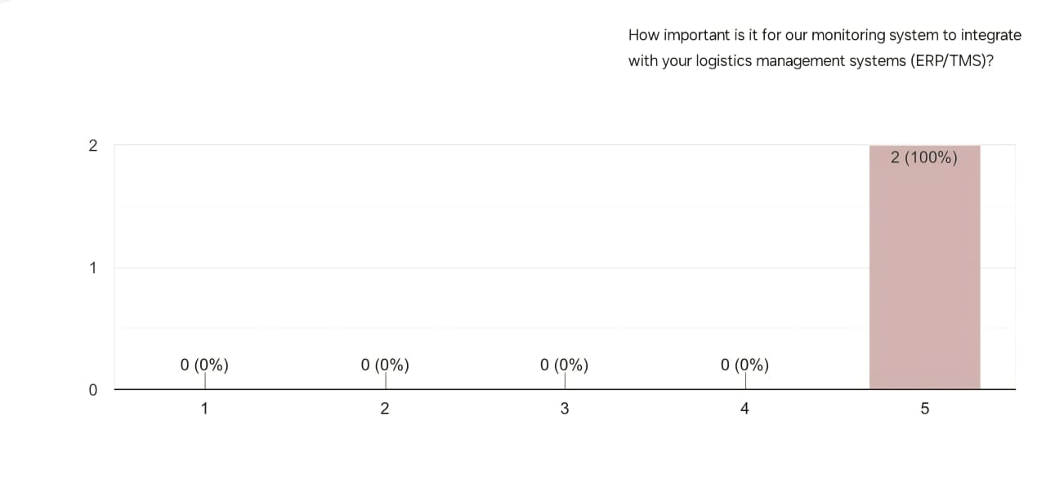
Figure 24 How important is the integration of the monitoring system with logistics management systems (ERP/TMS).
This figure shows how important it is to integrate the proposed monitoring system with the participants’ existing logistics management systems (e.g. ERP systems ERP and TMS transport management systems). The results indicate that integration is of the utmost importance, with 100% of respondents (on a scale of 5) indicating that such integration is very necessary. This result indicates that users in the logistics sector do not want a monitoring system that works in isolation from the platforms they use, but rather they consider that the maximum use of the new system requires a smooth flow of data between the monitoring system and operational systems, which ensures higher efficiency and avoids duplication of data entry.
Interpretation: The results show that all operators consider integration with ERP and TMS systems to be very important. This reflects the need for seamless data flow between monitoring and logistics platforms. Therefore, our system was designed to support integration with existing ERP and TMS systems to enhance operational efficiency and reduce manual data handling.

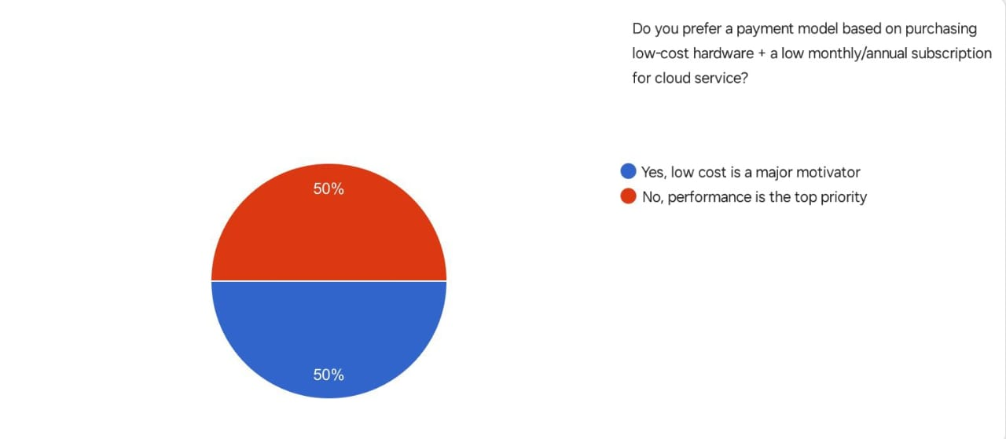
Figure 25 The preferences of the operating entities for a payment model based on the low cost of hardware and a cloud service subscription
This figure shows the preferences of participants regarding the payment model of the system, whether it is based on the purchase of low-cost devices with a low monthly or annual subscription for a cloud service, or performance is the main priority. The results indicate an even split among the participants, with 50% of them seeing low cost as a major motivating factor, while the other 50% confirmed that performance is the most important factor in decision-making. These results indicate that users ' priorities differ between the desire to reduce costs on the one hand, and ensuring the efficiency of the system and its high performance on the other hand, which indicates the need to balance both sides in the design of the pricing model.
Interpretation: The results indicate that operators are equally divided between prioritizing low cost and high system performance. This demonstrates that companies seek a balance between affordability and reliability. Accordingly, our system was designed to deliver strong performance while maintaining a reasonable cost, ensuring it meets both expectations.

2.4 Functional Requirements
Functional requirements involve clearly describing what the system should do — the specific behaviors, features, and functions it must support. The following provides description the system functional requirements.

2.4.1 User Login (FR_001):
Description: The User Login functionality allows registered users to access the platform securely using their email and password. This requirement supports session management, error handling for invalid credentials, and account security through lockout mechanisms. It is a core feature of the authentication module and integrates with user registration and password reset functionalities. Additionally, the system must identify whether the authenticated user is an Admin or a Standard User and load the corresponding access level.
Table 4 Functional Requirement – User Login
Field | Details
ID | FR_001
Title | User Login
Description | The system shall allow registered users to log in using their email and password, and it must identify whether the logged-in account belongs to an Admin or a Standard User.
Priority | Must-Have
Actors | Registered User (Admin / Standard User), System
Inputs | Email address, password, "Login" button click
Outputs | - Authenticated user is redirected to the appropriate dashboard based on their role (Admin or Standard User)  - Error message displayed for invalid credentials
Pre-conditions | - The user is registered with a valid email, password, and an assigned role (Admin or Standard User)  - The system is online and accessible
Post-conditions | - Valid credentials: user is logged in and redirected  - Invalid credentials: error message shown  - Locked account: user is notified to contact support
Flow | 1. User navigates to login page  2. Enters email and password  3. Clicks "Login"  4. System identifies whether the user is an Admin or Standard User  5. Redirects or shows error message
Acceptance Criteria | - Valid credentials grant access within 2 seconds  - System correctly identifies whether the user is an Admin or Standard User  - Invalid credentials show error without redirect  - 5 failed attempts lock account  - Failed attempts are logged  - Login page handles up to 5s latency

2.4.2 Sensor Data Monitoring (FR_002):
Description: the system must constantly collect and display live readings of temperature, humidity and gas emission, the status of the truck door through connected IoT sensors.
Table 5 Functional Requirement – Sensor Data Monitoring
Field | Details
ID | FR_002
Title | Sensor Data Monitoring
Description | The system must monitor and display real-time environmental data (temperature, humidity, gases, and door status) collected from IoT sensors.
Priority | Must-Have
Actors | System, Transport Company User
Inputs | Sensor readings sent via Raspberry Pi or IoT gateway
Outputs | Updated dashboard with live data visualization
Pre-conditions | Sensors must be calibrated and connected to the network
Post-conditions | Data is stored securely in the Database and visible on the dashboard
Flow | - Sensors collect data  - Raspberry Pi sends data  - Database stores it  - Dashboard updates instantly
Acceptance Criteria | - Data updates every ≤5 seconds  - Displayed readings match sensor accuracy ±2%  - Data loss < 1% during normal operation

2.4.3 Instant Alerts System (FR_003):
Description: The system must generate and send instant alerts to relevant users when any sensor reading (temperature, humidity, gases, or door status) exceeds predefined safe limits. These notifications are sent via multiple channels (in-app, email), along with an audible alert within the app or web interface, to ensure immediate corrective action and protect the shipment from damage, thereby minimizing loss and maintaining quality control.
Table 6 Functional Requirement – Instant Alerts System
Field | Details
ID | FR_003
Title | Instant Alerts System
Description | The system must generate and send instant alerts when any of the measured values (temperature, humidity, gas concentrations, door status, or network connection) exceeds the predefined safe limits. Alerts are sent automatically through multiple channels (in-app notification, email, and an audible alert within the app or web interface) to enable the user to take corrective action immediately.
Priority | Must-Have
Actors | The system, the company's transport user, the supervisor
Inputs | Sensor readings coming from a Raspberry Pi unit or IoT Gateway when they exceed or fall below the permitted values.
Outputs | -Instant notifications via the app, email, plus a visual alert on the dashboard.  - An audible alert is played in the app or web interface when a critical value is detected.
Pre-conditions | 1. That the sensors are active and calibrated.  2. That the user is registered and activated for the alerts service.  3. Seamless connection to the online open-source database
Post-conditions | 1. Register the alert in the database with the time and sensor identifier.  2. Send the notification to the specified users.  3. Keep the alert visible until it is confirmed or the values return to normal
Flow | 1. The sensors send data continuously.  2. The system compares the values with the specified limits.  3. Upon exceeding, the instant alerts engine is activated.  4. The user receives an immediate notification inside the app and an email.  5.The system plays an audible alert within the app or web interface.  6. The system logs the event in the database for review and reporting purposes.
Acceptance Criteria | - Detection of abnormal values and sending the alert within ≤ 5 seconds.  - Alert delivery via at least one channel (app, email (.  - Alert message containing the sensor name, measured value, time, and location.  - Ability to confirm the alert to remove it from the active alerts list.  - An audible alert must be triggered in the app or web interface when limits are exceeded.  - Saving all alerts in the database for use in subsequent reports.

2.4.4 Records and Reports Management (FR_004):
Description: This requirement focuses on the security management and storage of all historical sensor data and GPS locations in a dedicated cloud database. The system must also generate detailed periodic reports(daily/weekly/monthly) in standard export formats (PDF/Excel) and perform automatic data backup to ensure data integrity and business continuity over the long term for auditing purposes.

Table 7 Functional Requirement – Records and Reports Management
Field | Details
ID | FR_004
Title | Records and Reports Management
Description | This part of the system focuses on managing historical data and generating periodic reports in an organized and secure manner. The system shall store all sensor readings (temperature, humidity, gas levels, door status, and GPS location) in a secure cloud database that allows users to retrieve the information when needed. The system shall also generate daily, weekly, and monthly reports, enable searching through historical records, and perform automatic data backup to ensure data safety and continuity.
Priority | Must-Have
Actors | System, Transport Company User, Supervisor, Administrator
Inputs | All periodic sensor readings (temperature, gases, location...etc.) transmitted from the Internet of Things unit.
Outputs | Stored data in the open-source database. - Generated reports (daily, weekly, or monthly) in PDF or Excel format. - Displayed search results from historical records. - Automatically saved backup copies of the data.
Pre-conditions | - Sensors are properly connected and calibrated  - open-source database is active and accessible  - User has authorized access permissions
Post-conditions | 1. Data is successfully stored with timestamp and location information  2. Reports are successfully generated and available for viewing or download  3. User can access and review previous reports and search results  4. Backup process is successfully completed without data loss
Flow | 1. Sensors collect and transmit data to the system  2. The system stores the data periodically in the open-source database.  3. The user requests report generation or historical search.  4. The system retrieves the requested data and displays or exports it.  5. The system performs an automatic backup every 24 hours to ensure data protection.
Acceptance Criteria | 1. Data storage success rate shall be at least 99%  2. Historical data and records shall be displayed within 5 seconds  3. Reports shall be generated within 10 seconds  4. Reports shall include minimum, maximum, and average values for each parameter  5. The user shall be able to export search results in CSV format  6. The system shall automatically perform data backup every 24 hours without manual intervention  7. The system shall be capable of restoring data within 2 minutes  8. The system shall retain historical data for a minimum of 12 months, extendable up to 3 years

2.4.5 New User Registration Requirement (FR_005)
Description: the system should allow new users to create their accounts securely by entering basic information such as name, email, password and password confirmation. This function requires checking the integrity of the input data, ensuring the uniqueness of the e-mail address and making sure that the password complies with the conditions, sending a one-time verification password to the user's e-mail or phone. It is an essential authentication and authorization step before granting users access to the basic features of the platform.
Table 8 Functional Requirement – New User Registration Requirement
Field | Details
ID | FR_005
Title | User Registration (New Account Creation)
Description | The system should allow new users to create an account by securely sending basic information (name, e-mail, password, password confirmation), checking the integrity of the data and ensuring the uniqueness of the e-mail, making sure that the password complies with the conditions of force. When registering, the system must also send a one-time verification code (OTP) to the user's e-mail to verify the account.
Priority | Must-Have
Actors | New User, System, Administrator (for potential final activation)
Inputs | Full Name, Email address, Password, Password Confirmation, Mobile Number (to receive the verification code), "Register" button clicks.
Outputs | - Confirmation email sent to the user's address.  - Error message displayed for invalid or duplicate email credentials  - A one-time verification code (OTP) is delivered to the user’s email.  - User redirection to the login page.
Pre-conditions | - The user is not already registered in the system.  - The system's database and email service (SMTP) are operational.
Post-conditions | - A new user record is created in the database.  - An initial role (e.g., Driver/Manager) is assigned.  - The account creation attempt is logged.  - OTP generation and delivery are logged as part of the verification process.
Flow | 1. The user navigates to the "Create New Account" interface.  2. The user enters the required details.  3. The user clicks "Register".  4. The system validates the data and checks for email uniqueness.  5. The account is created, and an OTP code is sent to the user’s email for verification, along with an activation link.  6. The account is created, and an account activation link is sent via email.
Acceptance Criteria | 1. Account creation must be successfully completed within 3 seconds.  2. Clear instructions for password strength (e.g., minimum 8 characters) must be provided.  3. An immediate error message must be shown if the email address is already registered.  4. A valid OTP must be delivered to the user for account verification

2.4.6 Password Reset Requirement (FR_006)
Description: The system must provide a secure and verifiable mechanism for registered users to recover or change a lost or forgotten password. This process is typically handled through email verification, where a unique and temporary reset link is sent to the registered address. The new password must meet strong security criteria, including a minimum of 8 characters with at least one uppercase letter, one lowercase letter, one number, and one special character. This mechanism is essential for ensuring users maintain access to their accounts while upholding strict security standards

Table 9 Functional Requirement – Password Reset Requirement
Field | Details
ID | FR_006
Title | Password Reset/Recovery
Description | The system must provide a secure and verifiable mechanism for registered users to recover or change their password in case of loss, typically through email verification. The new password must meet strong security criteria: minimum 8 characters, including uppercase, lowercase, numeric, and special characters.
Priority | Must-Have
Actors | Registered User, System
Inputs | Email address (in the request step), New Password and Confirmation (in the reset step).
Outputs | - A secure, temporary password reset link sent to the email address provided. - A confirmation message upon successful password change.
Pre-conditions | - The user is registered with a valid, accessible email address. - The system's email service is active.
Post-conditions | - The user's password (hashed/encrypted) is updated in the database. - The temporary reset link is invalidated immediately after use or upon expiration.
Flow | 1. The user clicks "Forgot Password".  2. The user enters their registered email address.  3. The system sends a unique, time-sensitive reset link to the email  . 4. The user clicks the link and submits a new password.  5. The system logs the user out and directs them to the login page.
Acceptance Criteria | 1. The reset link must arrive in the user's inbox within 10 seconds.  2. The password reset link must remain valid for a maximum duration of 60 minutes.  3. The password must be successfully updated in the database within 2 seconds of confirmation.

2.4.7IoT Device Requirements

2.7.7.1 IoT Device Requirements
Description: the IoT device must collect readings of temperature, humidity and gas emission at constant and regular time intervals, not exceeding 30 seconds. This continuous data collection is essential for effective environmental monitoring and the compilation of the exact data required to be sent to the database for further analysis and display in real time.
Table 10 Functional Requirement – IoT Device Requirements
Field | Details
ID | FR_101
Title | Sensor Data Collection
Description | The device should collect readings at specified time intervals (for example, every 30 seconds) for temperature, humidity and gas emission. Each reading should include a timestamp using the format YYYY-MM-DD HH:MM: SS. If any sensor fails, returns an invalid value or does not respond, the system must detect failure, record an error message and continue uninterrupted operation. All readings should be stored locally or prepared for transmission to the data collector after proper compilation and timestamp.
Priority | Must-Have
Actors | System (Device)
Inputs | Internal System Timer signal.
Outputs | Raw sensor readings (Temperature, Humidity, Gases) with a Timestamp.  Raw sensor readings (Temperature, Humidity, Gases) with a Timestamp in format YYYY-MM-DD HH:MM: SS.
Pre-conditions | - The IoT Device is powered on. - Sensors are properly connected and calibrated.
Post-conditions | Data is collected and stored locally or prepared for cloud transmission.  If a sensor fails or returns an invalid value, the system logs an error and skips the faulty reading.
Flow | 1. The System Timer triggers  2. The device reads all connected sensors.  3. Data is aggregated and timestamped.  4. Data is stored temporarily (Buffering).
Acceptance Criteria | 1. Readings must be taken at intervals no greater than 30 seconds.  2. All specified parameters must be included.  3. Successful aggregation and local storage of data.  4. Each reading must include a timestamp using the format YYYY-MM-DD HH:MM: SS.  5. The system must detect missing or invalid sensor values and log an error.

2.4.7.2 Data Buffering - FR_102
Description: The IoT device must locally store all collected sensor readings in its internal memory in case of any network disconnection (whether LoRa, 4G or Wi-Fi). This data buffering mechanism is crucial for preventing the loss of valuable shipment data and ensuring the completeness of historical trip records once the network connection is successfully restored, guaranteeing data integrity.
Table 11 Functional Requirement – Data Buffering
Field | Details
ID | FR_102
Title | Data Buffering
Description | The device must store all readings locally in case of network disconnection (LoRa/4G or Wi-Fi).
Priority | Must-Have
Actors | System (Device)
Inputs | Raw Sensor Data, Network Disconnection Notification.
Outputs | Data stored locally in the device's memory (Local Storage).
Pre-conditions | - Sufficient storage memory is available on the device. - Network connection attempt fails (LoRa/4G or Wi-Fi).
Post-conditions | Readings are secured locally to prevent data loss.  Once the connection is restored, all buffered readings are uploaded successfully.
Flow | 1. The device tries to send data to the database.  2. The transmission failed due to a network outage.  3. The device converts the data to the local buffer.  4. When the network connection is restored, the device transfers all cached data to the database.
Acceptance Criteria | 1. There shall be no data loss during network disconnection.  2. Data is stored chronologically while maintaining the Timestamp.  3. Data must be retained until connection is restored.  4. All buffered data must be successfully transmitted once network connectivity (LoRa/4G or Wi-Fi) is restored.

2.4.7.3 Data Transmission to the Database - FR_103
Description: the device must fully and immediately send all locally stored data, including data cached during an outage, to the database as soon as the network connection is restored. This requirement ensures that the database is constantly updated with all the historical and real-time information necessary for continuous monitoring and detailed retrospective analysis of shipment conditions.
Table 12 Functional Requirement – Data Transmission to the Cloud
Field | Details
ID | FR_103
Title | Data Transmission to the Database
Description | The device must send all stored data (including buffered data) to the Database once the connection is restored.  All transmitted data must maintain chronological order and include a timestamp in the format YYYY-MM-DD HH:MM: SS.
Priority | Must-Have
Actors | System (Device)
Inputs | Newly collected data, Buffered Data, Network Connection Restoration Notification.
Outputs | - Successful transmission to the Database. - Clearing of the local Buffer upon confirmation.  Data is transmitted in chronological order while preserving the timestamp format (YYYY-MM-DD HH:MM: SS).
Pre-conditions | - Network connection is restored (LoRa/4G or Wi-Fi). - Data is ready to be sent in the local storage or newly collected.
Post-conditions | - The database is updated with historical and real-time data. - The local Buffer is cleared successfully.
Flow | 1. Network connection is restored.  2. The device flushes the buffer and sends the stored data sequentially.  3. The device ensures that all buffered data is sent in chronological order.  4. The device receives a successful storage confirmation from the Database.  5. Each transmitted record includes the required timestamp format (YYYY-MM-DD HH:MM: SS).
Acceptance Criteria | 1. Buffered data must be sent successfully at a 100% rate after connection is restored.  2. The buffer must be cleared only after receiving storage confirmation.  3. Data must be transmitted in strict chronological order.  4. Each transmitted record must include a timestamp using the format YYYY-MM-DD HH:MM: SS.

2.4.7.4 GPS Tracking - FR_104
Description: The device must continuously determine its current geographical location (longitude and latitude) and send these coordinates bundled with the other sensor readings. This GPS tracking function enables linking environmental data directly to the truck's precise location throughout the entire duration of the shipment, which is vital for route compliance and geo-fencing requirements.
Table 13 Functional Requirement – GPS Tracking
Field | Details
ID | FR_104
Title | GPS Tracking
Description | The device must continuously determine its current geographical location and send it with sensor readings.  The GPS coordinates must be recorded every 30 seconds and include a timestamp using the format YYYY-MM-DD HH:MM: SS.
Priority | Must-Have
Actors | System (Device)
Inputs | Satellite signals (GPS/GNSS Signals).
Outputs | Location Coordinates (Longitude, Latitude).  Location coordinates must include a timestamp (YYYY-MM-DD HH:MM: SS).
Pre-conditions | - The GPS receiver is connected and running. - The device must be in an area with GPS signal coverage.
Post-conditions | Location coordinates are recorded with every sensor reading.
Flow | 1. The device receives GPS signals.  2. The device calculates the location coordinates.  3. The coordinates are bundled with the sensor data.  4. The combined data is sent to the cloud.  5. Each GPS reading is timestamped and aligned with the 30-second sampling interval.
Acceptance Criteria | 1. Location accuracy must be within 5 meters.  2. GPS coordinates must be sent with every set of sensor readings.  3. GPS readings must be captured every 30 seconds.  4. Each GPS reading must include a timestamp in the format YYYY-MM-DD HH:MM: SS.

2.4.8 Web & Mobile App Requirements

2.4.8.1 Login/Logout - FR_201
Description: The web and mobile application must provide secure login and logout functionalities using the user's credentials (email and password). This function ensures proper user session management, where a secure session is established upon valid login and immediately terminated and its data cleared upon clicking the "Logout" button, adhering to best security practices.

Table 14 Functional Requirement – Login/Logout
Field | Details
ID | FR_201
Title | Login/Logout
Description | The application and website must allow users to securely log in using their credentials.  The system must support authenticated login for both regular users and administrators, enforcing access-level permissions. A maximum of 5 failed login attempts is allowed before temporarily blocking the account.
Priority | Must-Have
Actors | User, Admin, Web & Mobile App
Inputs | Credentials (Email and Password), Clicking the "Login" button, Clicking the "Logout" button.  User Role selection (User/Admin)  Number of login attempts
Outputs | - Login: Access to the dashboard. - Logout: Redirection to the login page.
Pre-conditions | - The user is registered in the system. - The system is connected to the internet and available.
Post-conditions | - Login: A secure user session is started. - Logout: The session is terminated, and its data is removed.  -if the user exceeds 5 failed login attempts, the account is temporarily locked.
Flow | 1. The user navigates to the login interface.  2. Enters credentials and clicks "Login".  3. The system verifies the credentials.  4. If valid, login proceeds; otherwise, an error message is displayed.  5. If credentials are invalid, the system increments the failed-attempt counter. After 5 failed attempts, the system blocks further login attempts.
Acceptance Criteria | 1. Login and logout must be successful in less than 2 seconds.  2. SSL/TLS encryption must be used for data transmission.  3. The system must limit login attempts to a maximum of 5 failed attempts before locking the account.  4. Only authenticated roles (User or Admin) may successfully log in.

2.4.8.2 Dashboard - FR_202
The system should display the list of trucks and their data based on the user's permissions, showing the user only the trucks associated with his account while the administrator can view all the trucks. The displayed data should be updated automatically as soon as new data is received without the need to refresh the page.
Table 15 Functional Requirement – Dashboard
Field | Details
ID | FR_202
Title | Dashboard
Description | The system should display truck data in the interface according to the user's permissions, with the values updated instantly without the need to refresh the page.
Priority | Must-Have
Actors | User, Admin , System.
Inputs | Successful login, User Role, Linked User Devices, Active shipment data, Recent alert data.
Outputs | The list of displayed trucks (by powers), a visual summary (Widgets/Cards) displays: the number of active shipments, the number of trucks under monitoring, the number of current alerts.
Pre-conditions | The user is successfully logged in. - Updated shipment data and alerts are available in the database.
Post-conditions | The user sees a comprehensive and immediate summary of shipment status.
Flow | 1. The system recognizes the type of USER (User or Admin).  2. The system fetches trucks linked to the user account (if it is User) or all trucks (if it is Admin).  3. The direct connection (WebSocket or Real-Time API) starts.  4. The system displays the data, and it is automatically updated when any new reading arrives.
Acceptance Criteria | 1. The dashboard must load and display the summary in less than 5 seconds.  2. The displayed truck and alert counts must match the actual data in the database.

2.4.8.3 Real-time monitoring - FR_203
Description: The system must display the current sensor readings and the truck's geographical location on a detailed, interactive interface that is continuously updated. This real-time monitoring allows users to track environmental conditions and truck movement moment-by-moment, supporting rapid decision-making and effective response to any sudden environmental changes during the transport phase.
Table 16 Functional Requirement – Real-time monitoring
Field | Details
ID | FR_203
Title | Real-time monitoring
Description | The system must display current sensor readings and truck location on a detailed interface.
Priority | Must-Have
Actors | User, Admin, System
Inputs | Live Sensor Data, GPS Coordinates.
Outputs | Graphical display of temperature, gases, humidity, door condition, interactive map of the truck location and Automatic Data Update
Pre-conditions | -The device continuously sends data (FR_103)  - The user is registered and linked to a specific truck (FR_210)  - The monitoring interface is open
Post-conditions | The user interface displays the latest status of the monitored trucks without the need to manually refresh the page
Flow | 1. The user opens the truck control interface.  2. The system checks the trucks associated with the user (User Role).  3. Receive real-time data streams from the cloud.  4. Update the graphic values and the location of the truck directly on the map.
Acceptance Criteria | 1. The data update should occur within ≤ 5 seconds of the sensor reading (FR_214).  2. The data is displayed automatically without reloading the page.

2.4.8.4 Threshold settings management - FR_204
Description: The system must enable authorized users (Supervisor/Admin) to define and modify the maximum and minimum safety limits for each specific shipment type (e.g., meat or vegetables, fresh produce). These configurable safety settings are directly applied as reference points to the instant alert system (FR_003) to ensure the accuracy and effectiveness of notifications based on product-specific quality standards.
Table 17 Functional Requirement – Threshold settings management
Field | Details
ID | FR_204.
Title | Threshold settings management.
Description | The system must allow the user (Admin/Supervisor) to define and modify safety limits for each shipment type (e.g., fruits, meat).
Priority | Must-Have.
Actors | User (Admin/Supervisor), Web (mainly).
Inputs | Choose the type of shipment, enter the maximum and minimum values, pressing the Save "button".
Outputs | - Save the new boundaries in the database  - Confirmation of the success of the operation  - Record each amendment in the Audit Log
Pre-conditions | - The user has the "Admin" or "Supervisor" role. - Shipment types are predefined in the system.
Post-conditions | - Apply the new limits directly to the instant alerts system (FR_003)  - The Audit log record contains the administrator's name and the date/time of the modification
Flow | 1. The administrator goes to the settings page.  2. Specifies the type of shipment and enters the values.  3. The system verifies that the minimum < maximum and that the values are within a reasonable range for each shipment type.  4. The administrator presses "save".  5. The system saves the value and registers the modification in the Audit Log.  6. The system directly reflects changes to the system of alerts (FR_003).  7. If saving fails, an error message appears to the user.
Acceptance Criteria | 1. The boundaries must be successfully adjusted and applied within ≤ 5 seconds.  2. No other user can modify these limits.  3. Each modification must be recorded in the Audit Log.  4. Changes should be reflected directly on the system of alerts.  5. In the event of an error in the values or a failure to save, an appropriate message appears to the user.

2.4.8.5 Alert log - FR_205
Description: the system should display a detailed, ready-to-scroll list of all previously recorded alerts, with the possibility of searching and filtering by truck, type, or time period. The user should also have the ability to export this data to PDF or Excel, with real-time updating of alarms every 30 seconds to ensure accurate and immediate follow-up
Table 18 Functional Requirement – Alert log
Field | Details
ID | FR_205
Title | Alert log
Description | A detailed list of alerts (Alert type, reading, time of occurrence, duration) should be displayed, with the possibility of filtering and exporting PDF/Excel.
Priority | Must-Have
Actors | System, Web & Mobile App
Inputs | User request to view the history of alerts, Alert data stored in the system, search criteria (truck, date, type)
Outputs | List of filtered alerts, instant update of alarms
Pre-conditions | - User is logged in. - Alerts are previously recorded in the database (FR_003).
Post-conditions | The user can review historical alerts with a continuous update every 30 seconds, and save the data in PDF and Excel
Flow | 1. The user requests to view the alarm history.  2. The system retrieves data from the database.  3. Alerts are displayed chronologically on the interface.  4. The user can export the data to PDF or Excel.
Acceptance Criteria | 1. The alert log must be displayed within 5 seconds.  2. The alert list must include the minimum required details (FR_003).

2.4.8.6 Report generation - FR_206
Description: The system must allow the user to generate comprehensive full-trip reports in exportable formats like PDF or Excel. These reports must show the shipment's compliance with required cold chain standards and provide summaries of minimum, maximum, and average values, which are essential documents for auditing, quality assurance, and dispute resolution procedures.
Table 19 Functional Requirement – Report generation
Field | Details
ID | FR_206
Title | Report generation
Description | The system must allow generating complete trip reports (PDF/Excel) showing cold chain compliance.
Priority | Must-Have
Actors | User, Web & Mobile App
Inputs | Report Request, Specifying the report period (trip start and end), Selecting the export format (PDF/Excel).
Outputs | The PDF or Excel report file is ready for viewing or downloading
Pre-conditions | - Historical data is recorded for the requested trip (FR_004). - The user has authorized access to generate reports.
Post-conditions | The report is available for the user to view or download.
Flow | 1. The user sets the parameters of the report (flight, period, export format).  2. The system retrieves the required data from the database (FR_004).  3. The system processes the data and puts it in the file of the required report.  4. It displays the file for the user to download or view.  5. Real-time data is automatically updated if the flight is underway.
Acceptance Criteria | 1. The report must be generated within 10 seconds.  2. The report must include minimum, maximum, and average values for each parameter.  3. Reports must be accurate and exportable in both PDF/Excel formats.

2.4.8.7 Instant notifications - FR_207
Description: Relevant users, such as the transport manager or supervisor, must receive instant Push Notifications on their mobile applications when predefined safety limits are exceeded. This ensures the user is immediately aware of the issue, enabling them to take necessary corrective actions within seconds of anomaly detection, which is crucial for sensitive and perishable cargo during transit.
Table 20 Functional Requirement – Instant notifications
Field | Details
ID | FR_207
Title | Instant notifications
Description | Send instant notifications to the relevant users when the safe limits are exceeded, with confirmation of delivery and automatic resend of failed notifications, attaching a Timestamp to each notification.
Priority | Must-Have
Actors | System, Mobile App
Inputs | Alert engine activation (FR_003), Alert data.
Outputs | Push Notification on the user's phone.
Pre-conditions | - Predefined safety limits are exceeded (FR_003). - The user has installed the app and enabled notifications.
Post-conditions | The user is immediately aware of the event and can take corrective actions, recording the date and time of the notification and confirming its arrival
Flow | 1. The alert engine (FR_003) identifies the users involved.  2. The system sends instant notification.  3. The system checks the receipt of the notification (acknowledge).  4. If the transmission fails, it is automatically retransmitted when the connection is restored.
Acceptance Criteria | 1. The notification must be sent within ≤ 5 seconds of the event being detected.  2. The required alert content must be included (sensitive name, value, time, and location).  3. Notification arrival must be confirmed or resend automatically when delivery fails.

2.4.8.8 Historical data filtering - FR_208
Description: The system must provide an interface that allows searching and filtering historical records and alerts. Users can specify filtering criteria based on the truck's ID, a defined date and time range, or the shipment type, thereby significantly enhancing the efficiency of searching and analyzing historical data for detailed investigation and reporting (FR_004).

Table 21 Functional Requirement – Historical data filtering
Field | Details
ID | FR_208
Title | Historical data filtering
Description | The system should allow searching and filtering historical records and alerts by truck, date, or cargo type, and exporting the results.
Priority | Must-Have
Actors | User, Web & Mobile App
Inputs | Search criteria (Truck name, Date range, Shipment type), Clicking the "Search" button.
Outputs | The filtered data set that displays matching records or alerts can be exported.
Pre-conditions | - A large amount of historical data exists (FR_004). - The user is on the search or records interface.
Post-conditions | Relevant results are displayed to the user for review or export.
Flow | 1. The user enters one or more search criteria.  2. The application sends the query to the database.  3. Matching records are retrieved and displayed in a table or list.  4. Records can be saved and exported.
Acceptance Criteria | 1. Search results must be displayed within 5 seconds.  2. The search operation must support at least three criteria (Truck, Date, Type).  3. The user must be able to export search results in CSV format (FR_004).

2.4.8.9 User and role management - FR_209
Description: The Administrator (Admin) must have full authority to create, delete, and modify other user accounts and assign different predefined roles to them (e.g., Driver, Manager, Supervisor). This crucial function ensures the proper implementation of access control policies and the precise management of user permissions within the overall system architecture, supporting security compliance.
Table 22 Functional Requirement – User and role management
Field | Details
ID | FR_209
Title | User and role management
Description | The system should allow the administrator to create, delete, and modify user accounts and assign roles (driver, manager, supervisor), and the modification date should appear in the logs.
Priority | Must-Have
Actors | User (Admin), Web
Inputs | New user data (Name, Email, Password), Assigned role (Driver, Manager, Supervisor), Account modification/deletion request.
Outputs | - Successful user account creation/modification/deletion. - New role applied to the user.
Pre-conditions | - User is logged in with the "Admin" role. - The system is connected to the user database.
Post-conditions | The user record and database are updated with new roles and permissions.
Flow | 1. The admin navigates to the user management interface.  2. Selects an action (Create/Modify/Delete).  3. Enters the required data and assigns the role.  4. The system confirms the change and displays a success message.
Acceptance Criteria | 1. Only the Admin can perform these modifications.  2. New rules must be applied immediately to users' access permissions.

2.4.9 Account–Device Binding Requirements

2.4.9.1 Device pairing - FR_210
Description: The website must enable the process of linking a new IoT device to a specific truck or user using a unique device ID or by scanning a device-specific QR code. This operation is necessary to electronically connect the physical monitoring unit to the digital truck record in the database and immediately initiate the flow of real-time monitoring data.
Table 23 Functional Requirement – Device pairing
Field | Details
ID | FR_210
Title | Device pairing
Description | The website should allow the new IoT device to be linked to a specific user/truck using a unique device ID or QR code and display the device's linking status (linked/unlinked).
Priority | Must-Have
Actors | User (Manager/Supervisor), Web
Inputs | Device ID or QR code scan, Specifying the truck/user to link the device to.
Outputs | Recording the new device/truck link in the database.
Pre-conditions | - The user has the "Manager" or "Supervisor" role. - The IoT device is not currently paired.
Post-conditions | The device is considered part of the company's assets, and monitoring can begin.
Flow | 1. The administrator enters the device ID (or scans the QR code).  2. The administrator selects the truck.  3. The device pairing status (paired/unpaired) is displayed.  4. The system sends a pairing request to the database.  5. A successful confirmation message is displayed.
Acceptance Criteria | 1. The device cannot be connected to more than one truck at a time.  2. The pairing process must be completed successfully within 3 seconds.  3. A connection history will be displayed to the user.

2.4.9.2 Device status verification - FR_211
Description: The system must display the current connection status of the paired device (Connected, Disconnected) on the main dashboard. This provides users with clear and immediate visibility into the connection health and operational status of all monitoring units installed on the tracked trucks, which is essential for identifying potential communication failures promptly.

Table 24 Functional Requirement – Device status verification
Field | Details
ID | FR_211
Title | Device status verification
Description | The system should display the connection status of the paired device (online, offline) on your dashboard, and it should also send a notification of this status.
Priority | Must-Have
Actors | System, Web & Mobile App
Inputs | Last Seen Timestamp data from the device.
Outputs | Visual status display (Connected, Disconnected).
Pre-conditions | - The device is already paired (FR_210). - The device is attempting to send data periodically (FR_103).
Post-conditions | The user has clear visibility of any device connectivity issues.
Flow | 1. The system receives periodic update data from the device.  2. If updates are paused for a specified period, the status changes to "Offline".  3. The status is updated on the user interface (FR_202).  4. A notification is sent immediately upon this status.
Acceptance Criteria | 1. The status display must accurately reflect the actual connection state.

2.4.9.3 Device unpairing - FR_212
Description: The system must allow an authorized user (Admin or Supervisor) to unpair a device from a specific truck. This function is necessary when a shipment trip is fully concluded or the truck is replaced, making the device available to be reassigned to a new shipment or vehicle, ensuring efficient asset management.

Table 25 Functional Requirement – Device unpairing
Field | Details
ID | FR_212
Title | Device unpairing
Description | The system must allow the admin to unpair the device when the trip ends or the truck is replaced.
Priority | Must-Have
Actors | User (Manager/Supervisor), Web
Inputs | Unpairing request, Specifying the Device ID to unpair.
Outputs | Removal of the device link from the truck/account in the database.
Pre-conditions | - The device is currently paired (FR_210). - The user has the "Manager" or "Supervisor" role.
Post-conditions | The device becomes available for pairing with a new truck or shipment.
Flow | 1. The admin identifies the device to unpair.  2. The admin confirms the unpairing process.  3. The system removes the pairing record from the database.  4. Real-time monitoring for the device stops.
Acceptance Criteria | 1. The unpairing process must be completed in less than 5 seconds.  2. After unpairing, the truck/user must stop seeing this device's data on the dashboard (FR_215).

2.4.10 Post-Login Data Fetch Requirements

2.4.10.1 Automatic data fetch - FR_213
Description: Upon successful user login to the system, the platform must automatically fetch and display a list of all trucks and devices currently linked to that specific user's account. This ensures that the user immediately sees all assets they are responsible for monitoring directly on the dashboard upon entry, significantly streamlining the workflow and improving efficiency.
Table 26 Functional Requirement – Automatic data fetch
Field | Details
ID | FR_213
Title | Automatic data fetch
Description | Upon successful login, the system must automatically fetch and display all trucks linked to the user’s account.
Priority | Must-Have
Actors | System, Web & Mobile App
Inputs | Successful user login, User ID.
Outputs | List of all trucks (and devices) linked to the account.
Pre-conditions | - The user is logged in (FR_001). - A binding exists between the user and at least one truck (FR_210).
Post-conditions | The user is directed to the Dashboard, displaying all their assets.
Flow | 1. The system verifies login credentials.  2. The system queries for trucks linked to the User ID.  3. The list is fetched and displayed on the Dashboard (FR_202).
Acceptance Criteria | 1. The list of trucks must be fetched and displayed within 5 seconds.  2. The list displayed must exactly match the trucks linked to the user's profile.

2.4.10.2 Live data update - FR_214
Description: The monitoring interface (control panel) should automatically and instantly update the displayed information, reflecting the latest data from the sensors and the geographical location of the truck. This ensures that the user sees the state of the assets accurately and in real time, enabling him to make informed and urgent decisions based on the latest available information, without the need for any manual intervention such as updating the page. This function is fundamental for achieving effective and proactive monitoring.
Table 27 Functional Requirement – Live data update
Field | Details
ID | FR_214
Title | Live data update
Description | The monitoring interface must continuously update in real-time to reflect the latest sensor readings and location.
Priority | Must-Have
Actors | System, Web & Mobile App
Inputs | Real-time Data Stream of sensor data and location from the Database.
Outputs | Instant visual update of measurement values and location on the interface (FR_203).
Pre-conditions | - The monitoring interface is open. - The IoT device is sending data (FR_103).
Post-conditions | The user sees the latest truck status without needing to manually refresh the page.
Flow | 1. The interface establishes a Persistent Connection with the data server.  2. Upon new data arrival, the server pushes it to the interface.  3. UI Elements update automatically.
Acceptance Criteria | 1. Updates must occur within a defined time frame consistent with the sensor's transmission rate (≤ 10 seconds) (FR_002).  2. Data loss during live transmission must not exceed 1% (FR_002).

2.4.10.3 Account-specific alerts - FR_215
Description: The system should filter and display alerts and notifications only for those related to devices and trucks that are directly related to the logged-in user account. This prevents the user from seeing any information or alarms of other assets or entities, which enhances the security and privacy of data. It also improves the efficiency and concentration of the user by providing a personalized and Direct presentation only of issues relevant to his responsibility, eliminating the confusion caused by irrelevant information.
Table 28 Functional Requirement – Account-specific alerts
Field | Details
ID | FR_215
Title | Account-specific alerts
Description | The system must show only the alerts related to the devices linked to the logged-in account.
Priority | Must-Have
Actors | System, Web & Mobile App
Inputs | User ID, Alert data stored in the system (FR_003), Account-Device binding records (FR_210).
Outputs | Filtered Alert List specific to the user's devices.
Pre-conditions | - The user is logged in. - Active or historical alerts exist in the system.
Post-conditions | The user sees alerts relevant only to their assets, improving focus and security.
Flow | 1. The user requests to view alerts (FR_205).  2. The system uses the User ID to filter alerts, displaying only those matching the linked devices (FR_210).  3. The filtered list is displayed to the user.
Acceptance Criteria | 1. No alert for an unlinked device must be displayed to the current user.  2. Filtering must work effectively for all user roles.

2.5 Dependencies

2.5.1 Functional dependencies
- Login (FR_001)
User registration (FR_005): the user must be pre-registered in the system to log in.
Password reset (FR_006): if the password is forgotten, a password recovery system should be available.
Records and reports Management (FR_004): failed and successful login attempts are recorded in the system logs.
- Sensor data monitoring (FR_002)
Sensor data collection (FR_101): sensors must collect data first before displaying it.
Data transfer to the Database (FR_103): data must be transferred to the Database to be displayed on the control panel.
Real-time monitoring (FR_203): the displayed data is available via the monitoring interface.
- Instant notification system (FR_003)
Manage thresholds settings (FR_204): security thresholds must be specified before the system can detect deviations.
Account-specific alerts (FR_215): alerts are filtered by user accounts.
Alarm log (FR_205): all alerts are saved in a log for later reference.
- Records and reports Management (FR_004)
Data transfer to the Database (FR_103): all data must be transferred to the Database to be stored.
Generate reports (FR_206): reports are generated from data stored in the database.
Historical data filtering (FR_208): can search and filter the stored data.
- Connecting device (FR_210)
Manage users and roles (FR_209): the user must be an administrator or admin to connect devices.
Device decoupling (FR_212): provides the reverse process of connecting the device.
Device status check (FR_211): after connecting, the device status can be monitored.
- Control panel (FR_202)
Login (FR_001): the user must be logged in first to access the control panel.
Automatic data fetching (FR_213): data is fetched automatically when accessing the control panel.
Live data update (FR_214): the data is updated on the control panel in real time.
- Real-time monitoring (FR_203)
Data transfer to the Database (FR_103): the data must reach the Database first.
Connecting the device (FR_210): the device must be connected to a specific truck.
Live data update (FR_214): the interface is constantly updated with new data.

2.6 Non- Functional Requirements
This section outlines the non-functional requirements that define the quality attributes of the system. These requirements ensure the system is secure, user-friendly, and compliant with modern web standards.

2.6.1 Security
These requirements ensure the protection of the system and data from unauthorized access and potential threats:
NFR_306 (Communication Encryption): All data transmitted between the IoT device and the Database, as well as between the application/website and the Database, must be encrypted using secure protocols (TLS/SSL).
NFR_307 (Physical Device Security): The IoT device must have a design that limits unauthorized physical access.
NFR_308 (Backup): A full daily backup of all stored data in the database must be performed, with a data restoration plan within 2 hours

2.6.2 Privacy
These requirements define how personal user data is collected, stored, and processed to ensure compliance with regulations and to protect users' rights:
NFR_004: The system must provide a clear and accessible privacy policy outlining how user data is collected, stored, and used.
NFR_005: Users must be able to view, update, or delete their personal data in compliance with data protection regulations.

2.6.3 Performance and Reliability Requirements
These requirements define the speed, stability, and capacity of the system to operate under load:
NFR_301 (Interface Response Time): The loading time for the Dashboard or the detailed monitoring interface on the website and application must not exceed 3 seconds.
NFR_302 (Availability Rate): The Database server and supporting services must be available at a rate of no less than 99.9% monthly.
NFR_303 (Max Latency): The data arrival time from the IoT device to the database must be less than 60 seconds under in the worst circumstances.
NFR_304 (Capacity/Scalability): The system must be able to handle at least 500,000 sensor readings daily without deterioration in response time.
NFR_305 (Connection Recovery): The device must automatically and quickly resume the accumulated data transmission process once network connectivity is restored.
NFR_306 (Processing Latency): The system should process and display new sensor data within 2 seconds of transmission.
NFR_307 (Concurrent Users): The system should handle up to 100 concurrent users without performance degradation.
NFR_308 (Target Latency): The data transmission latency between the IoT device and Database must not exceed 5 seconds under normal circumstances.
NFR_309 (Network Resilience): The system must recover from temporary network interruptions automatically without data loss.

2.6.4 Usability and Compatibility Requirements
These requirements ensure the system is easy to use and compatible with various user environments and devices.
NFR_310 (Browser Compatibility): The website must function fully and without errors on the latest versions of browsers Google Chrome, Safari, and Firefox.

NFR_311 (OS Compatibility): The mobile application must operate efficiently on the latest three major releases of systems iOS and Android.

NFR_312 (Ease of Use): A new user must be able to understand the basic Dashboard functionalities and use them effectively after 15 minutes of initial interaction.

NFR_313 (Responsive Design): The website must function correctly on all screen sizes (desktop, tablets, smartphones) to ensure access from any device.

NFR_314 (Interface Languages): Support for both Arabic and English languages must be provided in the user interfaces (application and website).

2.6.5 Logging & Auditing Requirements
These requirements ensure that all significant system events are recorded for traceability, diagnostics, and security auditing.
NFR_315 (Event Logging): The system must record all critical events, including user login/logout, data updates, sensor failures, and configuration changes.
NFR_316 (Audit Trail): An audit trail must be maintained for all administrative actions, showing the actor, timestamp, action type, and status.
NFR_317 (Log Retention): All system logs must be securely stored and retained for a minimum of 90 days.

2.6.6 Maintainability Requirements
These requirements ensure the system can be easily updated, fixed, and extended.
NFR_318 (Modular Design): The system must follow a modular software architecture to allow independent updates to components without impacting the entire system.
NFR_319 (Documentation): All system components (web, mobile, IoT firmware, Database) must include technical documentation to support future maintenance and enhancements.
NFR_320 (Error Traceability): The system must provide detailed error messages for developers through logs, without exposing sensitive details to end users.

2.6.7 Error Handling Requirements
These requirements ensure the system behaves safely and predictably when failures occur.
NFR_321 (Graceful Failure): The system must continue running in a degraded mode when a non-critical failure occurs, instead of crashing.
NFR_322 (User-Friendly Errors): End-users must receive clear, non-technical error messages when issues occur (e.g., “Network connection lost”).
NFR_323 (Automatic Recovery): If a temporary failure occurs (e.g., network outage), the system must attempt automatic recovery without user intervention.

2.6.8 Data Integrity Requirements
These requirements ensure accuracy, consistency, and protection of transmitted data.
NFR_324 (Transmission Validation): All data transmitted between the IoT device and the Database must include timestamps and integrity checks to prevent corruption.
NFR_325 (Duplicate Prevention): The system must prevent duplicated sensor readings or GPS logs during retransmission after outages.
NFR_326 (Atomic Updates): Database updates must be atomic — meaning each update must complete fully or not at all— to avoid partial records.

2.6.9 Energy Efficiency Requirements (Important for IoT Device)
These requirements ensure the IoT device consumes minimal power.
NFR_327 (Low-Power Operation): The IoT device must optimize battery usage by switching sensors and communication modules to low-power mode when idle.
NFR_328 (Transmission Efficiency): Data transmissions must be batched whenever possible to reduce energy consumption.
NFR_329 (Hardware Power Management): The system must support automatic reduction of power consumption when battery levels drop below predefined thresholds.

2.7 Data Flow Diagram
- Data Flow Diagram - Context Diagram
The context diagram of the "Safe Chain System" the top level of which shows the interaction of the system as a single unit with surrounding external entities. The system receives key inputs from two sources: first, it receives sensor data from the microcontroller to process field readings. Secondly, it receives control and management data from users to change its settings and turn it on. Based on these inputs and processing, the system sends its output in the form of display and interaction data to users, in addition to sending instant alert data to external notification service to ensure immediate notification of any critical event.
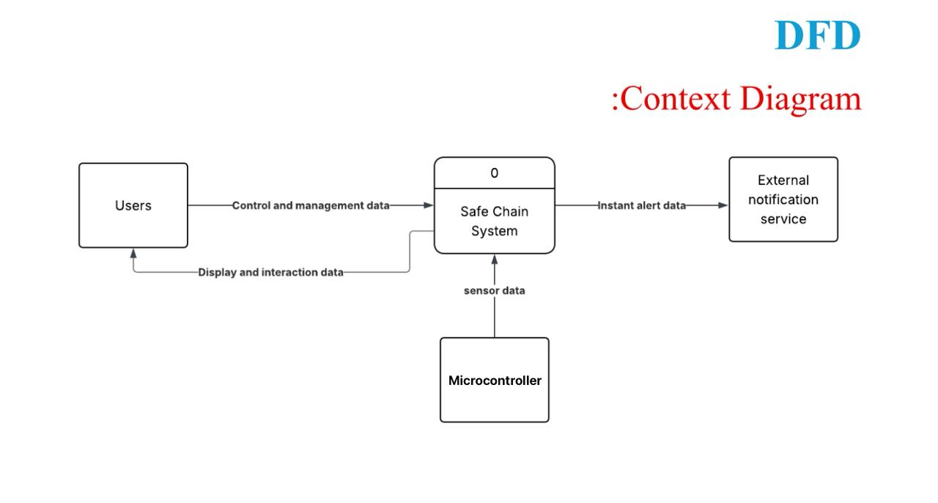
Figure 10 context diagram of the "Safe Chain System"
- Data Flow Diagram - Level 0
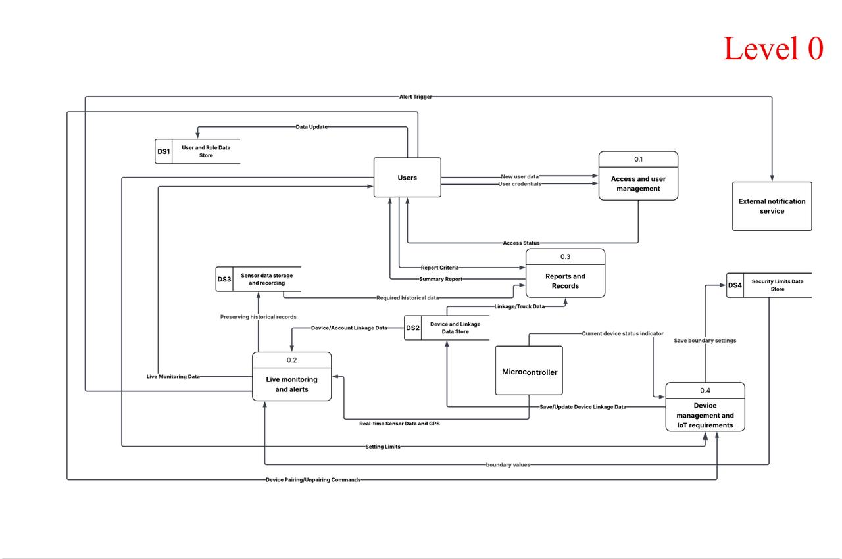
The Level 1 data flow diagram (DFD) provides an in-depth breakdown of the internal processes of the "Safe Chain System" that were represented by a single process in the context diagram. The system is divided into four main sub-processes that interact among themselves and with four data stores (DS1 to DS4).

Figure 11 Data Flow Diagram - Level 0
- Data Flow Diagram - Level 1 (p1) Access and user management
The course starts with 0.1 Access and User management, which is responsible for checking users ' credentials and determining their access status.
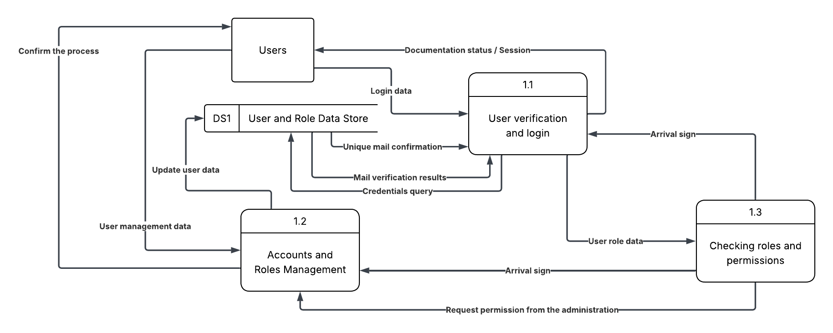
Figure 12 Data Flow Diagram - Level 1 (p1) Access and user management

- Data Flow Diagram - Level 1 (p2) Real-time Monitoring and Alerts
the 0.2 Live monitoring and alerts process receives live sensor data, stores it in DS3 (Sensor Data Storage), uses historical data and updated hardware limitations to issue the necessary alerts, which, in turn, are sent as alert triggers (Alert Trigger) to the external notification service.
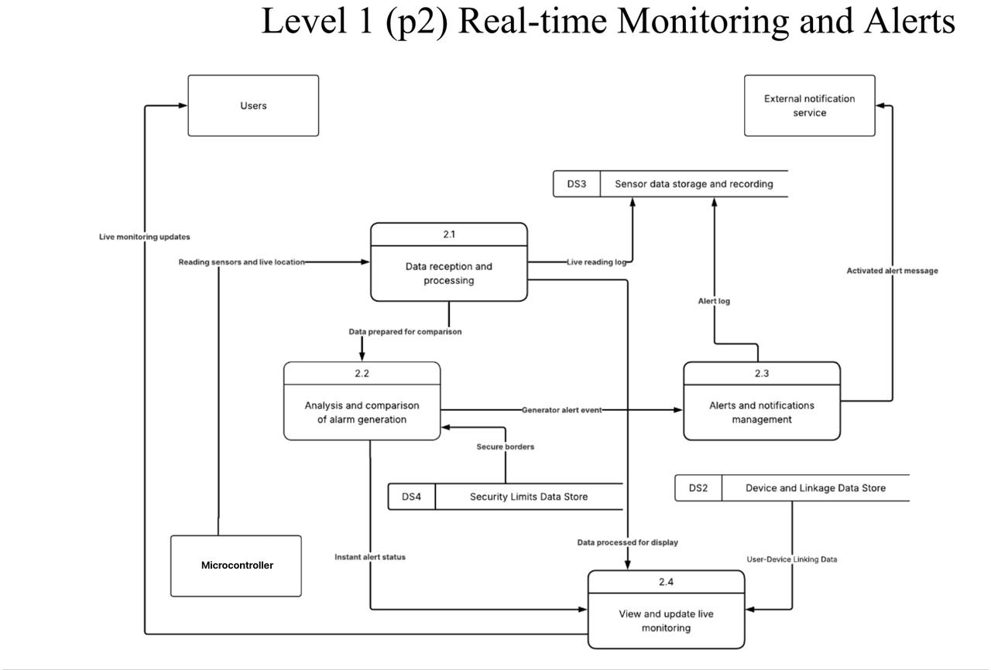

Figure.13 Data Flow Diagram - Level 1 (p2) Real-time Monitoring and Alerts

- Data Flow Diagram - Level 1 (p3) Reports and Records
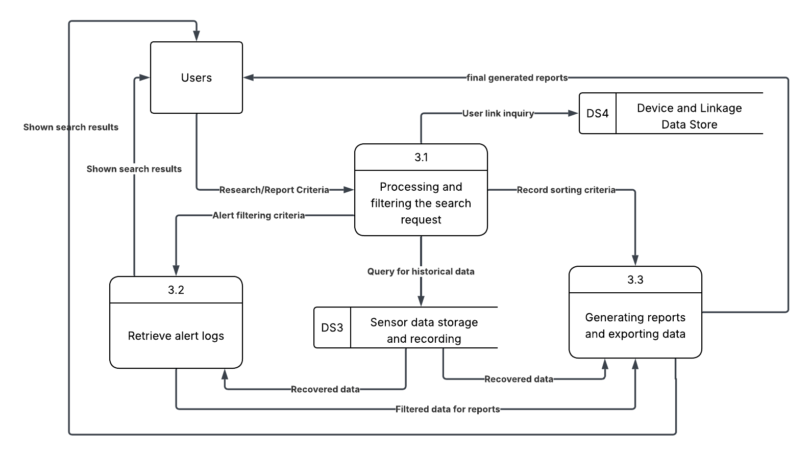
The previous operations are integrated with 0.3 Reports and Records, which takes advantage of all data stores to create the required statistical reports and records for users and management.
Figure 14 Data Flow Diagram - Level 1 (p3) Reports and Records

- Data Flow Diagram - Level 1 (p4) Device management and IoT requirements
the 0.4 Device management and IoT requirements process is concerned with setting up devices and updating restrictions for monitoring limits
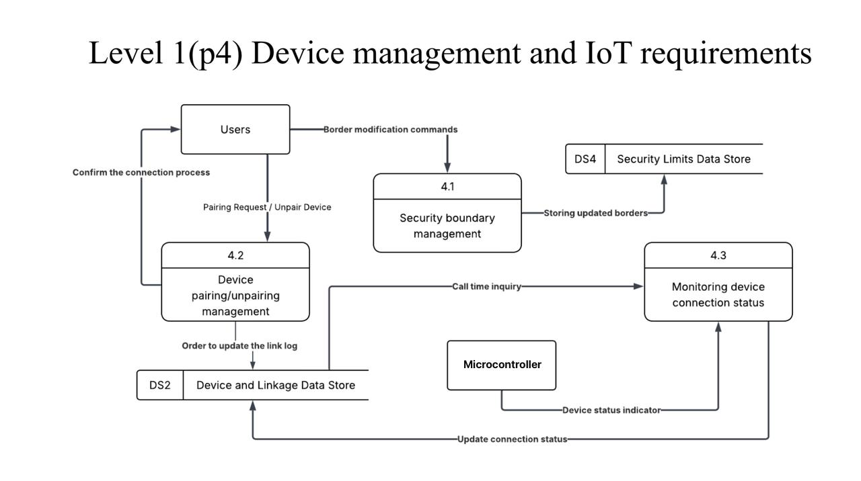
Figure 15 Data Flow Diagram - Level 1 (p4) Device management and IoT requirements

- Data Flow Diagram - Level 2 (p1.1) User verification and login
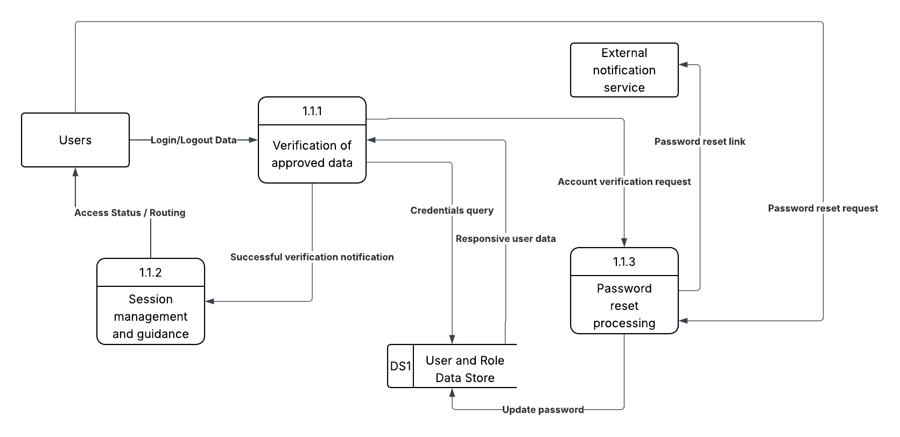
Figure 16 Data Flow Diagram - Level 2 (p1.1) User verification and login

- Data Flow Diagram - Level 2 (p1.2) Accounts and Roles Management
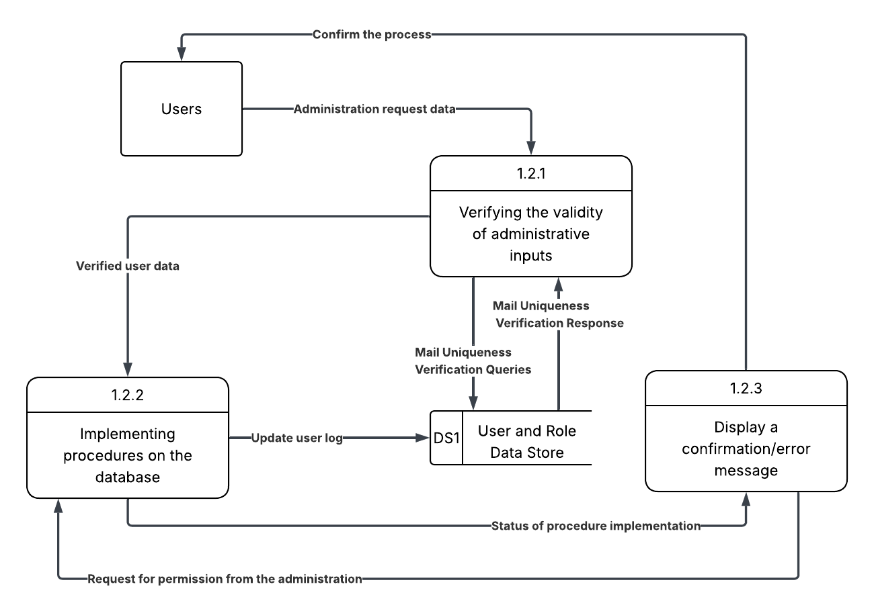

Figure 17 Data Flow Diagram - Level 2 (p1.2) Accounts and Roles Management
- Data Flow Diagram - Level 2 (p 1.3) Checking roles and permissions
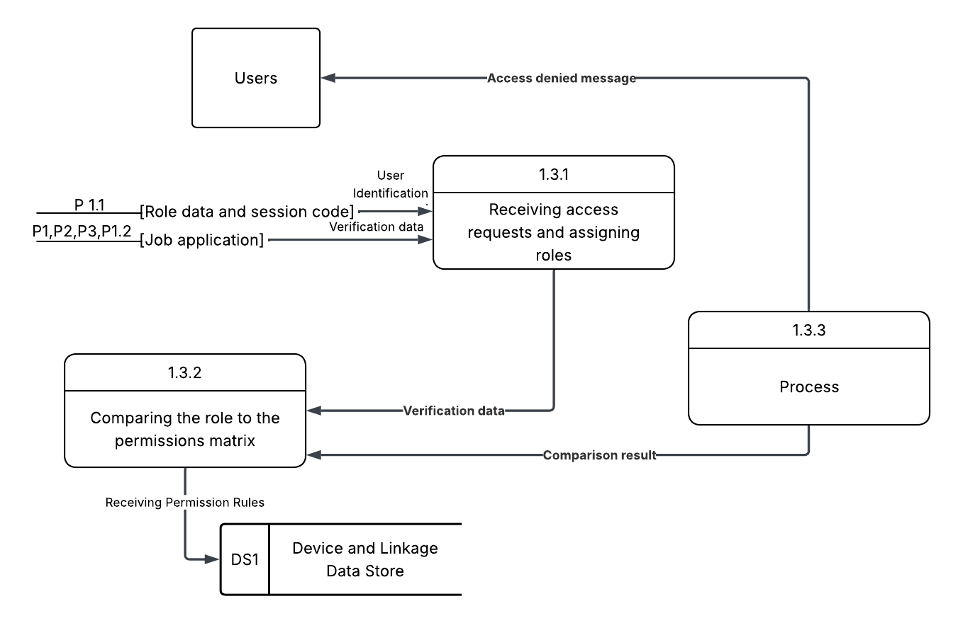

Figure 18 Data Flow Diagram - Level 2 (p 1.3) Checking roles and permissions

- Data Flow Diagram - Level 2 (p2.1) Receiving and processing IoT data
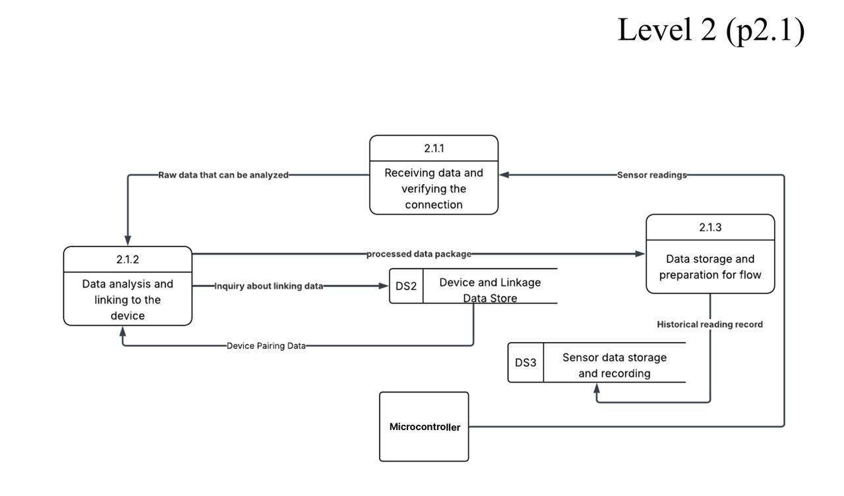
Figure 19 Data Flow Diagram - Level 2 (p2.1) Receiving and processing IoT data

- Data Flow Diagram - Level 2 (p2.2)Analysis and comparison of alarm generation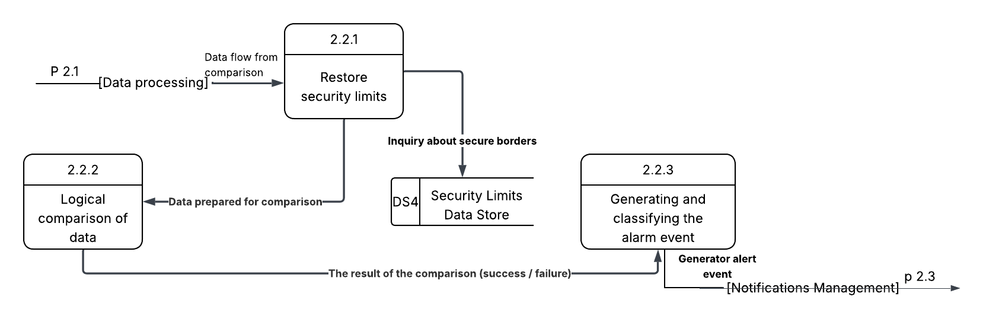
Figure 20 Data Flow Diagram - Level 2 (p2.2)Analysis and comparison of alarm generation

- Data Flow Diagram - Level 2 (p2.3)Alerts and notifications management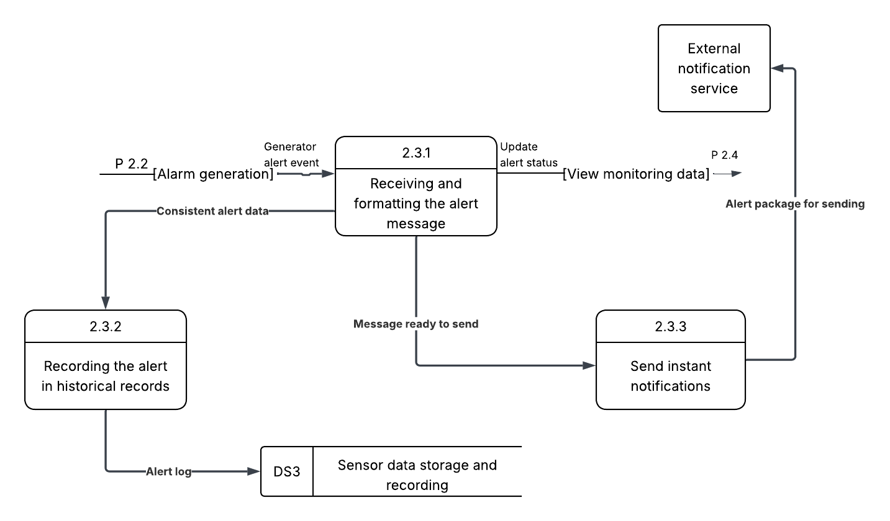
Figure 21 Data Flow Diagram - Level 2 (p2.3) Alerts and notifications management

- Data Flow Diagram - Level 2 (p2.4) Managing safety limits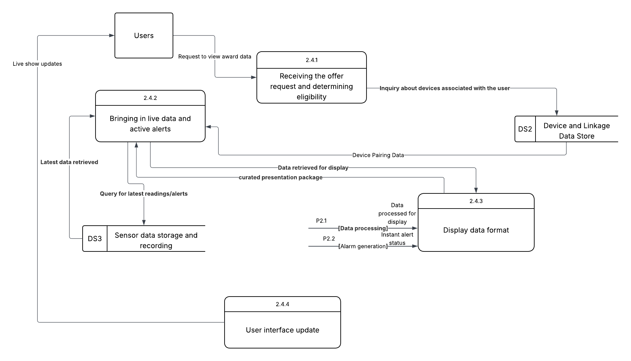
Figure 22 Data Flow Diagram - Level 2 (p2.4) Managing safety limits

- Data Flow Diagram - Level 2 (p 3.1) Search Request Processing and Filtering
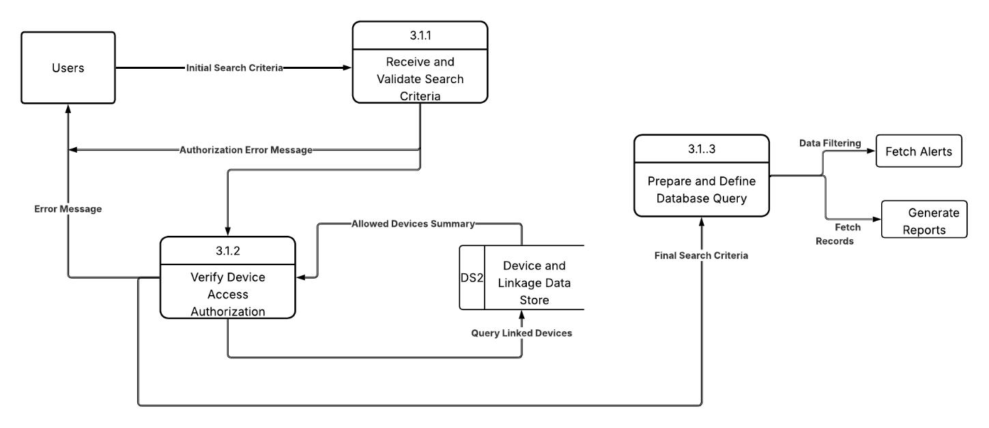
Figure 23 Data Flow Diagram - Level 2 (p 3.1) Search Request Processing and Filtering

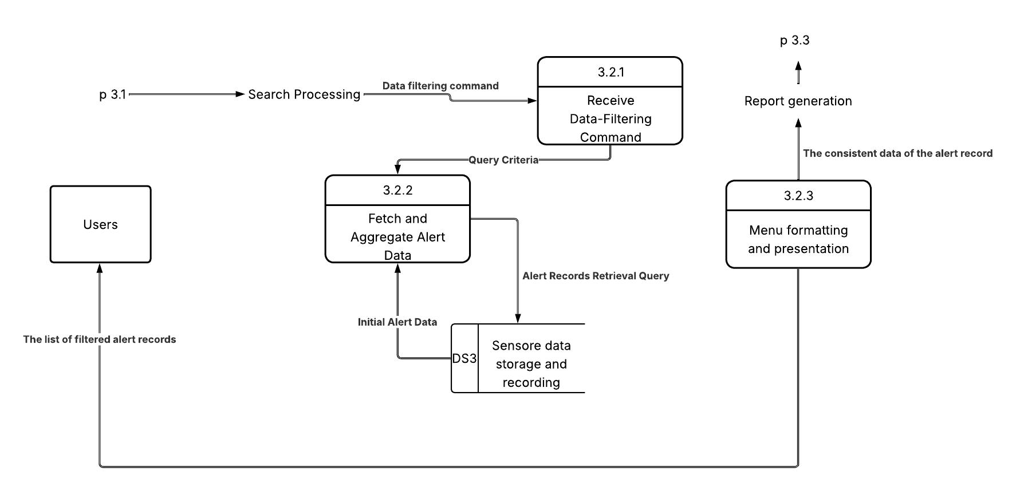
- Data Flow Diagram - Level 2 (p 3.2) Fetch Alert Records
Figure 24 Data Flow Diagram - Level 2 (p 3.2) Fetch Alert Records

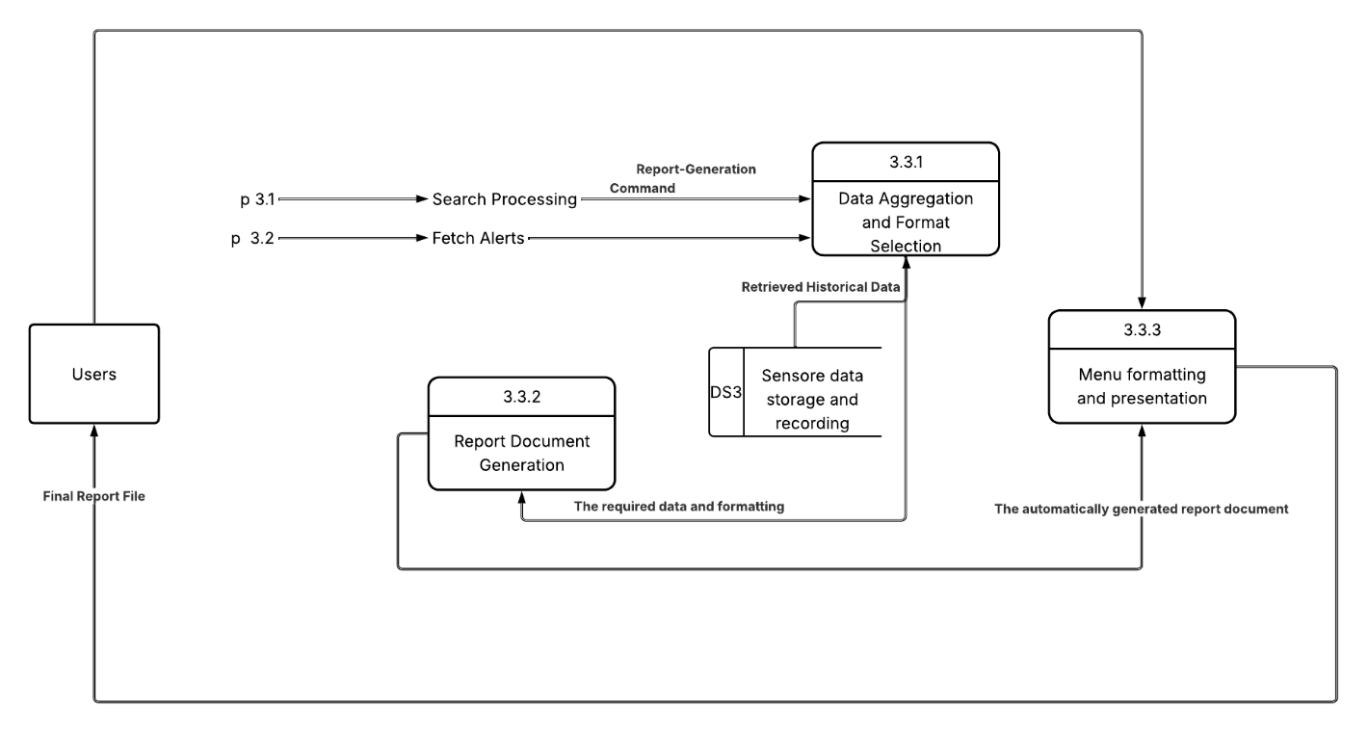
- Data Flow Diagram - Level 2 (p 3.3) The generation of reports and the export of data
Figure 25 Data Flow Diagram - Level 2 (p 3.3) The generation of reports and the export of data

- Data Flow Diagram - Level 2 (p4.1) Managing safety limits 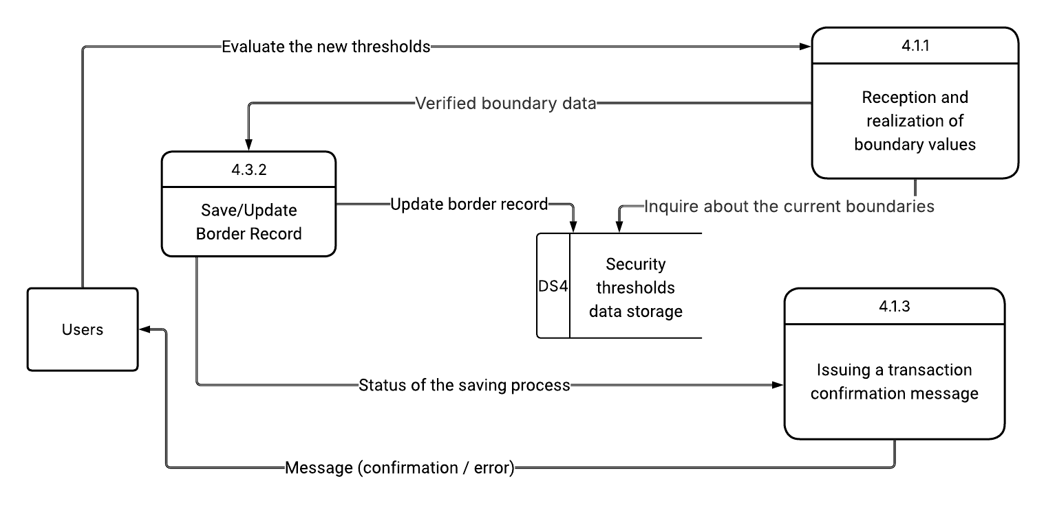
Figure 26 Data Flow Diagram - Level 2 (p4.1) Managing safety threshold

- Data Flow Diagram - Level 2 (p4.2) Managing the connection/disconnection 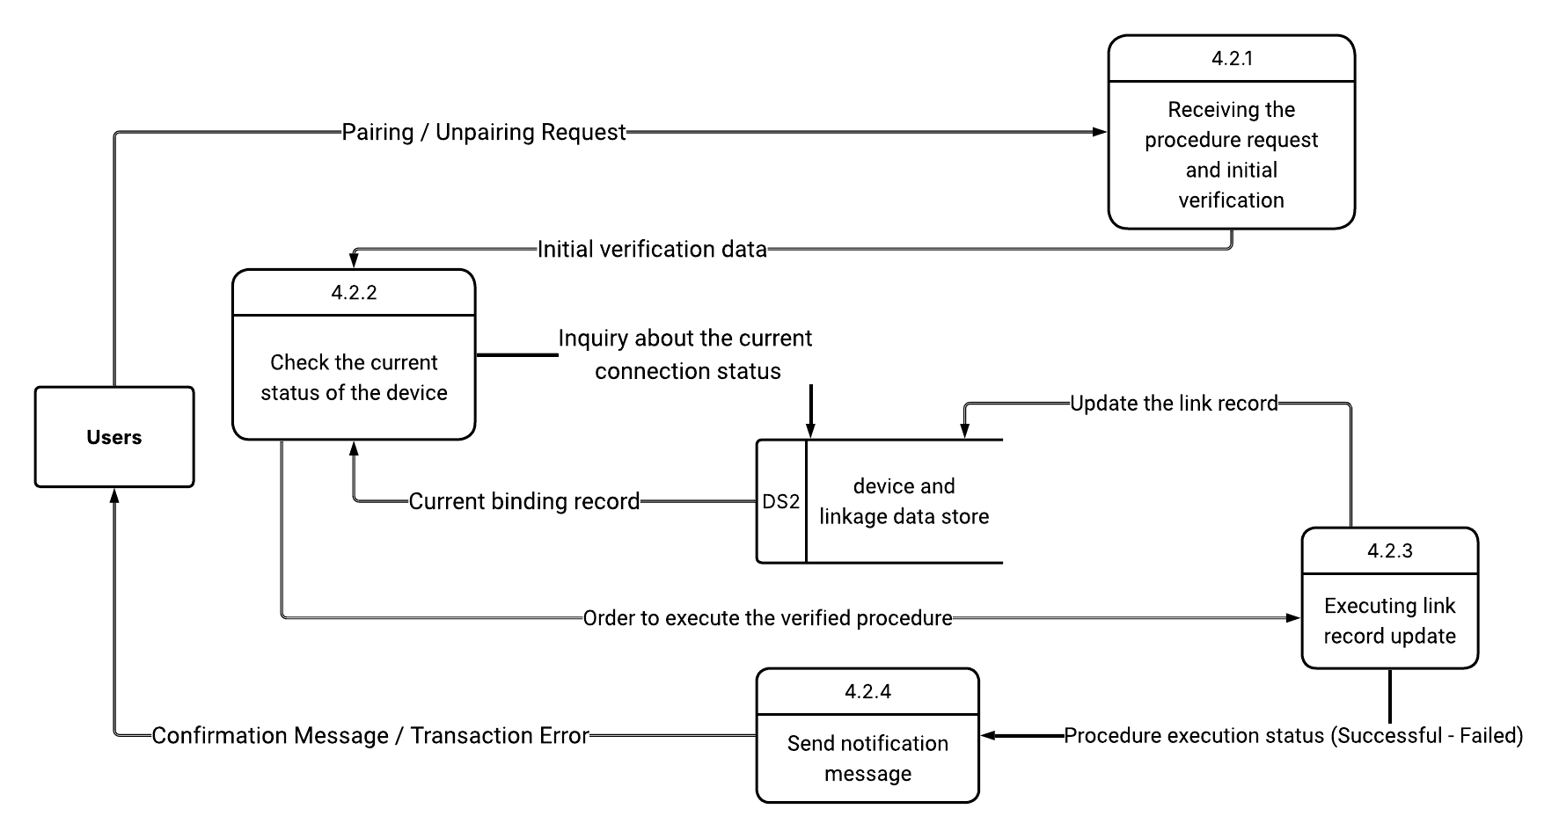
Figure 27 Data Flow Diagram - Level 2 (p4.2) Managing the connection/disconnection

- Data Flow Diagram - Level 2 (p4.3) Review the device’s connection status 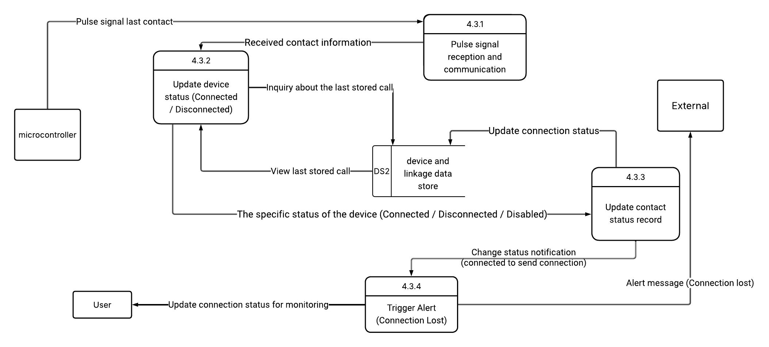
Figure 28 Data Flow Diagram - Level 2 (p4.3) Review the device’s connection status

2.8 Requirements Modelling UML
Unified Modelling Language (UML) is a standardized modelling language used in software engineering to visualize, specify, construct, and document the structure and behavior of software systems. UML diagrams help simplify complex system designs by providing a clear and structured representation of system components and their interactions. This section presents the key UML diagrams used to model
2.8.1 Use Case Diagram
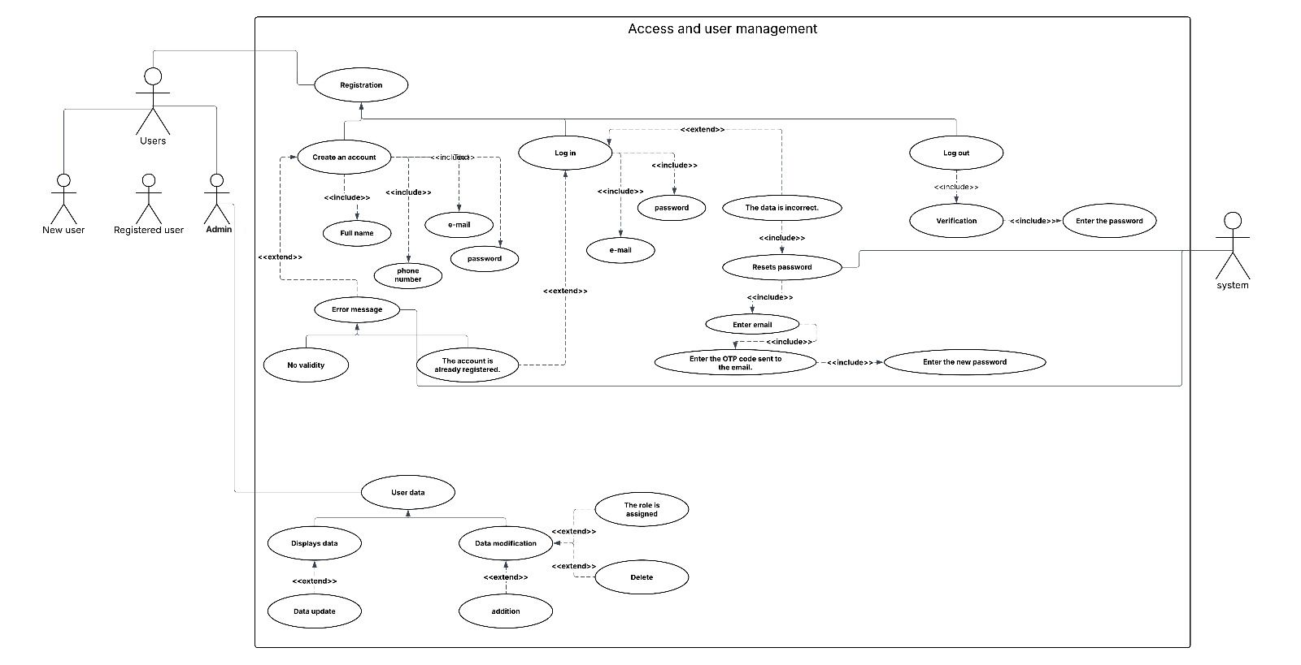
- Use Case diagrams - Access and user management
Figure 29 use case diagrams - Access and user management

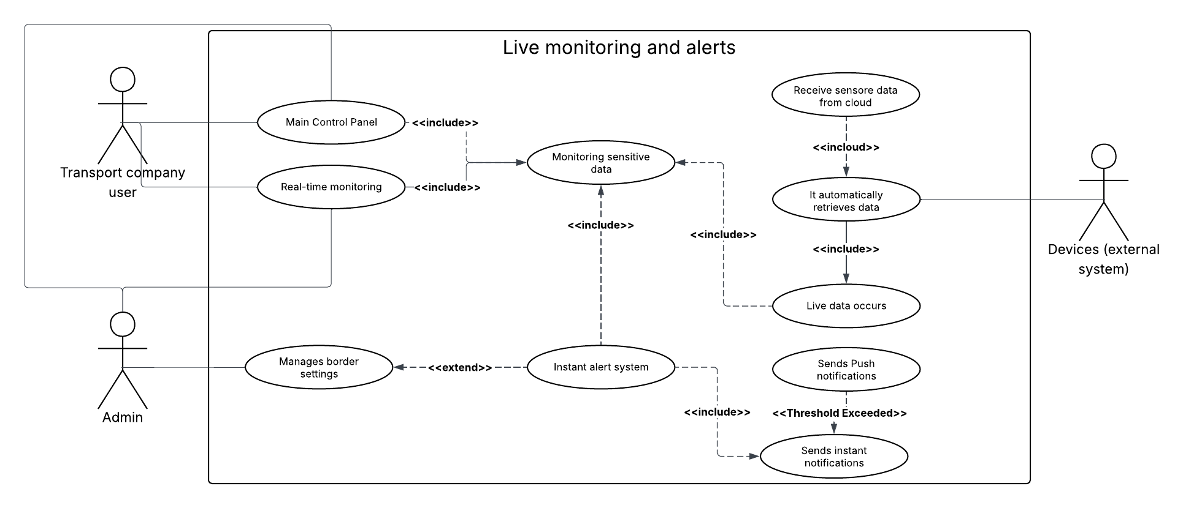
- use case diagrams- Live monitoring and alerts
Figure 30 use case diagrams - Live monitoring and alerts

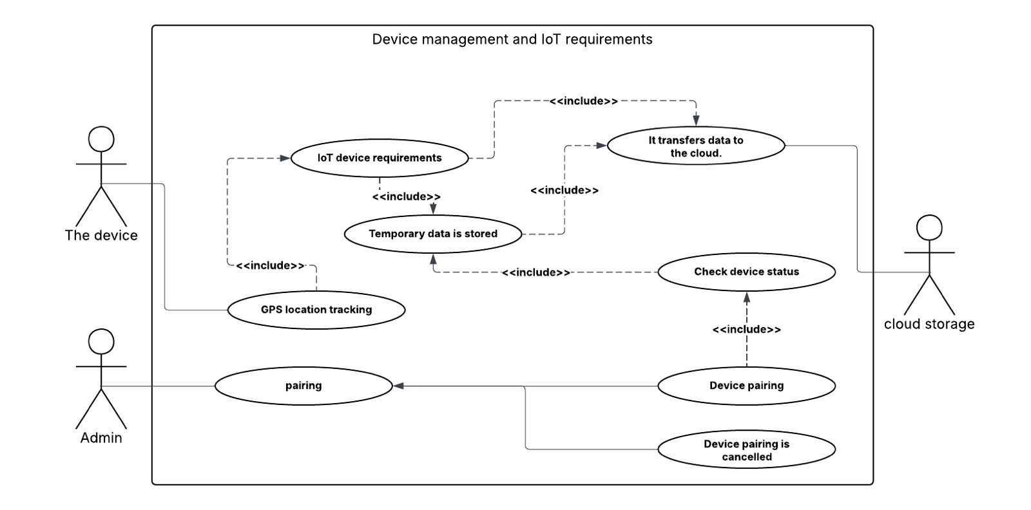
- use case diagrams - Device management and IoT requirements
Figure 31 use case diagrams - Device management and IoT requirements

- use case diagrams - Records and Inquiry Reports
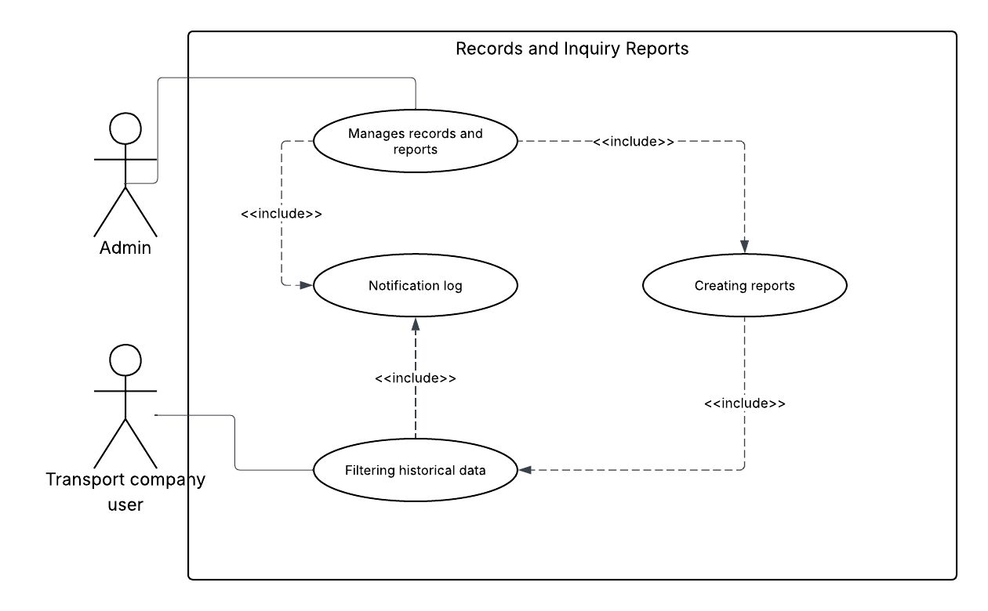
Figure 32 use case diagrams - Records and Inquiry Reports

2.8.2 Sequence Diagram
The Sequence Diagram illustrates the step-by-step interaction between a user and the system during the login process. Figure 2 shows how the user inputs credentials, how the system validates them, and what happens based on the result.

- Sequence Diagram-Login
Description:
The drawing shows the process of logging into the system for a registered user. The user starts by entering the username and password on the login page (Login Page). After that, the data is sent to the auth Controller for validation against the database.
If the user is normal, he is allowed to enter the normal user interface.
If the user is an addict/manager, he is allowed to enter the management control panel with additional powers.
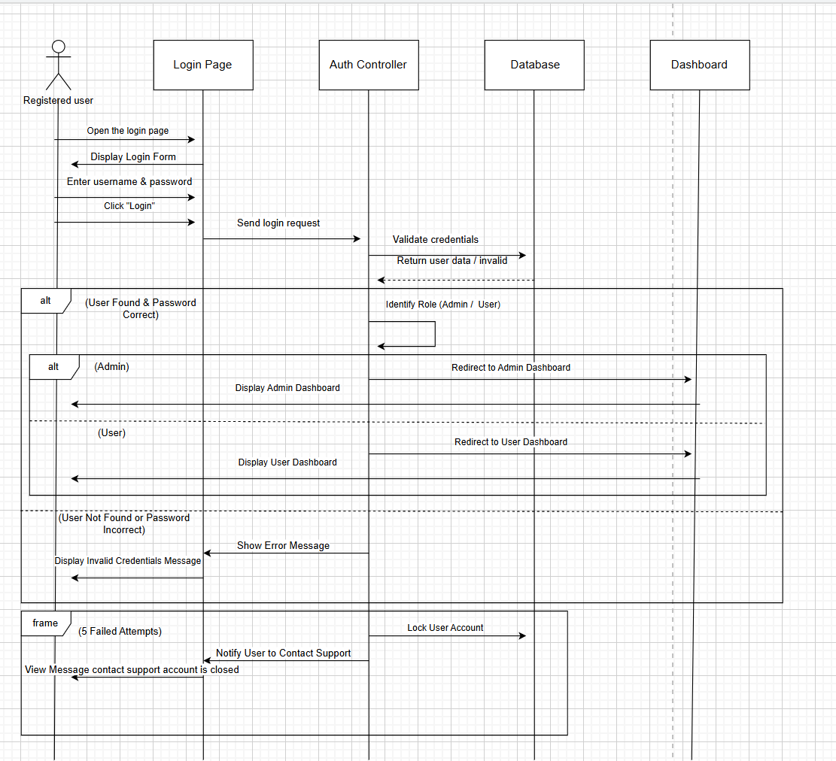
If the data is erroneous, the login is denied and an appropriate error message is displayed.
Figure 33 Sequence Diagram-Login

- Sequence Diagram-Create an account
Description :
The drawing shows the process of registering a new user in the system. The user starts by opening the registration page (Registration Page) and filling in the required data such as name, e-mail, password and its confirmation. After that, the data is sent to the system for validation.
If there are empty fields, an alert appears asking to fill in the fields.
If the email is incorrect, an alert appears with the Invalid Mail Format.
If the password and its confirmation do not match, a mismatch alert appears.
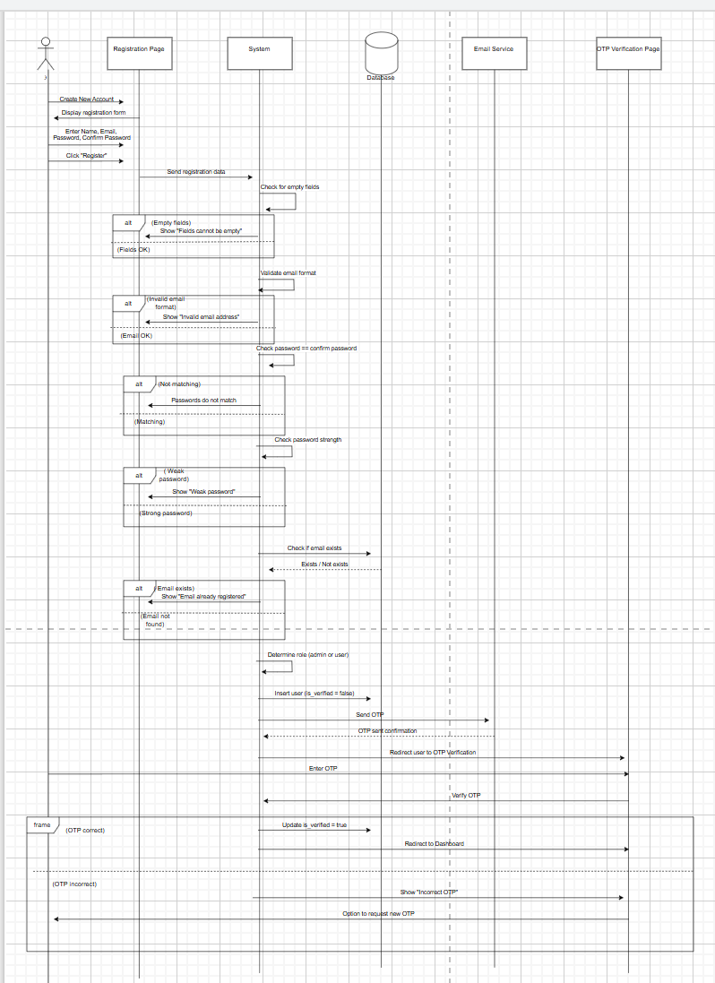
When all the data is validated, the system sends a verification message (OTP) via e-mail, and the verification page (OTP Verification Page) is displayed to complete the registration process.
Figure 34 Sequence Diagram-Create an account

- Sequence Diagram-Generating instant alerts
Description :
The drawing shows how the user interacts with the IoT sensitivities system for managing alerts. The user starts by sending data from the IoT device, which passes through the sensor data service, and then is processed by the alert management system and external notification service to send instant alerts (such as email or SMS) when the permissible limits are exceeded. The user can then confirm the alarm through the web/app interface, where the alarm status is updated in the database and audio and video alerts are turned off upon confirmation.
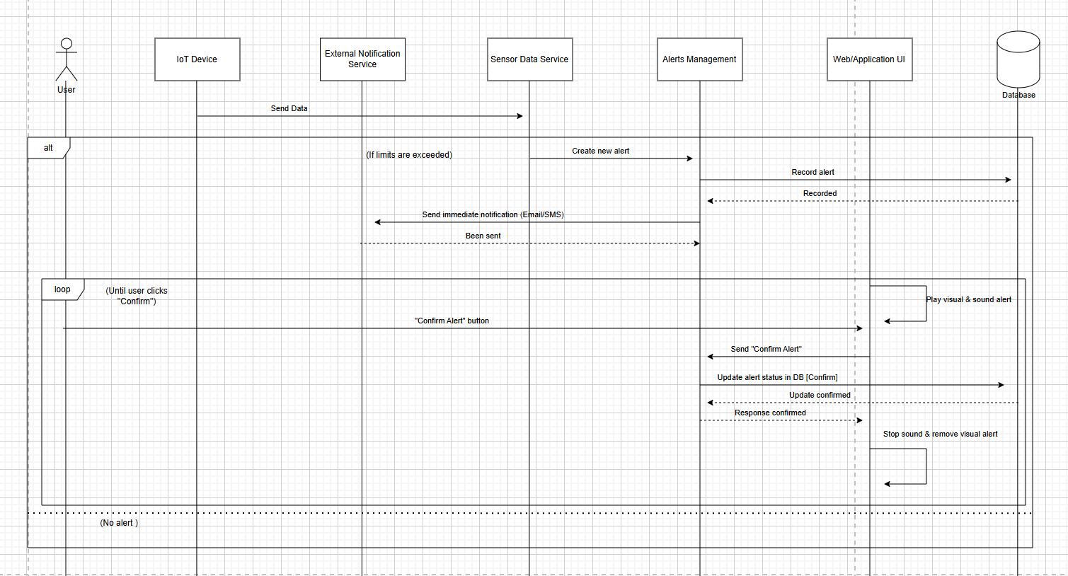

Figure 35 Sequence Diagram-Generating instant alerts

- Sequence Diagram-Security Service
Description :
The drawing shows the truck data reporting management system. The user or administrator starts by entering the web interface, where the system first checks the user's role via the authentication service to determine his powers, is he an Administrator (Admin) or an ordinary user.
The administrator can enter the truck number to view its data, while the average user is automatically fetched the data of his trucks. After that, the report controller communicates with the sensor data service and the database to retrieve the required information, be it live data or historical records.
The data is then passed to the report generator for processing and processing for viewing, and finally the results are displayed in the user interface in the form of a table, so that the user can easily review the truck information and associated reports.

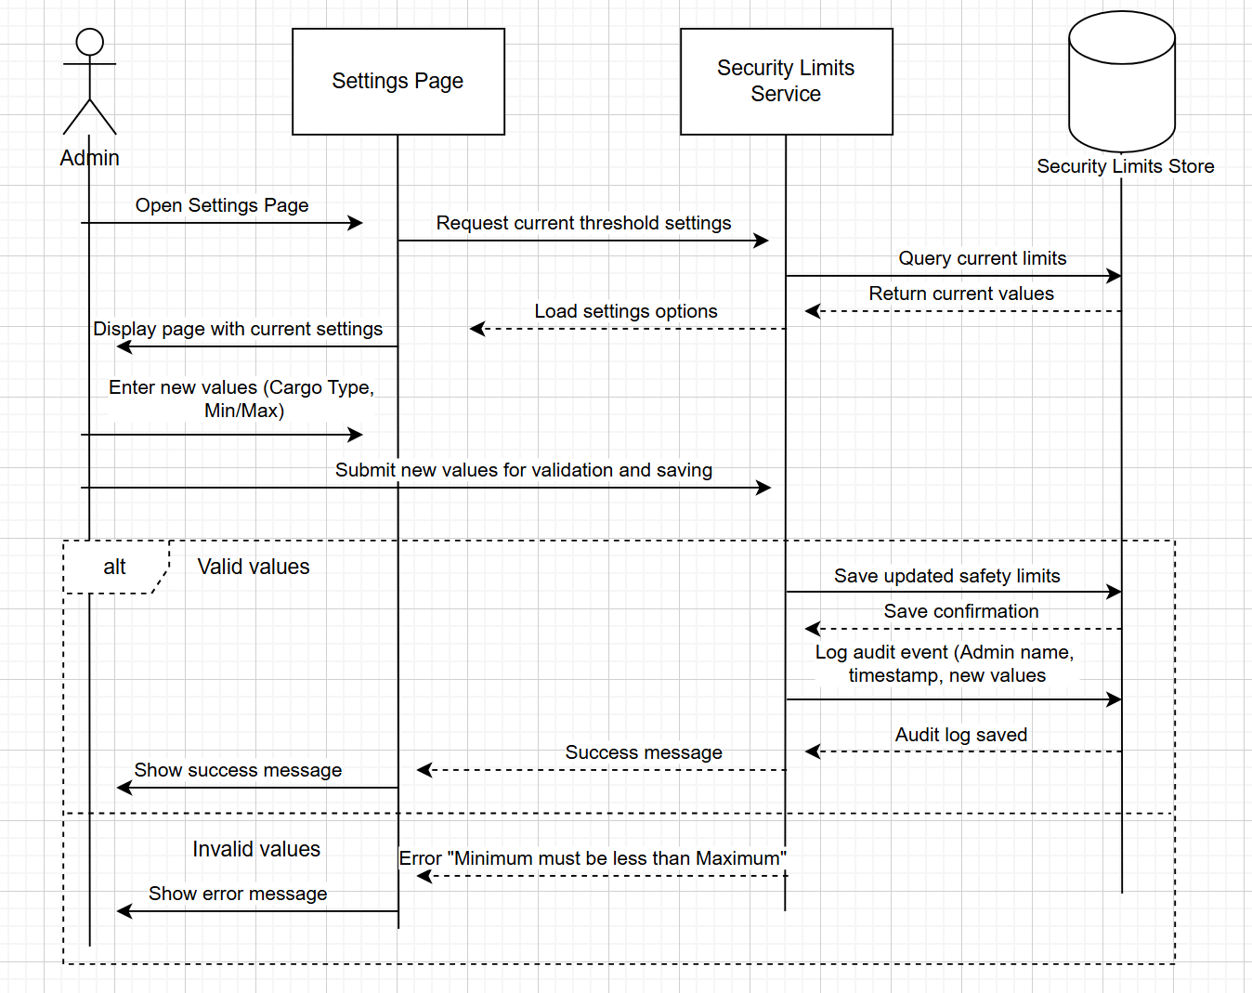
Figure 36 Sequence Diagram-Security Service

- Sequence Diagram-Create reports
Description :
The Administrator (Admin) opens the settings page and then enters new values for the security limits (such as the type of shipment and the minimum/maximum). The system checks the values: If the values are correct, it saves the new limits in the database, displays a success message, and records the event in the audit log. If the values are incorrect (for example, the minimum is greater than the maximum), the system displays an error message with an explanation of the problem.
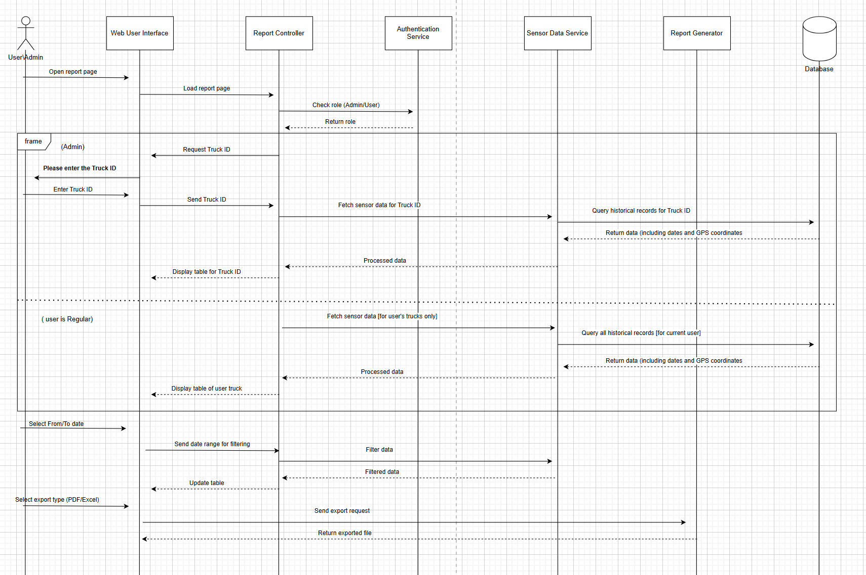
Figure 37 Sequence Diagram-Create reports

- Sequence Diagram-logout page
Description:
The user presses the logout button on the site, and the system sends the request to the authentication service. After that, the user's session in the database is terminated, he is shown confirmation of successful logout, and then he is automatically transferred to the login page.
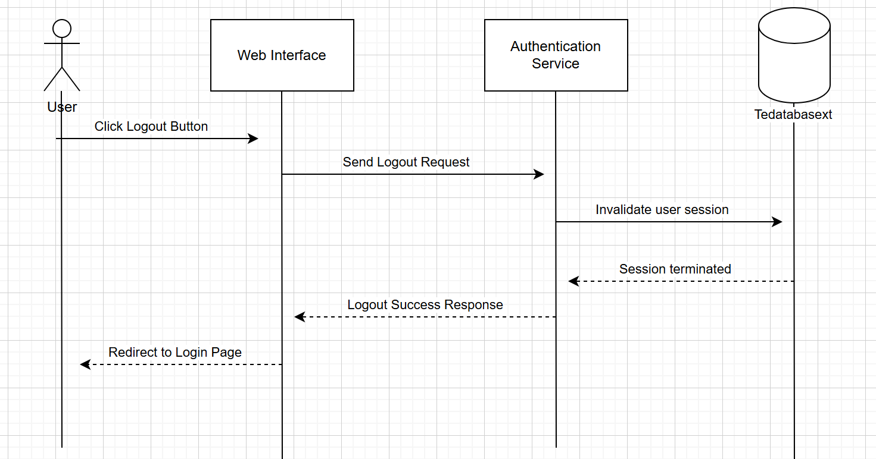

Figure 38 Sequence Diagram-logout page

- Sequence Diagram-Administrator control
Description :
This graphic shows the workflow of the truck monitoring system from the administrator's (Admin) perspective. The administrator accesses the monitoring page, where the system interacts with the API to fetch truck data including locations and statuses. Trucks are shown on the map with color highlighting, where green indicates safe trucks, while alerts show trucks with problems. The administrator can click on any truck to view its details and graphic data, and the information is periodically updated every five seconds to ensure the accuracy of the data and its display in real time.
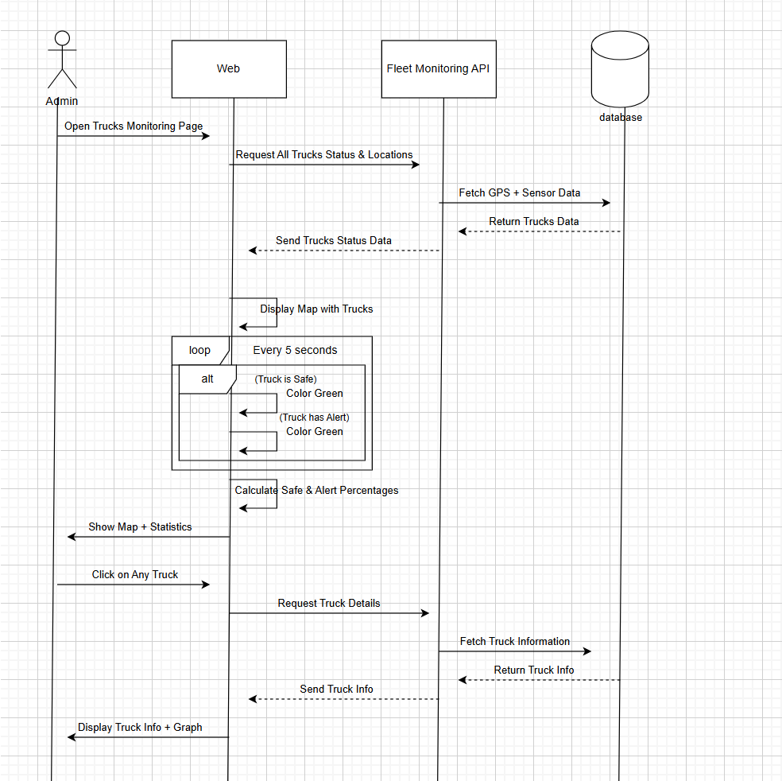
Figure 39 Sequence Diagram-Administrator control

- Sequence Diagram-sensor data service
Description:
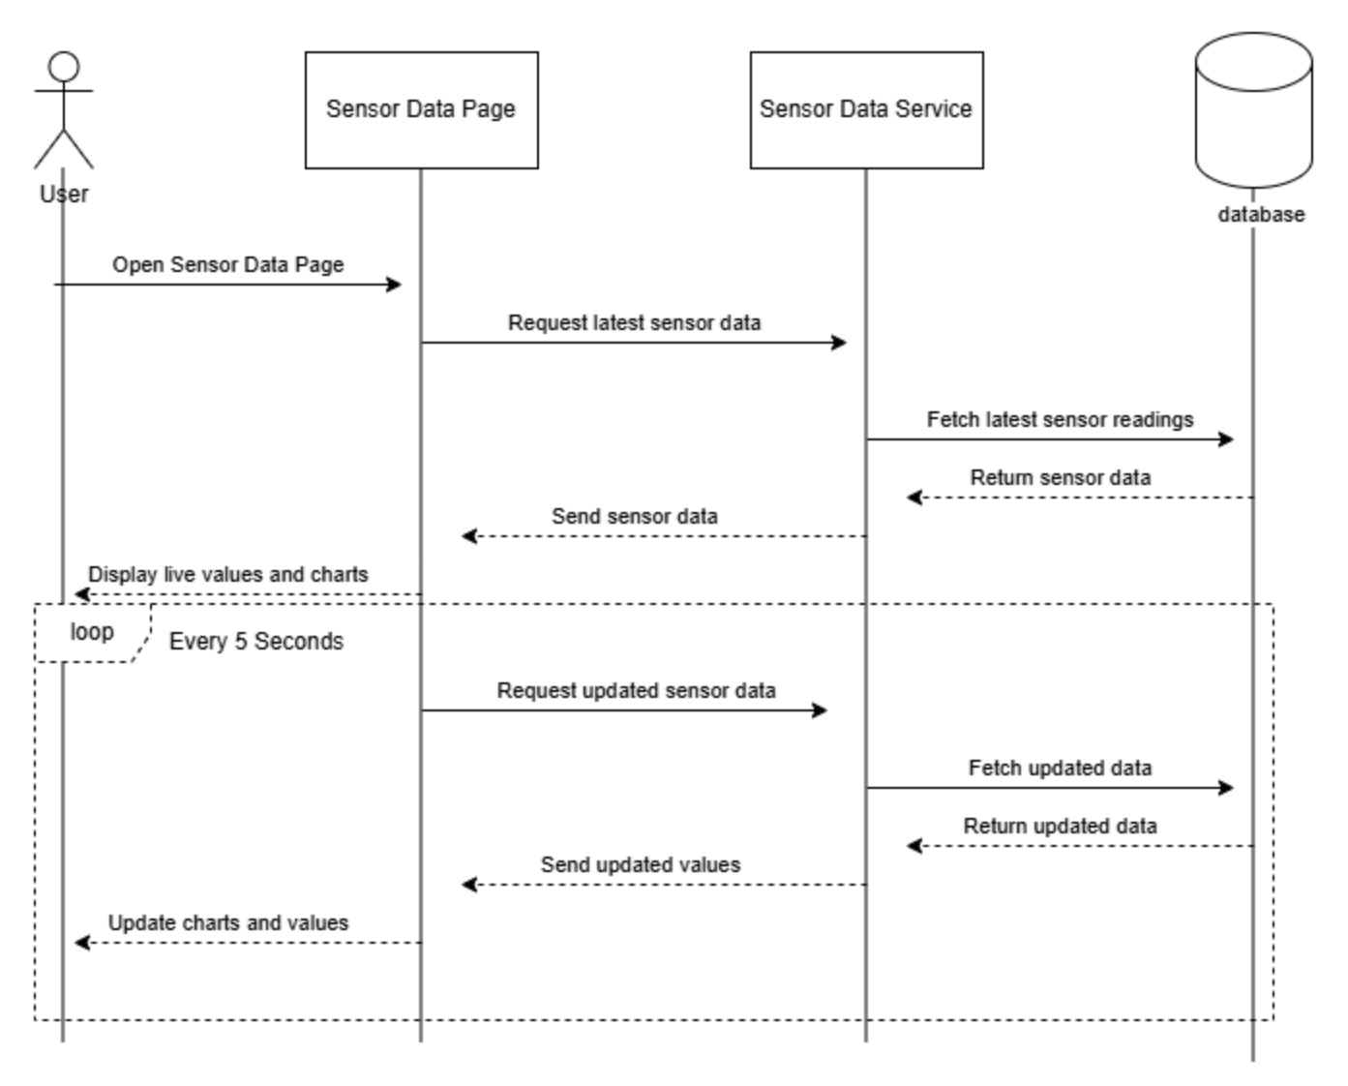
The diagram shows the sensor data flow in the system. The user starts by opening the sensor data page, where the system sends a request for the latest readings from the sensor data service. This service communicates with the database to retrieve data, and then sends it back to display to the user in the form of live values and graphs. The process is repeated every 5 seconds to ensure that the values and graphs are continuously updated, allowing continuous monitoring of the performance of the sensors.

Figure 40 s Sequence Diagram-ensor data service

- Sequence Diagram-Password Reset
Description:
The drawing shows the password recovery process in the system. The user starts by accessing the login page, and when forgetting the password presses the "Forget Password" option. The user is directed to the password reset page, where he enters the e-mail, the new password and its confirmation. After submitting the request, the system checks the correctness of the data:
If the user is present and the password matches the strength requirements, the password is updated in the database.
If the data is incorrect or the passwords do not match, the system displays an appropriate error message to the user.
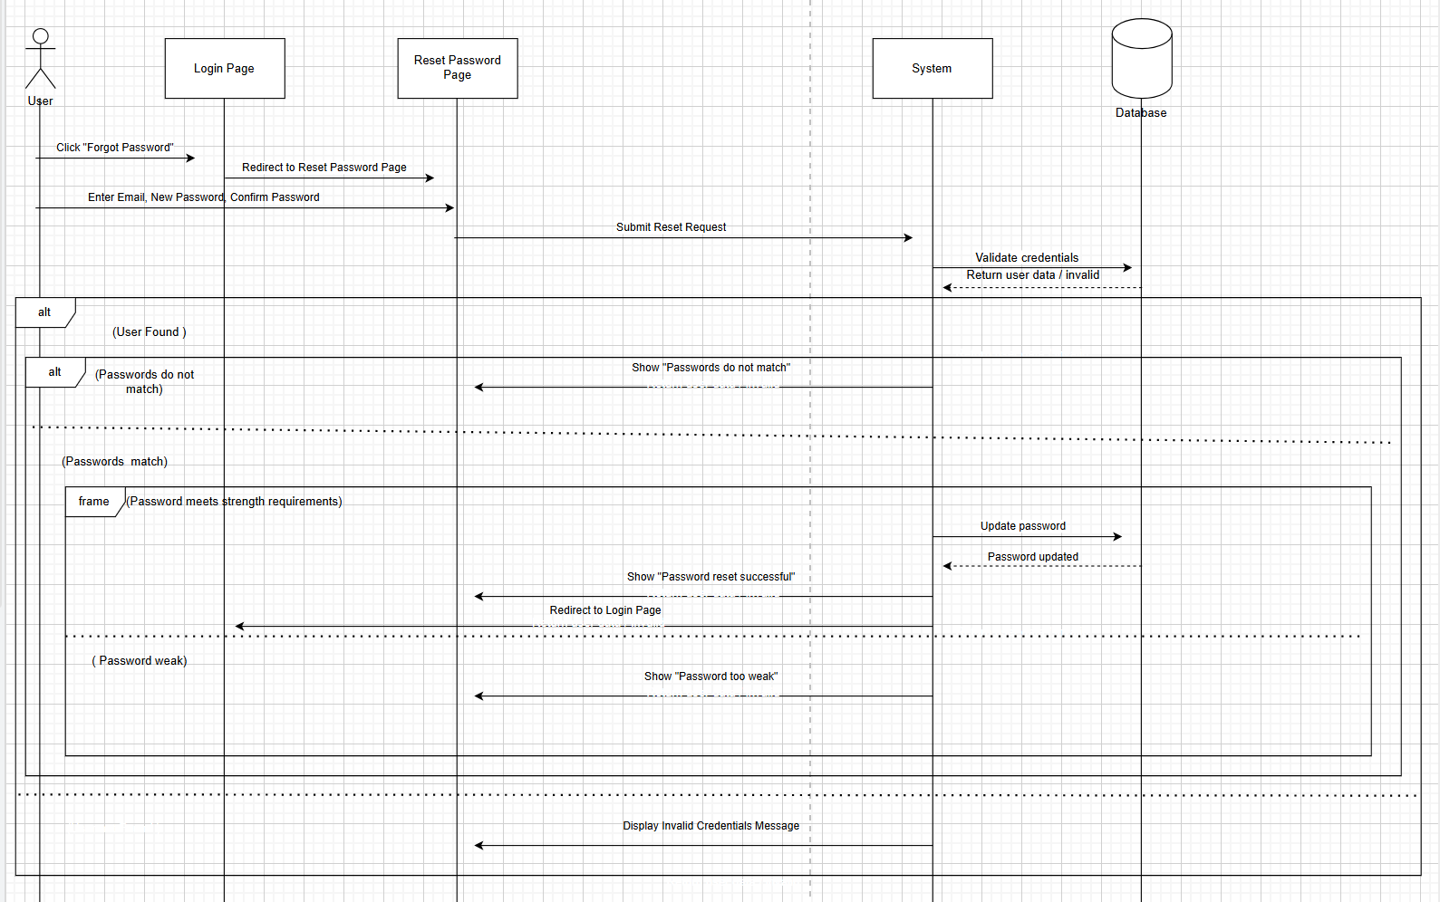
Figure 41 Sequence Diagram-Password Reset

2.8.3 Activity Diagram
- Activity Diagram – Login
Description:
This diagram illustrates the login process.
The user enters their email and password, and the system validates the credentials.
If the information is incorrect, the system increases the failed-attempt counter and may lock the account after five failed attempts.
If the login is successful, the system identifies the user’s role (Admin or User), redirects them to the appropriate dashboard, and loads their linked data and alerts.
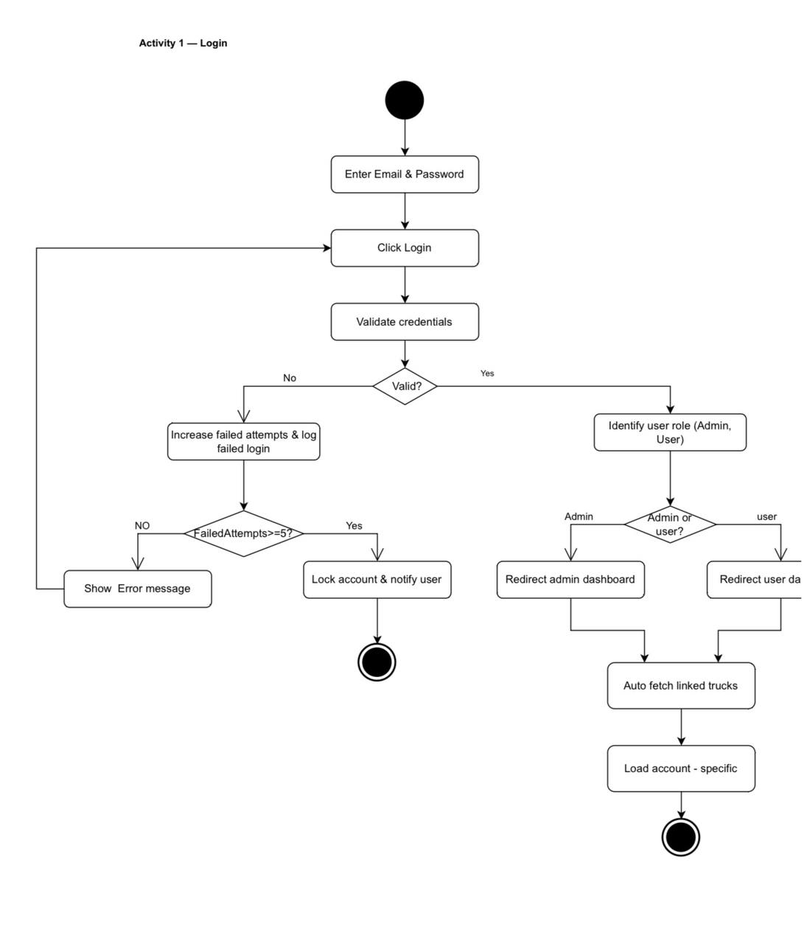
Figure 42 Activity Diagram - Login

- Activity Diagram - Generate Custom Report

Description:
This diagram shows the steps for
generating a custom report.
The system first checks if the user has permission, then the user enters the required report parameters.
The system retrieves the needed data, calculates the KPIs (minimum, maximum, and average), and builds the report in PDF or Excel format.
If successful, the report is shown to the user and automatically updated if the trip is ongoing.
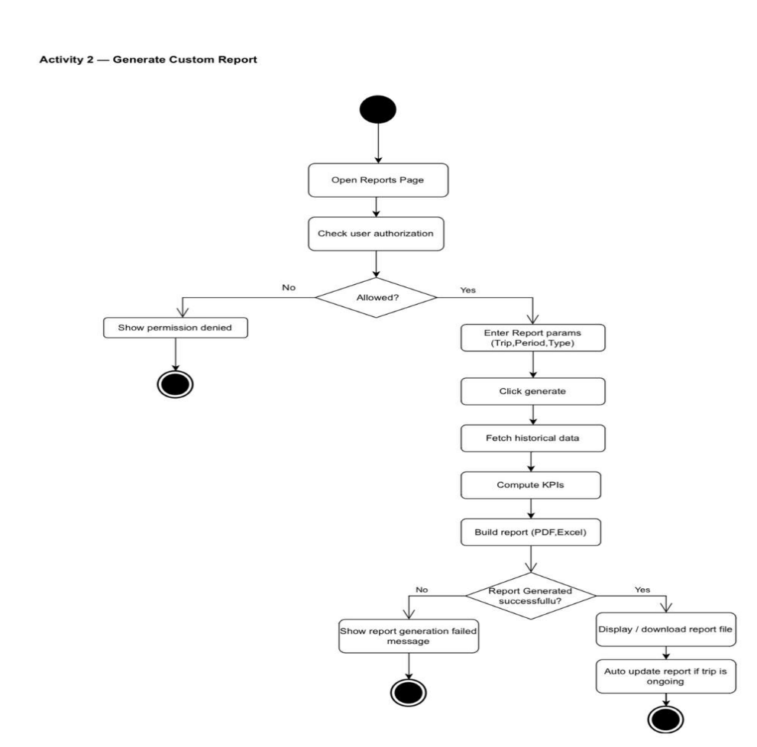
If the process fails, an error message is displayed.
Figure 43 Activity Diagram - Generate Custom Report
- Activity Diagram - Sensor Data Lifecycle (Iot)
Description:
This diagram represents how sensor data is processed in the device.
Every 30 seconds, the device reads sensor values and GPS location, then validates the readings.
Valid data is packaged and either sent to the cloud if the network is available, or stored in a buffer if not.
When the network returns, all buffered data is sent in correct order and confirmed by the cloud.
The process repeats continuously.

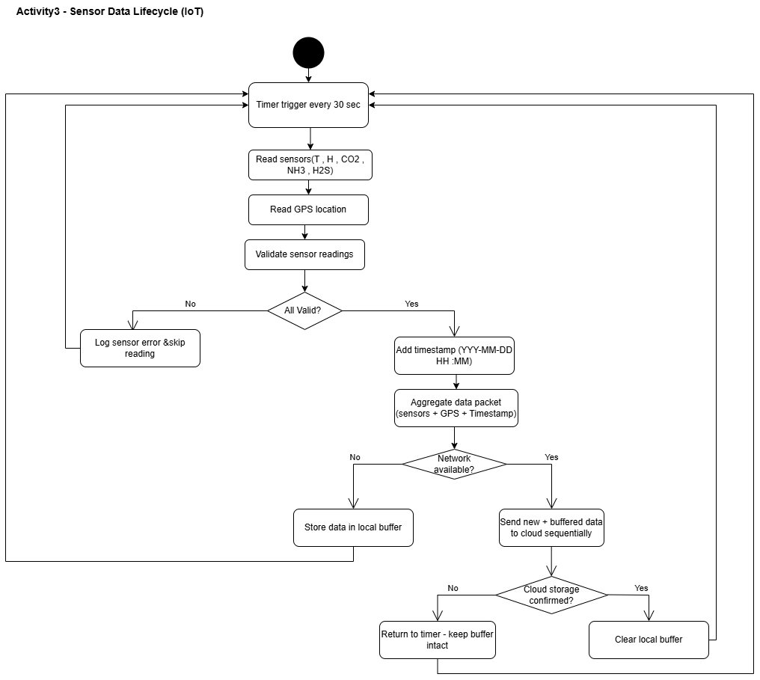
Figure 44 Activity Diagram - Sensor Data Lifecycle (Iot)

- Activity Diagram - Password Reset
Description:
This activity diagram illustrates the process of resetting a forgotten password.
The user begins the process by clicking the ‘Forgot Password’ option.
They then enter their registered email address, and the system sends a password reset link to that email.
After receiving the link, the user opens it and enters a new password along with its confirmation.
Finally, the system updates the password and redirects the user back to the login page
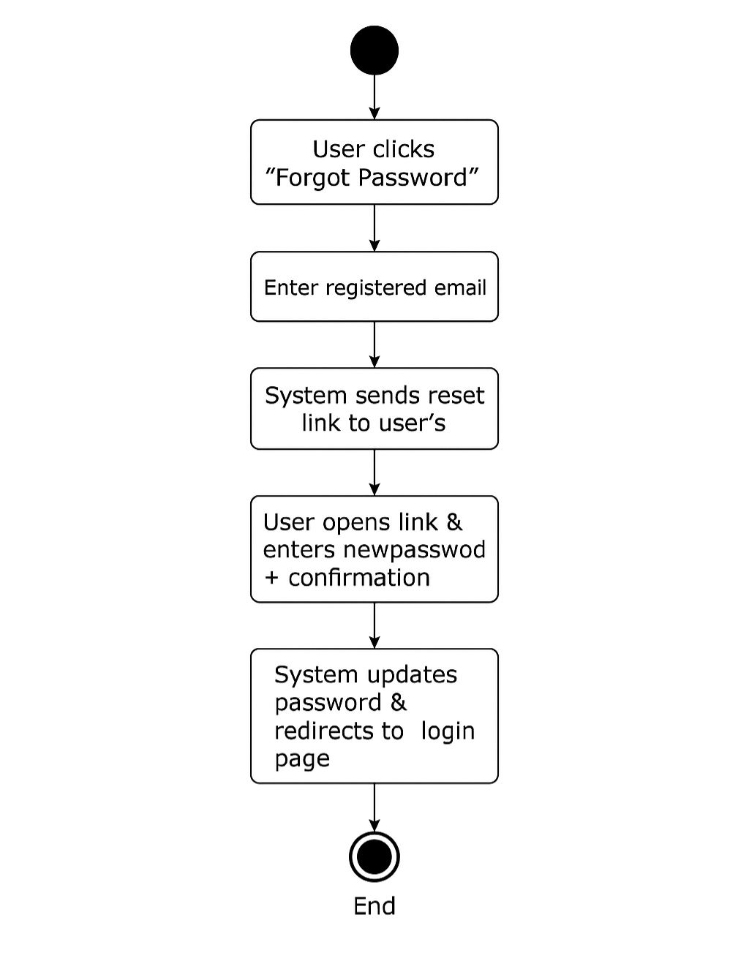
Figure 45 Activity Diagram - Password Reset

2.8.4 Class Diagram
- Class diagram – all System
This Class Diagram shows the design of the system of users and roles. The diagram shows the hierarchical structure of roles such as manager, supervisor, driver and customer, specifying the powers and functions assigned to each role, which organizes the access and control of the system securely and flexibly.
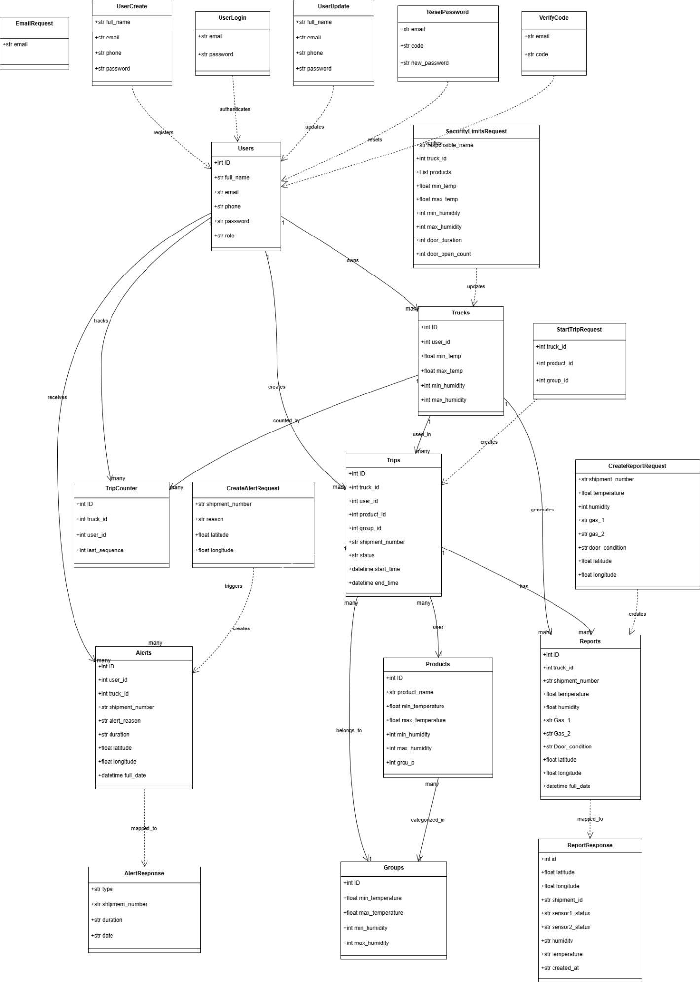
Figure 46 Class diagram - all System

- class diagram- Truck system and devices
This Class Diagram Diagram shows the design of the truck and hardware system. The diagram shows the relationships between the company and the trucks, the devices installed on them and the tracking devices, which makes it possible to monitor the status of the fleet and collect data important for the efficient management of transport operations.

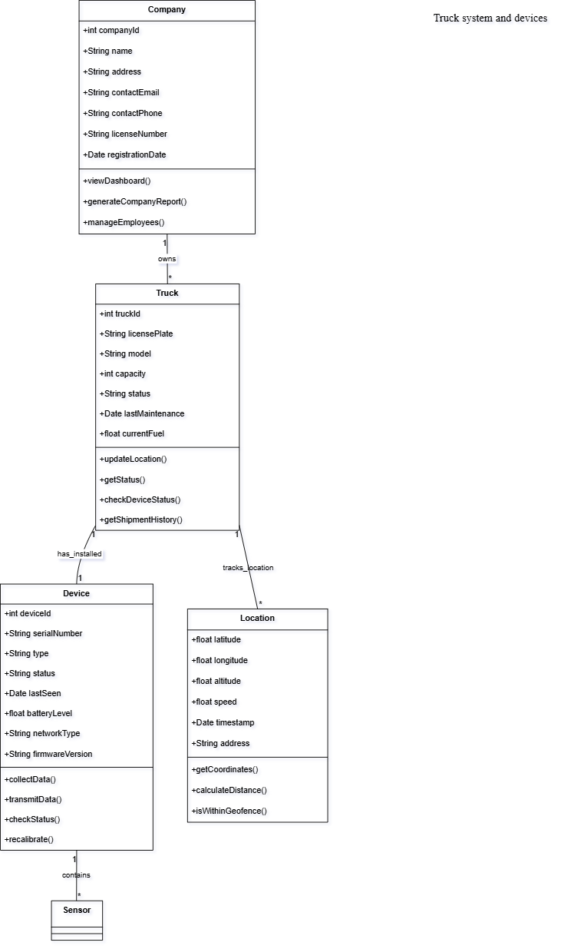
Figure 47 Class diagram - Truck system and devices

- Class Diagram - Sensor and reading system

This Class Diagram shows the design of the sensor and monitoring system. The drawing shows the different types of sensors such as temperature, humidity and gas sensors, and how to collect and read data, which enables the system to monitor environmental conditions and alert in case they exceed the permissible limits.
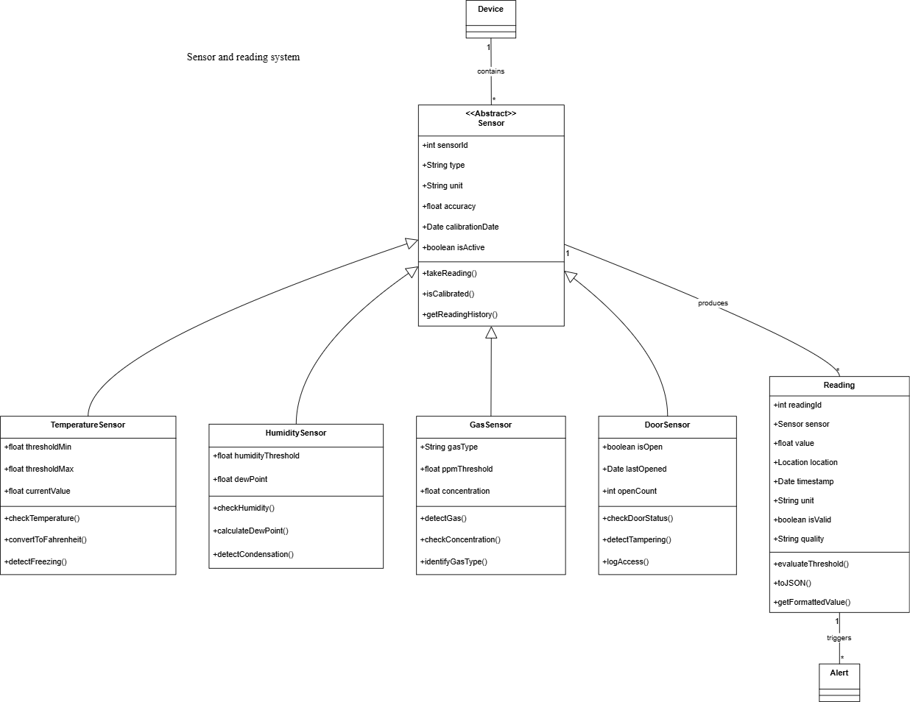
Figure 48 Class diagram - Sensor and reading system

- Class Diagram – Shipments and Reporting System

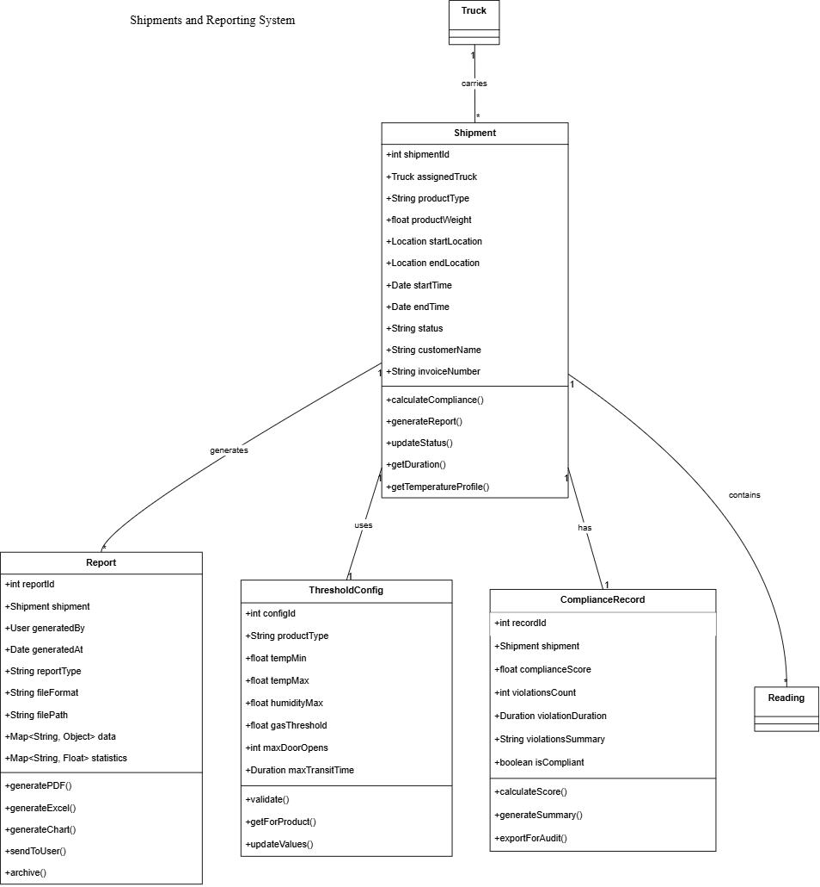
This Class Diagram shows the design of the shipment and reporting system. The diagram shows the main categories responsible for managing shipments, monitoring compliance with standards, and creating various reports, which helps to track and analyze supply chain performance in an organized manner.
Figure 49 Class Diagram – Shipments and Reporting System

- Class Diagram –Alerts and notifications system

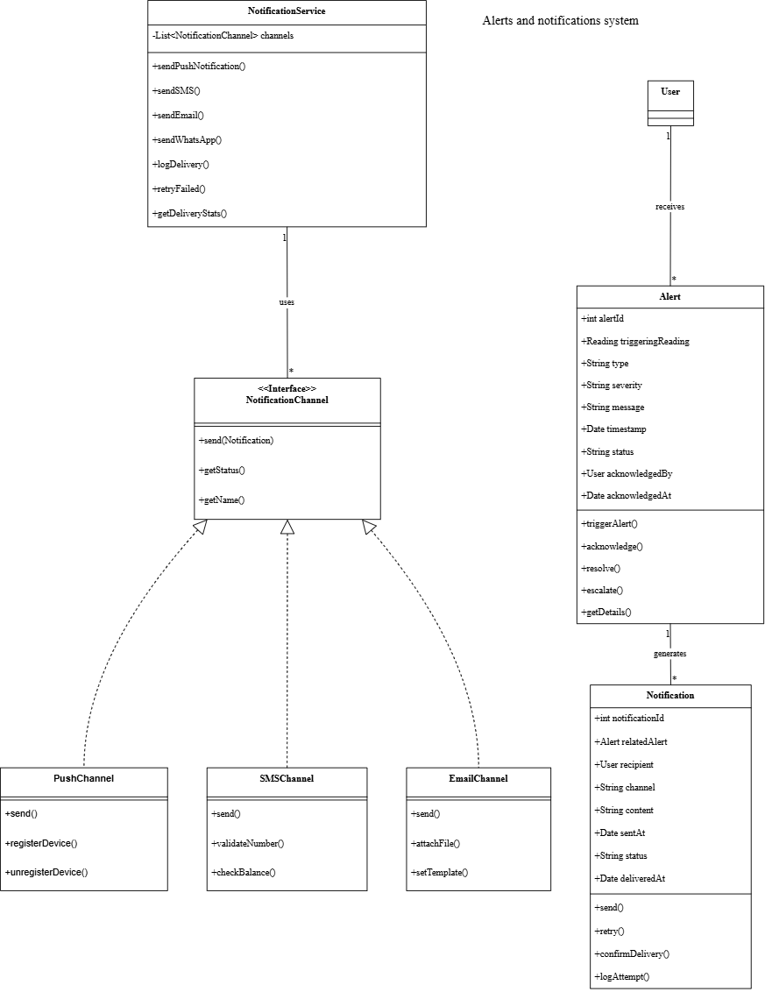
This Class Diagram shows the design of the alerts and notifications system. The graphic shows the main categories and how they are related together, so that the system can send alerts via multiple channels such as email and text messages, track the status of each notification and manage it efficiently.
Figure 50 Class Diagram –Alerts and notifications system

2.8.5 Entity-relationship diagram
The diagram shows the relationships between the basic entities of the system: the company and the hardware. The drawing shows how these entities are related and related to each other, which helps to clearly and logically understand the structure of the database and the organization of information.

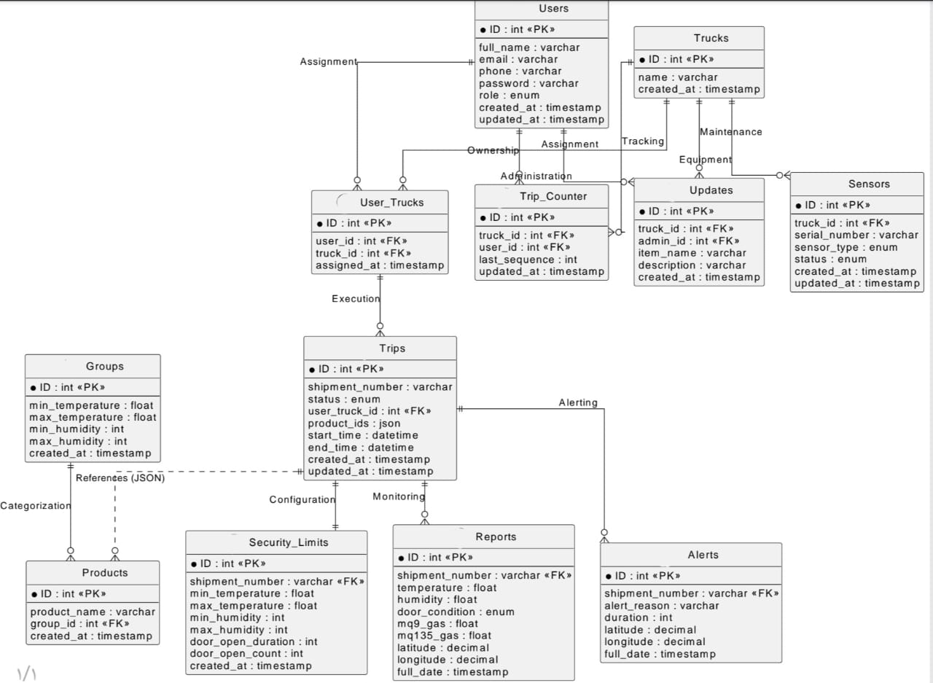
Figure 51 ER Diagram

2.9 Summary
This chapter represents the main pillar of the project, as it turned the understanding of the problem into accurate systematic documentation. This analysis has established a solid knowledge base that ensures the construction of a technical solution that meets the actual needs, by formulating comprehensive functional and technical requirements covering aspects of performance, security, and ease of use.
The chapter also contributed to the identification of stakeholder roles and operational constraints, while enhancing structural clarity through unified visual models such as (Data flow, UML and ER) explaining the behavior and structure of the system. These outputs serve as a final roadmap that completes the planning stage, representing a direct starting point towards the third chapter on architectural design and practical implementation.

Chapter3:DESIGN CONSIDERATIONS

3.1 INTRODUCTION

The design considerations of the proposed system focus on delivering a reliable, efficient, and user-friendly solution. These considerations include functionality, usability, scalability, performance, maintainability, security, compatibility, and cost. The system is designed to meet user requirements while ensuring compliance with the project specifications and supporting future enhancements.

3.2 ARCHITECTURAL STRATEGY

The system follows a well-defined architectural strategy to ensure modularity, scalability, and maintainability. The architecture organizes system components into structured layers that handle user interaction, data processing, and data storage. When a user performs an action, the system processes the input, applies business rules, securely stores data, and provides appropriate feedback or updates based on predefined logic.

3.2.1 PRESENTATION LAYER (USER INTERFACE LAYER)

This layer represents the user-facing part of the system. It allows users to interact with the application through intuitive interfaces for logging in, viewing dashboards, generating reports, and monitoring system data. The presentation layer ensures ease of use and responsive interaction across different devices.

3.2.2 BUSINESS LOGIC LAYER (PROCESSING AND NOTIFICATIONS)

The business logic layer handles the core functionality of the system. It processes user inputs, validates data, applies business rules, computes key performance indicators (KPIs), and triggers system responses such as alerts, notifications, and automated actions. This layer ensures correct system behavior under different operational scenarios.

3.2.3 DATA LAYER (STORAGE AND SYNCHRONIZATION)

The data layer is responsible for storing, managing, and synchronizing system data. It ensures data security, consistency, and availability by utilizing Database storage and local buffering mechanisms. This layer supports real-time data synchronization and reliable data recovery in case of network interruptions.

3.3 Development Requirements
This section defines the technical environment necessary for the development and operation of the SafeChain system. This includes the physical components (Hardware) required to build sensors and a control station, as well as software components (Software) that include programming languages, development environments, databases, and networking tools necessary to build interfaces and manage the back-end processes of the system.

3.3.1 Hardware Requirements
  - Computer or laptop used for system programming, dashboard development, and Database configuration Stable internet connectivity.
  - Main controller unit (Raspberry Pi) used to collect sensor data, perform initial processing, and transmit data to the database. Standard peripherals like keyboard, mouse, and monitor.
  - Temperature and humidity sensor (SHT31) used to monitor environmental conditions inside trucks or storage facilities.
  - Gas sensors (MQ-series sensors) are used to measure the emission of gases scattering, carbon dioxide
  - Door status sensor (magnetic reed switch) is used to monitor truck door opening and closing for security purposes.
  - GPS module is used to track the real-time geographical location of the truck and record the transportation route.
  - Communication modules (Wi-Fi, LoRa WAN or 4G) used to transmit sensor data from the controller to the Database.
  - Power supply (rechargeable battery or USB power source) to ensure continuous system operation during power interruptions.

3.3.2 Software Requirements
- To develop the SafeChain system, the following software components are required:
- Operating System: Windows 11 for system development, programming, and testing.
- A Server: A local web server used to manage the backend services and system operations.
- Back-end development programing languages and frameworks: required for the system development- Backend.
- Python for processing sensor data and communicating with the controller unit
- FASTAPI for handling server-side logic and local communication
- MQTT protocol for real-time data transmission from IoT devices.
- database (MYSQL) for storing sensor data, historical records, and alert logs.
- Frontend programing languages and frameworks: Required for the system development- Frontend
- Flutter for To develop the application's front-end, as it allows building applications with modern and fast interfaces using a single codebase and also provides high performance and ease of connecting the application with API services and back-end systems.
- Development tools:
- Integrated Development Environment (IDE) such as Visual Studio Code.
- Monitoring and testing tools for validating system performance and data accuracy.
- Design of algorithms and logic
Used to define the decision-making rules for the system, such as sensor threshold triggers, data encryption logic, and communication flow between the Raspberry Pi and the Database.

Food Transport Temperatures
This section reviews the temperature and humidity standards adopted globally for the transportation and management of the food and medical logistics chain. This includes the determination of optimal temperature ranges and critical limits for each category of products (refrigerated, dry, and medical) to ensure the preservation of their quality and integrity and prevent spoilage during the transportation process.

3.4.1 Refrigerated and Chilled Foods
This segment is specialized for perishable food products that require constant cooling (above freezing) to slow down enzymatic activities and bacterial growth. The exact temperature requirements vary from product to product to avoid frost damage or wilting.

3.4.1.1 Fresh Vegetables [14]
This table outlines the specific temperature requirements for transporting various types of fresh vegetables, ranging from 0 C to 18C depending on the item's sensitivity.

Table 29 Fresh Vegetables
Food Item Type | Temperature (C°)
Asparagus | 0
Beans, Lima (in pods) | 0 to 7
Beans, Green | 0 to 5
Beets | 0
Cauliflower | 0
Cabbage | 0
Carrots | 0
Celery | 0
Cucumber | 7 to 10
Eggplant | 7 to 10
Lettuce | 0 to 1
Watermelon | 4 to 10
Peas | 0
Pepper | 7 to 10
Potatoes | 10 to 16
Mushroom | 0
Okra | 7 to 10
Dry Onion | 0 to 1
Green Onion | 0
Parsley | 0
Parsnip | 0
Spinach | 0 to 4
Sweet Corn | 13 to 18
Tomato, Ripe Green | 7 to 10
Tomato, Ripe Pink | 10 to 13
Zucchini and Gourds | 0
Radish | 0

3.4.1.2 Fresh Fruits [14]
This table provides the ideal temperature ranges for various fresh fruits during transport to maintain quality and prevent shriveling.

Table 30 Fresh Fruits
Food Item Type | Temperature (C°)
Apples | -1 to 4
Apricots | -1 to 0
Avocado | 4
Bananas | 13 to 14
Blackberries | -1 to 0
Grapefruit | 5 to 10
Lemon, Green | 10 to 13
Lime, Colored | 10 to 13
Lime, Salty | 9 to 10
Peach | 0
Pears | -1 to 0
Pineapple, Ripe Green | 10 to 16
Pineapple, Ripe Fruits | 7
Mango | 7 to 10
Guava | 8 to 10
Dates (Fresh) | 0
Figs | -0.5 to 0
Grapes | -0.5
Plums | -1 to 0
Strawberries | 0 to 2
Mandarin (Yusufi) | 2 to 5
Papaya | 7 to 10
Cherries | -1 to 0
Orange | - to 8

3.4.1.3 Chilled Dairy Products and Their Derivatives [14]
This table specifies the maximum temperature limits (typically 5C) required for chilled dairy products to ensure safety and prevent bacterial growth.

Table 31 Chilled Dairy Products and Their Derivatives
Food Item/Product Type | Maximum Temperature (C°)
Milk and Flavored Milk | 5
Yogurt, Flavored Yogurt, and Yogurt with Fruit Pieces | 5
Buttermilk and Flavored Buttermilk | 5
Buttermilk Drink (Shnineh or Ayran) | 5
Unripened Cheeses | 5
Labneh and Flavored Labneh | 5
Cream and Flavored Cream (Kareem or Qaimer) | 5
Butter | 5

3.4.1.4 Chilled Meats and Their Derivatives [14]
This table details the maximum allowable temperatures for various types of chilled red meat, poultry, and seafood during the logistics process.

Table 32 Chilled Meats and Their Derivatives
Food Item/Product Type | Maximum Temperature (C°)
Red Meats (Beef, Buffalo, Camel, Deer, etc.) | 5
Lamb and Goat Meats | 5
Minced Red Meats | 5
Red Meat Burger | 5
Chicken Meats | 5
Chicken Burger | 5
Chicken Giblets | 5
Meats (Duck, Goose, Turkey, Rabbit, Pigeon, Quail, Ostrich, etc.) | 5
Edible Organs and Offal from Large Animals | 5
Meat and Poultry Sausage (Hot Dogs) | -0.5 to 1
Brain, Testicles, and Tripe | 5
Kebab, Kofta, and Meatballs | 5
Packaged and Unpackaged Fish | 0
Shellfish | 0
Fish Burger | 5
Lobster | 5
Caviar (Fish Eggs) in Brine | - o 18

3.4.2 Non-Refrigerated and Non-Frozen Foods

3.4.2.1 Infant Foods [14]
This table lists the maximum storage and transport temperatures for different types of baby food and infant formulas to preserve their nutritional integrity.

Table 33 Infant Foods
Food Item/Product Type | Maximum Temperature (C°)
Ready-to-use Sterilized Liquid Milk for Infants | 25
Dried Milk-based Foods for Infants | 25
Strained Infant Foods | 25
Fruit Juices for Infants | 25
Powder or Granular Infant Foods prepared from Cereals, Legumes, Vegetables, or Fruits | 30
Flavored Liquid Nutritional Supplement for Infants | 25
Flavored Powdered Nutritional Supplement for Infants | 25
Flavored Liquid Milk for Infants | 25

3.4.2.2 Meats and Their Derivatives [14]
This table indicates the maximum temperatures for canned, dried, and salted meat products that do not require continuous refrigeration.

Table 34 Meats and Their Derivatives
Food Item/Product Type | Maximum Temperature (C°)
Canned Meats | 30
Salted, Seasoned Meats such as Pastrami and Salami slices | 30 (Note: Sliced Pastrami must be stored at 0 to 5 C°)
Canned Meat with Vegetables | 30
Dried Meats | 30
Whole Egg Powder, Egg White Powder, and Egg Yolk Powder | 30
Canned Fish | 30
Canned Shellfish | 30
Dried Fish and Shellfish | 30
Salted Fish in Brine | 30

3.4.2.3 Dairy Products and Their Derivatives [14]
This table provides temperature limits for powdered, sterilized, and UHT-treated dairy products intended for non-refrigerated storage.

Table 35 Dairy Products and Their Derivatives
Food Item/Product Type | Maximum Temperature (C°)
Skimmed Milk Powder | 30
Whole Milk Powder | 30
Sterilized Milk | 30
Evaporated Milk | 30
Sweetened Condensed Milk | 30
Flavored Sterilized Milk | 30
Cream Powder (Topping Cream) | 30
Whey Powder | 30
Cheeses Packaged in Brine such as Dumyati, Akawi, and Nabulsi | 30
Natural Ghee | 30
Processed Cheese | 30
Ice Cream Powder | 30
Cream (Kareem – Qaimer) | 30
Sterilized Skimmed Cream Analogue (UHT Treated) | 30
UHT Treated Milk (Long Life) | 30

3.4.2.4 Fruits, Vegetables, and Their Derivative [14]
This table summarizes the temperature requirements for canned produce, jams, sauces, and other processed vegetable or fruit derivatives.
Table 36 Fruits, Vegetables, and Their Derivative
Food Item/Product Type | Maximum Temperature (C°)
Canned Vegetables and Canned Fruits | 30
Dried Fruit Juices | 30
Jams, Jellies, and Marmalades | 30
Fried Potato Slices (Chips) and Corn Puffs | 30
Dried Fruits and Vegetables such as Figs, Raisins, Prunes, Apricots, etc. | 30
Hot Sauces of all types | 30
Pickles | 30
Seasoned Tomato Sauce | 30
Tomato Paste Sauce | 30
Hot Chili Sauce | 30
Tomato Pulp, Ketchup, and Peeled Tomatoes (Note: Must be packaged under sterile conditions) | 30
Concentrated Fruit or Vegetable Juices | 30
Fruit Nectar or Sterilized Mixed Fruit Nectar | 30
Sterilized Fruit Syrup and Juices | 30
Date Molasses, Grape Molasses | 30
Table Olives preserved in Brine or by Sterilization and Heat Treated | 30
Mustard Salad | 30
Spices and Condiments | 30
Fungi such as Mushroom | 30
Dried Apricot Paste (Qamar El Din) | 30
Fried Fruit Slices such as Apple, Pear, and Peach slices with various flavors | 30
Canned Fruit Pulp and Canned Concentrated Fruit and Vegetable Juices, intended for manufacturing purposes | 30
Stuffed Grape Leaves | 30
Grape Leaves in Brine | 30
Dried and Processed Vegetables | 30
Processed Vegetables | 30

3.4.2.5 Vegetable Oils, Fats, and Their Derivatives [14]
This table outlines the thermal limits for vegetable oils, ghee, and margarine to prevent oxidation and maintain product stability

Table 37 Vegetable Oils, Fats, and Their Derivatives
Food Item/Product Type | Maximum Temperature (C°)
Vegetable Ghee, Vegetable Oils, Hydrogenated Vegetable Oils, and their derivatives such as Palm Olein, Palm Stearin | 30
Margarine | 30
Vegetable or Animal Ghee | 30

3.4.2.6 Cereals, Legumes, Nuts, and Their Derivatives [14]
This table lists the temperature standards for dry goods, including grains, flour, and coffee, various baked items.
Table 38 Cereals, Legumes, Nuts, and Their Derivatives
Food Item/Product Type | Maximum Temperature (C°)
Regular Bread | 30
Croissant Pastries | 30
Cake, Cake Slices, Sponge Cake, Chocolate Cake, Fruit Cake, Pound Cake, Baked Rolls | 30
Cheesecake | 30
Ready-made Cake (Ka'ak) | 30
Stuffed Pies such as Cheese, Thyme, etc. | 30
Doughnut Pastries | 30
Ground Roasted Coffee | 30
Instant Coffee | 30
Sweet and Salted Biscuits | 30
Stuffed or Coated Biscuits | 30
Oat Flakes | 30
Cake Mixes | 30
Industrially Processed and Packaged Cakes, Croissants, and Baked Pastries | 30
Cakes with Cream | 30
Legume Powders | 30
Crushed Legumes | 30
Wheat Bran | 30
Instant Vermicelli | 30
Canned Legumes such as Chickpeas, Chickpeas with Tahini, Fava Beans (Foul Medames), etc. | 30
Dry Grains such as Barley, Oats, Corn, etc. | 30
Roasted Peeled Nuts, Salted or Sweetened | 30
Roasted Peeled Nuts Coated with a Layer of Dry Candy | 30
Rice | 30
Flour (Daqeeq) | 30
Legume Powders such as Chickpea Powder and Dried Falafel Grits | 30
Peanut Butter | 30
Starches of all types | 30
Breakfast Cereal Products such as Corn Flakes, Wheat, Rice, etc. | 30
Roasted Ground Coffee with Cardamom (Arabic Coffee) | 30
Pasta | 30
Unwhole Semolina | 30

3.4.2.7 Water and Beverages [14]
This table specifies the maximum allowable temperatures for bottled water, soft drinks, and various types of juices or syrups.

Table 39 Water and Beverages
Food Item/Product Type | Maximum Temperature (C°)
Barley Drink | 30
Natural Concentrated Fruit Syrup (Squash) | 30
Artificial Concentrated Fruit Syrup | 30
Artificial Syrup with Natural or Artificial Flavors (Note: Must be packaged under sterile conditions) | 30
Carbonated Soft Drinks and Non-Carbonated Energy Drinks | 30
Aromatic Waters such as Rose Water and Orange Blossom Water | 30
Naturally Sparkling Mineral Water (Carbonated) | 30
Naturally Still Mineral Water (Non-Carbonated) | 30
Bottled Drinking Water | 30

3.4.2.8 Other Miscellaneous Products [14]
This table covers a wide array of miscellaneous items, including eggs, honey, chocolate, and powdered food additives.

Table 40 Other Miscellaneous Products
Food Item/Product Type | Maximum Temperature (C°)
Compressed Inactive Baker's Yeast | 30
Dried Uncompressed Inactive Baker's Yeast | 30
Baking Powder | 30
Custard Powder | 30
Cappuccino Powder | 30
Crème Caramel Powder | 30
Muhallabia Powder | 30
Ground Spices and Condiments | 30
Luqmat Al-Qadi Powder | 30
Vanilla Powder | 30
Powdered Food Colors and Flavors | 30
Liquid Food Colors and Flavors | 30
Crispy Snack Foods | 30
Fresh Eggs (Table Eggs) | 11 to 15
Pasteurized Liquid Egg | 5
Vinegar | 30
Chewing Gum | 30
Coffee Whitener | 30
Tea of all types packaged in bags | 30
Powdered Nutritional Drinks | 30
Artificial Drink Powder | 30
Cocoa Powder | 30
Jelly Powder | 30
Plain Dry Candy | 30
Fortified Dry Candy | 30
Honey | 30
Soup Powders | 30
Partially Dehydrated Soup in Cubes or other forms | 30
Prepared Basbousa Powder | 30
Brown Sugar and White Sugar | 30
Concentrated Sugarcane Syrup | 30
Tea | 30
Green Tea | 30
Table Salt | 30
Iodized Salt | 30
Halawa Tahiniya | 25
Tahini | 25
Mayonnaise Salad | 25
Chocolate of all types | 25
Raw Chocolate (Unprocessed) | 25
Royal Jelly | 30
Liquid and Dried Glucose | 30

3.4.3 Recommended Relative Humidity (RH) for Food Transportation
This table defines the necessary humidity levels for different food categories to prevent wilting, condensation, or microbial growth.
Table 41 Recommended Relative Humidity (RH) for Food Transportation
Food Item/Product Type | Recommended Relative Humidity (RH) Range | Important Notes
Fresh Vegetables (Lettuce, Leafy Greens) | 95% to 98% [15] | Requires very high humidity to prevent drying, wilting, and weight loss.
Fresh Fruits | 85% to 90% [15] | Less sensitive to humidity than leafy greens; this level helps maintain their shape and prevent shriveling.
Chilled Dairy Products and Derivatives (Milk, Yogurt, Cheese) | 75% to 85% [16] | Good humidity control within this range prevents condensation (dew) on packaging, which can cause mold growth or label damage.
Chilled Meats and Derivatives | 75% to 85% [16] | This range helps prevent rapid drying out (dry out) of unpackaged meats and reduces the chance of bacterial growth compared to higher humidity.
Non-Refrigerated Foods (Dry and Canned) | Does not exceed 60% to 65% [17] | The environment must be dry to maintain the quality of grains, flour, and legumes, and to prevent clumping, mold, and insect growth.
Cereals, Legumes, Nuts, and Their Derivatives | Less than 65% [17] | Foods with low water content must be transported and stored in a very dry environment to prevent microbial spoilage.

3.4.4 Food Safety and Refrigerator Cooling Guidelines [18]
This table provides essential instructions for safe food handling, including the "Danger Zone" temperatures and proper refrigerator maintenance to inhibit bacterial growth

Table 42 Food Safety and Refrigerator Cooling Guidelines
Aspect | Essential Details and Instructions
Importance of Refrigeration | Reduces the multiplication of harmful and spoilage-causing bacteria.
The Danger Zone | The temperature range where bacterial growth increases rapidly: 40°F – 140°F (5°C – 60°C), where bacteria numbers double every 20 minutes.
Appropriate Refrigerator Temperature | Must be set to 40°F (5°C) or below to inhibit bacterial growth.
Types of Bacteria | Pathogenic: Grow in the Danger Zone and do not necessarily affect food quality. Spoilage: Grow at low temperatures and cause deterioration in taste, odor, and appearance.
Power Outage | If the temperature rises above 40°F (5°C) for two hours or more, the food must be discarded immediately.
Proper Handling Procedures | Rapidly cool hot food (e.g., using an ice water bath) before placing it inside. Cover foods to protect them from microbes and retain moisture. Divide large quantities (like soup or a meat dish) into smaller or shallower containers before cooling. Segment and wrap whole cuts of meat separately.
Food Placement Method | Store uncooked meats, poultry, and seafood in leak-proof containers or tightly wrapped to prevent leakage of fluids.
Refrigerator Door Storage | Avoid storing perishable foods (like eggs) on door shelves; their temperature fluctuates compared to the interior.
Internal Refrigerator Features | Shelves: Preferably removable, glass/plastic, and easy to clean. Storage Bins (Drawers): Provide an optimal environment (high humidity for vegetables, low for fruits). Meat/Cheese Drawers: Kept at a temperature lower than freezing to extend storage duration.
Defrosting (in older models) | Remove frozen foods and place them in the refrigerator with a cooling source (ice packs). Avoid using sharp or heat-generating tools to remove frost.
Maintaining Cleanliness | Weekly Cleaning: Wipe up spills quickly and clean with hot water and soap. Leftover Storage Duration: 4 days for raw poultry and ground meat, and 1-2 days for pre-cooked foods. For Odor: Place an open box of baking soda.
Odor Removal | Use solutions such as: Equal parts water and vinegar, or water and baking soda. Ground coffee beans or newspapers can also be placed inside the refrigerator for several days.

3.4.5 Natural and Critical Concentrations of Gases and Dust.
This table monitors the levels of various gases and dust particles in the food environment, defining safe target ratios and critical indicators of spoilage or hazards.

Table 43 Natural and Critical Concentrations of Gases and Dust
Observed Factor | Chemical Formula | Unit of Measurement | Natural/Target Ratio (Safe) | Critical Ratio (Abnormal) | Notes and References
Ammonia | NH3 | Parts per million (ppm) | 0 – 5 ppm (in a safe/clean environment) | Starts to rise (above 5–10 ppm). | A strong indicator of spoilage in protein products (meat, dairy, and fish). The rise indicates protein breakdown [21]
Hydrogen Sulfide | H2S | Parts per million (ppm) | 0 ppm (in a safe environment) | Starts to appear (above 0 ppm). | A clear and strong indicator of spoilage in protein-rich foods (especially eggs and fish) [22]
Carbon Dioxide | CO2 | Percentage (%) or ppm | 0.04% (in general atmosphere) [20]. Target in transportation: Varies (e.g., 1–5% for some fruits) [19]. | Above 10% (may lead to physiological damage in fresh produce) [19]. | Used in Controlled Atmosphere (CA) storage to reduce respiration and extend shelf life.
Oxygen | O2 | Percentage (%) | 20.95% (in the atmosphere) [20]. Target in transportation: 3–5% (for some produce) [19] | Below 1% (leads to anaerobic respiration and spoilage) [19] | Maintaining a low (but not zero) level is essential to reduce the deterioration rate of fresh produce.
Nitrogen | N2 | Percentage (%) | 78.09% (in the atmosphere) [20] Target in transportation: Represents the remaining volume after adjusting CO2 and O2 [19]. | Significant drop indicates an uncontrolled increase in O2 or CO2. | An inert gas that fills the space to dilute oxygen concentration and reduce fire hazard.
Ethylene | C2H4 | Parts per million (ppm) | Less than 0.01 ppm (for preserving sensitive non-ripe produce) [19] | More than 0.1 ppm (starts to induce ripening and rapid spoilage) [19]. | Considered a ripening hormone; must be eliminated during the transportation of ripening-sensitive produce.
Dust (Suspended Particles) | N/A | Cleanliness measure | Should be zero (no accumulation on surfaces) [23]. | Any visible accumulation, or high concentration of particles in the air. | Considered a physical contaminant. Dust from dry foods (like flour, grains) poses an explosion and fire risk [24]

3.4.6 Natural and Critical Ratios for Monitored Factors in Pharmaceutical Transport.
This table outlines the strict temperature and environmental requirements for pharmaceutical products, including the Cold Chain for vaccines and controlled room temperature for other medications.
Table 44 Natural and Critical Ratios for Monitored Factors in Pharmaceutical Transport.
Observed Factor | Unit of Measurement | Natural/Target Ratio (Safe) | Critical Ratio (Abnormal) | Notes and References
Temperature (Refrigerated) | Celsius (°C) | 2°C to 8°C (Cold Chain) [26][27][28] | Below 2°C (Risk of freezing, damaging solutions/ampoules) [25]. Above 8°C (Drug efficacy starts to degrade) [27]. | Essential for vaccines, insulin, and other highly heat-sensitive biological products.
Temperature (Controlled Room) | Celsius (°C) | 15°C to 25°C (or 15°C to 30°C max) [25] [26] | Above 30°C (Warm place/Excessive heat) [26]. Above 40°C (Very high heat, leading to rapid degradation) [25]. | The common range for most tablets, capsules, and non-refrigerated medicines.
Temperature (Deep Freeze) | Celsius (°C) | 20°C to -10°C [26].  -70°C (for some highly sensitive vaccines) [28]. | Any deviation from the manufacturer's specified range. | Used for certain vaccines and highly sensitive biological products.
Relative Humidity | Percentage (%) | Should not exceed 60% - 65% [27]. | Above 70% (Risk of condensation and high moisture) [25]. | High humidity can degrade the efficacy of solid dosage forms (capsules and tablets) [25].
Gases (Oxygen, Ammonia, H2S) | N/A | Normal atmospheric air. | Not monitored as a spoilage indicator. | Drug integrity relies on primary packaging. Oxygen is monitored indirectly through packaging integrity to prevent oxidation-prone degradation [25].

3.5 Graphical User Interface Design and Wireframe
This section presents the visual design and structure of the official user interfaces (Wireframes) of the SafeChain system. These interfaces are built to ensure a smooth and straightforward UX user experience, allowing users and administrators to monitor vital truck data in real time, manage settings, receive instant alerts, considering responsive design that is compatible with various screens (mobile phones, tablets, personal computers).

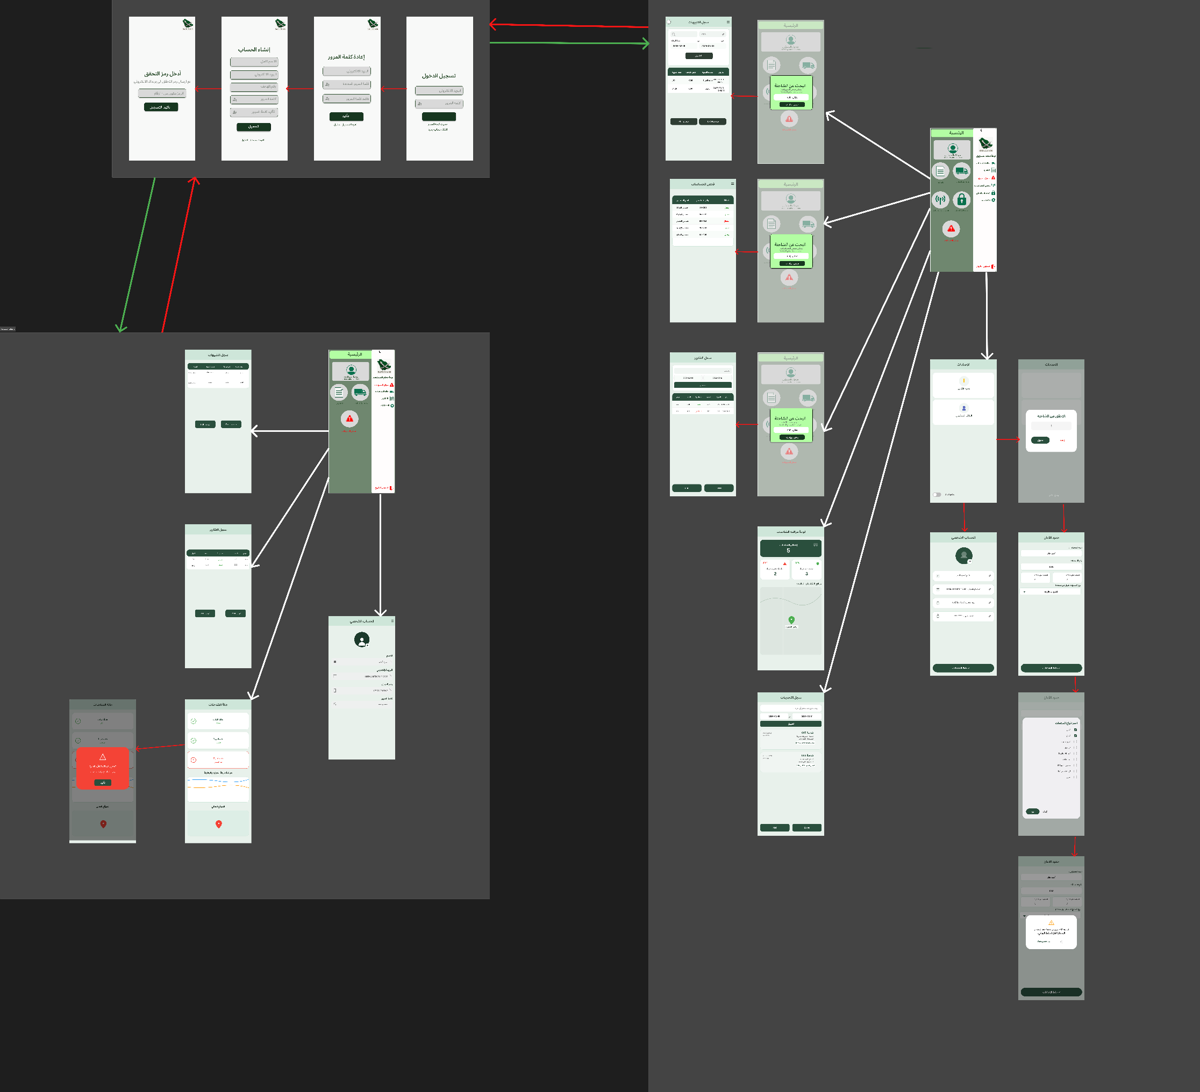
Figure 52 Safe Chain Graphic User Interface

3.6 Summary
This chapter presented the design considerations of the SafeChain system, focusing on the architectural strategy, system layers, hardware and software requirements, and user interface design. The proposed architecture was designed to ensure scalability, reliability, and efficient integration between IoT devices, cloud services, and user applications. By clearly defining the presentation layer, business logic layer, and data layer, the system design supports real-time monitoring, secure data handling, and responsive alert mechanisms.
In addition, the chapter outlined the essential development requirements and provided an overview of the graphical user interface and wireframe design, emphasizing usability and accessibility for different user types. These design decisions form a solid foundation for the implementation phase and ensure that the system meets both functional and non-functional requirements. Overall, the design presented in this chapter prepares the SafeChain project for successful development, testing, and future scalability.

Chapter 4: System Implementation

4.1 Introduction

This section presents the design concept of the SafeChain system, explaining its purpose and main objectives. The system is intended to provide real-time monitoring, automated alerts, and reliable data collection to ensure the safety and quality of food products during transportation and storage

The design combines hardware components, such as sensors and controllers, with software solutions including mobile applications, backend services, and visualization tools. This integration ensures the system is efficient, scalable, and dependable.

Key design decisions, such as technology choices and communication protocols, were made to meet the required standards for safety, reliability, and performance.

By the end of this section, the reader will have a clear understanding of the system’s overall concept and the core components that will be further detailed in the following sections.

4.2 Development Environment
This section reviews the development environment of the system with its physical and software components. To ensure efficient performance and system stability, a comparison was made between the available technologies and their alternatives, choosing the most suitable ones based on speed, accuracy, cost, and energy consumption. The following table (Table 45) shows the approved components and the justification for their selection

Figure | Technology/Tool | Alternatives | ؤ
  Figure 53 Flutter | Flutter (Mobile App Framework) | React Native, Native Android | Single codebase for Android and iOS, faster UI development, and better performance.
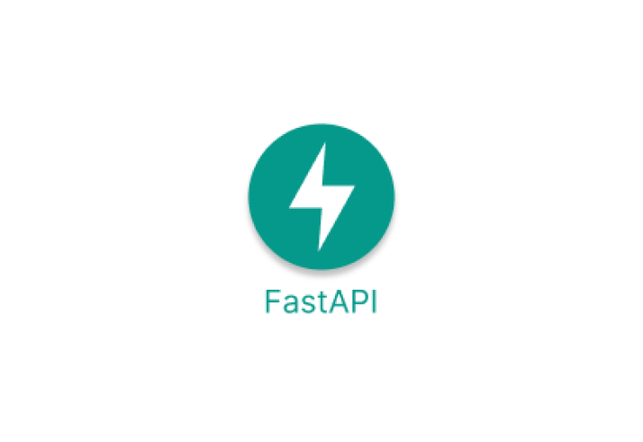  Figure 54 Fast Api | FastAPI(Backend Framework) | Flask, Django | High performance, fast API development, async support, and efficient handling of IoT real-time data.
  Figure 55 Wi-Fi Communication | Wi-Fi Communication | Bluetooth | Faster data transfer and stable internet connectivity for cloud communication.
  Figure 56 4G LTE Communication | 4G LTE Communication | 3G, GSM | Faster and more reliable real-time data transmission during transportation.
  Figure 57 LoRaWAN | LoRaWAN | Zigbee | Long-range communication with low power consumption in remote areas.
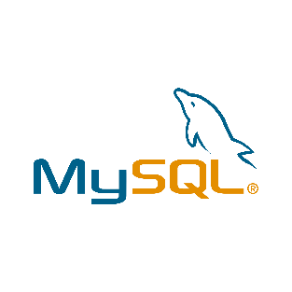  Figure 58 MySQL | MySQL | MongoDB, postgreSQL | Reliable relational database management and efficient handling of structured data.
  Figure 59 Prometheus (Monitoring) | Prometheus (Monitoring) | Nagoios, Zabbix | Efficient real-time monitoring, powerful metrics collection, and easy integration.
  Figure 60 Grafana (Visualization) | Grafana (Visualization) | Kibana, Tableau | Interactive dashboards, real-time visualization, and easy integration with Prometheus.
  Figure 61 IDE Visual Studio Code | Visual Studio Code | PyCharm, Android Studio | Lightweight, easy to use, and supports Flutter, Python, FastAPI, and IoT development through useful extensions.

4.3 Hardware Components

figure | tools | Alternatives | Reason for Selection
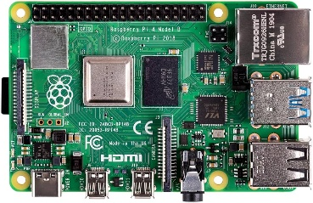  Figure 62 Raspberry pi 4 | Raspberry Pi 4 | ESP32 , Arduino | Higher processing power, supports multitasking, and easy integration with cloud and databases.
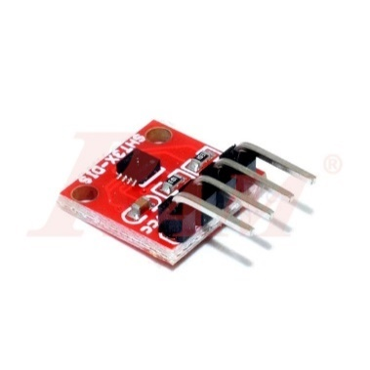  Figure 63 SHT31 Temp & Humid | SHT31 sensor | DHT11 , DHT22 | Higher accuracy, better stability, and faster response.
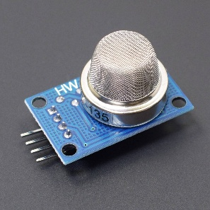  Figure 64 Gas sensor Mq-135 | MQ-135 sensor | MQ-2,MQ-7,MQ-3 | Detects multiple harmful gases (NH3, CO2, etc.) suitable for food spoilage detection.
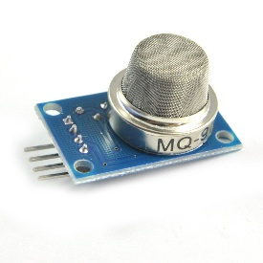  Figure 65 Gas sensor Mq-9 | MQ-9 | Neo-6M,SIM808 GPS | Reliable detection of CO and combustible gases at low cost.
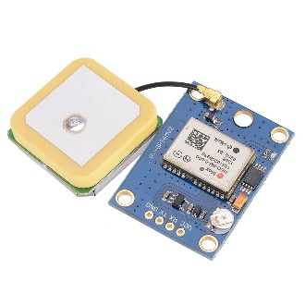  Figure 66 Neo-6M GPS Module | Neo-6M GPS Module | Mechanical Switches | Higher positioning accuracy, fast signal acquisition, and reliable real-time tracking.
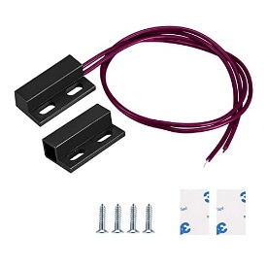  Figure 67 Magnetic Reed Switch | Magnetic Reed Switch | Reed Native, Native Android | Reliable door status detection with low power consumption and simple installation.

4.4 Hardware Implementation
The hardware implementation of the SafeChain system involved physically connecting all sensors to the Raspberry Pi 4 and ensuring proper power distribution and signal integrity.
- 4.4.1 Connection Diagram
All sensors were connected to the Raspberry Pi 4 using its 40-pin GPIO header. The following connections were established:
Component | GPIO Pin | Function
SHT31 (Temp/Humidity) | GPIO 2 (SDA), GPIO 3 (SCL) | I²C communication
MQ-135 Gas Sensor | MCP3008 CH0 → GPIO 9,10,11 | Analog input via ADC
MQ-9 Gas Sensor | MCP3008 CH1 → GPIO 9,10,11 | Analog input via ADC
Magnetic Reed Switch | GPIO 17 | Digital input (Door status)
NEO-6M GPS Module | GPIO 14 (TX), GPIO 15 (RX) | UART serial communication

4.4.2 Power Supply
The Raspberry Pi 4 was powered using a 5V/3A USB-C power supply. All sensors drew power from the Raspberry Pi's 3.3V and 5V pins. A 1000µF capacitor was added across the power rails to stabilize voltage during peak current draws from the gas sensors.

4.4.3 Final Assembly
All components were mounted inside a ventilated plastic enclosure (200mm × 120mm × 75mm) to protect them during transportation. Holes were drilled for:
- GPS antenna (SMA connector)
- 4G antenna (for optional cellular backup)
- Cable access for door sensor wiring

shows the fully assembled Safe Chain IoT device with all connected components.
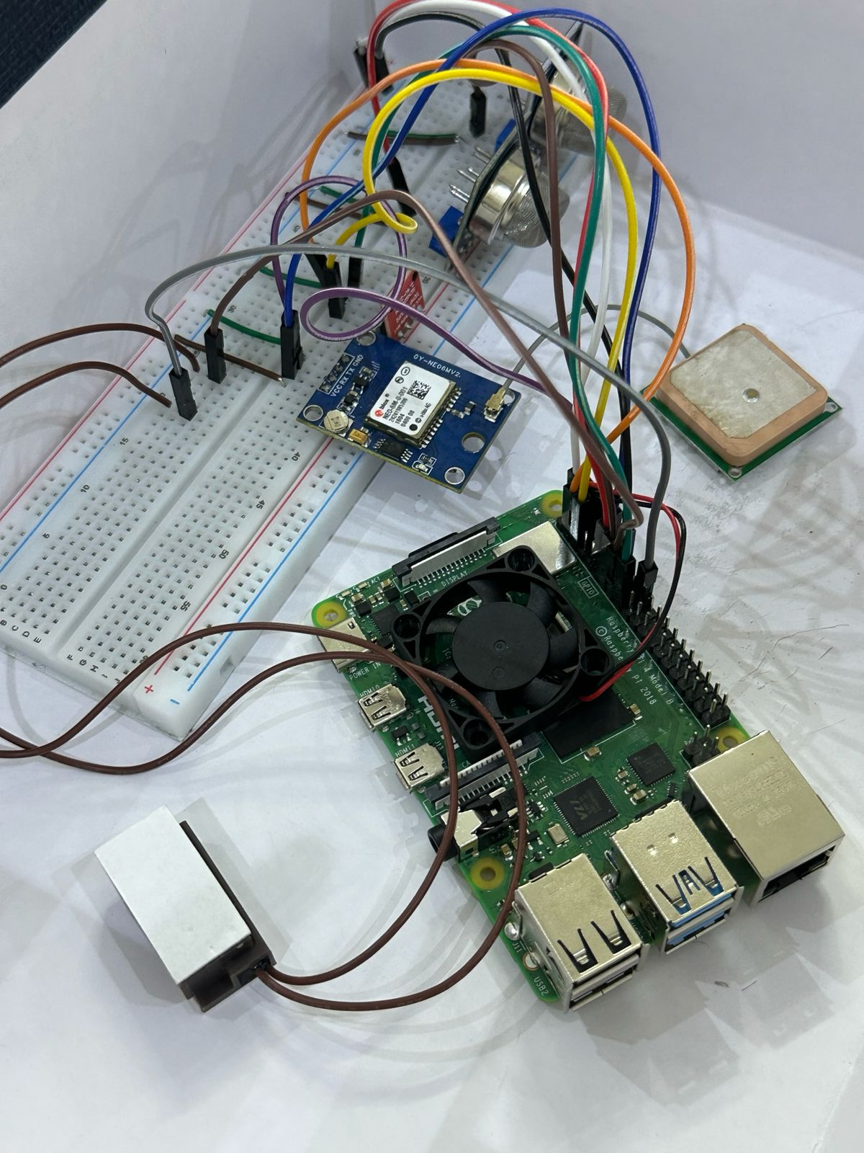
Figure 68 Complete hardware assembly of the SafeChain IoT device

4.5 Database Implementation
This part is about the database architecture of the SafeChain system. It tells you how the SafeChain system stores data, manages it and lets you access it. The SafeChain system uses two technologies that work together: MySQL and Prometheus. MySQL is used for the SafeChain systems data, like the kind you find in tables and it is used with something called XAMPP. The SafeChain system uses Prometheus for the real-time sensor metrics that come in over time. This part of the explanation is about the MySQL part of the SafeChain system. It covers how to set up the MySQL database for the SafeChain system how the connections to the database are managed so that many users can use the SafeChain system at the time and what the tables , in the database look like for the SafeChain system.
- 4.5.1 Initialization Script
Of creating table models by hand in Python code the SafeChain backend uses a feature from SQLAlchemy that automatically reads the existing table structure from the MySQL database when it starts up.
This way when the system begins it connects to the database and turns all the existing tables into Python objects on its own. It does not need a script to move or create things in the application.
The tables are. Defined right in MySQL like it says in Section 5.3.3.2 and the backend just copies them.
This way of doing things has a lot of points for the SafeChain system:
- Any changes, to the database plan are picked up by the backend without changing the Python code
- It gets rid of work. The table structure is only defined in one place, which is MySQL
- It makes it easier for new developers to join because they do not have to match up the models
- 4.5.2 Connection Pool
In the SafeChain system you do not have to define table models in Python code.
A connection pool for the SafeChain system is a cache of -established database connections that the SafeChain system reuses across multiple requests for the SafeChain system.
This is done of opening and closing a new connection for every single operation in the SafeChain system.
In the SafeChain system the connection pool for the SafeChain system is managed automatically by SQLAlchemy the moment the create_engine function is called for the SafeChain system.
By default SQLAlchemy for the SafeChain system maintains the following:
- pool_size is 5. This means the SafeChain system keeps 5 connections ready at all times for the SafeChain system
- max_overflow is 10. This means the SafeChain system can create up to 10 additional connections during peak load for the SafeChain system
- pool_timeout is 30 seconds. This is the maximum wait time before raising an error if no connection is available for the SafeChain system
This connection pool is very important for the SafeChain system.
This is because IoT sensors for the SafeChain system transmit data continuously and simultaneously from trucks for the SafeChain system.
Without a connection pool for the SafeChain system each sensor reading would require opening a database connection for the SafeChain system. This would cause delays and overloading the server for the SafeChain system.
With connection pooling for the SafeChain system all incoming data requests are served from -existing connections for the SafeChain system. This ensures fast and consistent performance, for the SafeChain system.
- 4.5.3 MySQL
As established in Section 5.2 (Table 45), MySQL was selected over alternatives such as MongoDB and PostgreSQL. The following table provides a detailed comparison:

Table 49 Comparison of Database Technologies and Justification for Selection
Prometheus | XAMPP + MySQL | InfluxDB | Firebase | Criteria
Time-Series | Relational SQL | Time-Series | NoSQL / Real-time | Type
Weak | Excellent | Weak | Weak | Structured data (users, logs)
Excellent | Good | Excellent | Moderate | Real-time sensor data
Not supported | Excellent | Not supported | Not supported | Table relationships (Foreign Keys)
Good | Excellent | Moderate | Moderate | FastAPI integration
Yes | Yes | Limited | Limited | Fully free
Live sensor data | Structured data | Not available | NOT  Not available | Role in SafeChain

MySQL was picked because it can handle the way SafeChain data organized. Where users are connected to trucks trucks are connected to trips and trips are connected to reports and alerts. This chain of relationships needs a database that keeps everything connected and makes sure all the relationships are correct, which MySQL can do.
MySQL is good at handling this kind of data. MongoDB and Firebase are not as good at this.
Prometheus is used with MySQL to handle the data that comes from sensors. This data is different because it happens a lot and needs to be written and read quickly. It does not need to be connected like the other data. Prometheus is good at handling this kind of data over time.

4.5.3.1 Connection to MySQL
The following code, located in the backend's database.py file, establishes the connection between the FastAPI backend and the MySQL database:
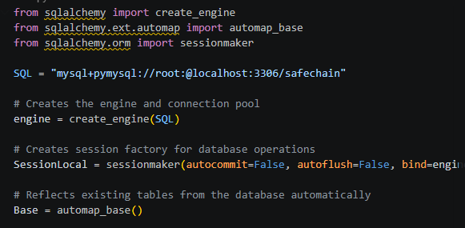
Figure 69 Database Engine Configuration (SQLAlchemy)

4.5.3.2 Tables in MySQL
The SafeChain database consists of eleven tables, each responsible for a specific domain within the system. All tables are created directly in MySQL and automatically reflected by the backend as described in Section 5.3.1.
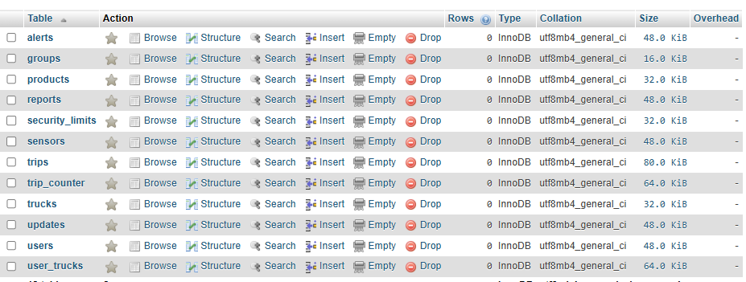
Figure 70 Tables in MySQL

4.5.3.2.1 Table 1: users
Stores all system user accounts including drivers, managers, and administrators. Each user is assigned a role that determines their level of access within the SafeChain platform.
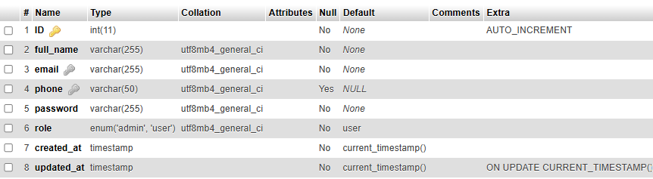
Figure 71 Table users in MySQL

4.5.3.2.2 Table 2: trucks
Stores the trucks registered in the system. Each truck is linked to a responsible user, establishing ownership and accountability for monitoring purposes.
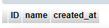
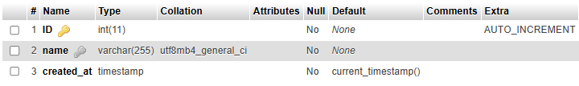
Figure 72 Table trucks in MySQL

4.5.3.2.3 Table3: user_Trucks
The table contains the connection information between each user and the trucks assigned to them, allowing more than one truck to be assigned to a single user, as well as the ability to share one truck between multiple users when needed.
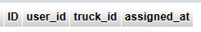
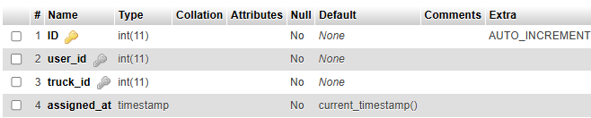
Figure 73 Table user_trucks in MySQL

4.5.3.2.3 Table 4: groups
Defines reusable environmental threshold groups that specify the acceptable temperature and humidity ranges. These groups can be assigned to multiple products, allowing consistent safety standards to be applied across similar product categories.
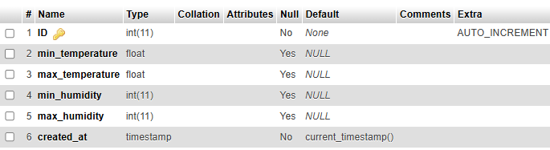
Figure 74 Table groups in MySQL

4.5.3.2.4 Table 5: products
Stores the products being transported within the SafeChain system. Each product has its own safe environmental range for temperature and humidity, and can be associated with a predefined threshold group.
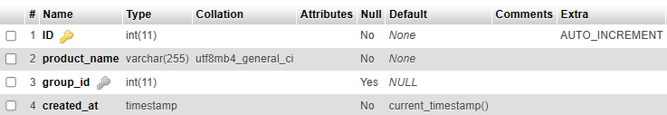
Figure 75 Table products in MySQL

4.5.3.2.5 Table 6: trips
Records each shipment trip carried out by a truck. A trip connects the truck, the responsible user, the transported product, and the applicable threshold group, serving as the central reference for all monitoring activity during a shipment.
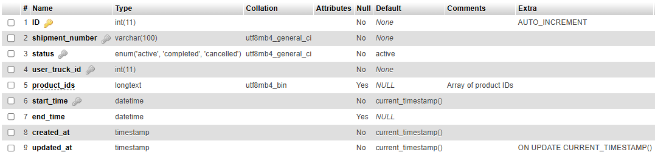
Figure 76 Table Trips in MySQL

4.5.3.2.6 Table 7: trip_counter
Tracks the total number of trips completed per truck in order to generate sequential and unique shipment numbers automatically. Each truck has exactly one record in this table, updated with every new trip.

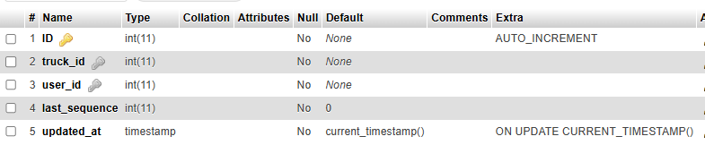
Figure 77 Table trip_counter in MySQL

4.5.3.2.7 Table 8: reports
The primary data table of the system. Stores every sensor reading recorded during a trip, including temperature, humidity, gas levels, door status, timestamp, and GPS coordinates. This table accumulates the highest volume of data in the system due to the continuous nature of sensor transmissions.
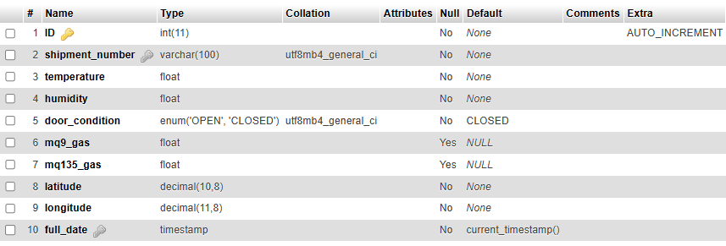
Figure 78 Table reports in MySQL

4.5.3.2.8 Table 9: Alerts
Stores all alerts triggered by the system when a sensor reading exceeds the defined safety thresholds. Each alert captures the reason, duration, timestamp, and GPS location at the moment the violation occurred.
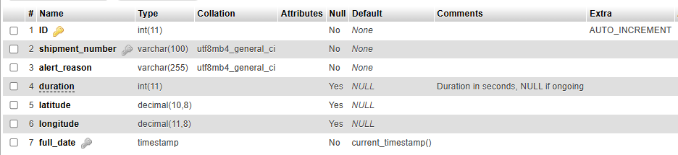
Figure 79 Table alerts in MySQL

4.5.3.2.9 Table 10: sensors
Stores information about the physical sensors installed in each truck, including their type, serial number, and current operational status. This table allows the system to track and manage the hardware components associated with each vehicle.
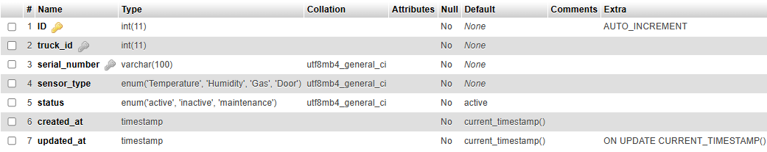
Figure 80 Table sensors in MySQL

4.5.3.2.10 Table 11: security_limits
Stores the custom safety thresholds configured per truck by the user or administrator. These limits define the acceptable ranges for temperature, humidity, and door activity, and are used by the system to determine when an alert should be triggered.
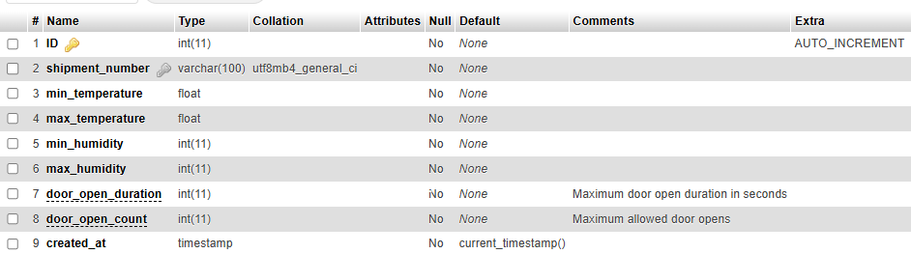
Figure 81 Table security_limits in MySQL

4.5.3.2.11 Table 12: updates
Logs all administrative actions and changes applied to trucks within the system. This table serves as an audit trail, recording what was changed, by whom, and when, ensuring full transparency and traceability of system modifications.
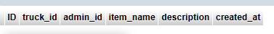
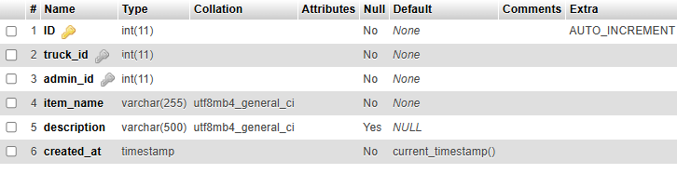
Figure 82 Table updates in MySQL

4.6 System Interface Screenshots

4.6.1 Login Screen
This screen allows registered users to securely access the SafeChain system using their email and password credentials.
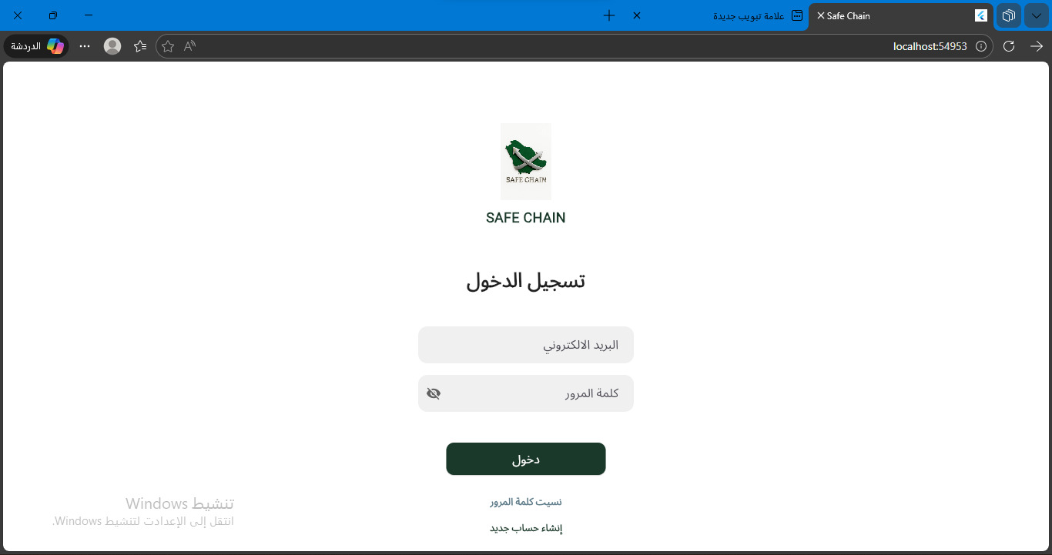
Figure 83 Login Screen

4.6.2 User Registration Screen
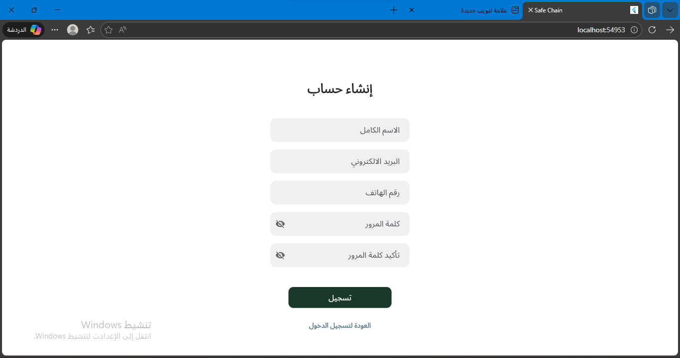
This screen enables new users to create an account and access the SafeChain monitoring platform.
Figure 84 User Registration Screen

4.6.3 figure 3: OTP Verification Screen
This secure screen handles the two-factor authentication layer, prompting users to enter a 4-digit temporary verification code (OTP) sent to their registered email address during setup.
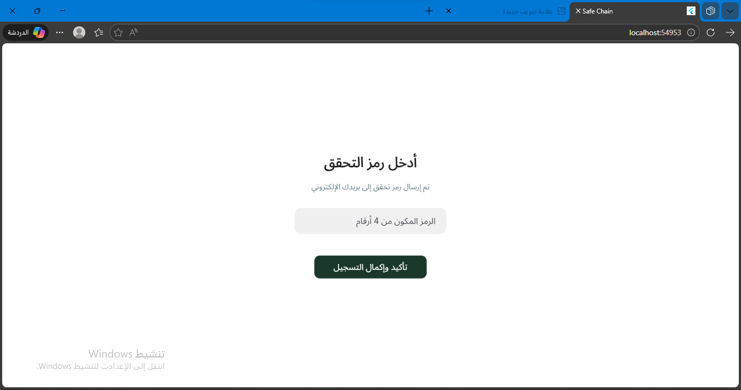
Figure 85 OTP Verification Screen

4.6.4 Password Reset Screen
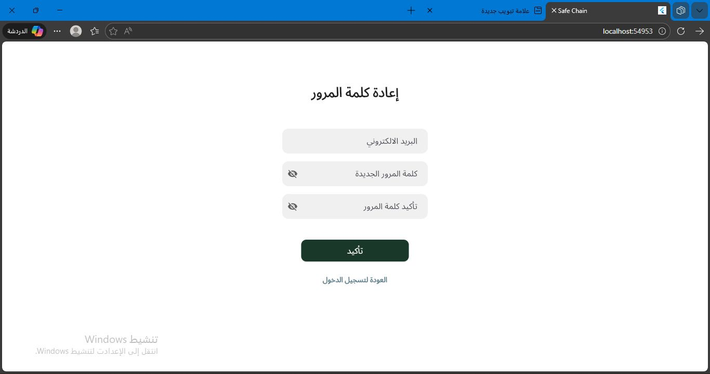
This recovery screen enables registered users to securely change their old credentials and set a new password after verifying their identity.
Figure 86 Password Reset Screen

4.6.5 Admin Screen
The central control panel for administrators, presenting quick overview metrics and an unfolded sidebar drawer for fluid navigation through system modules.
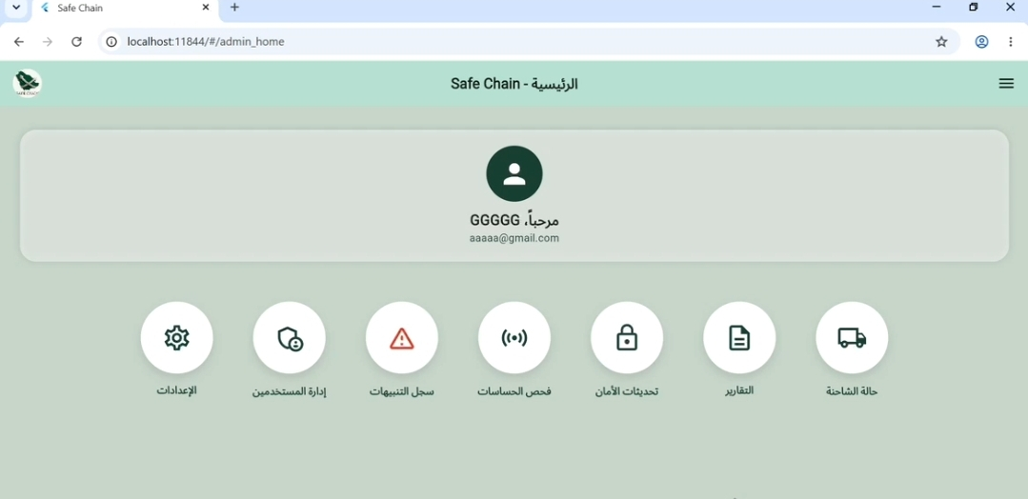
Figure 87 Admin Screen
- 4.6.6 User management
An administrative screen that displays a list of all system users with their names, email addresses, roles, and status, along with buttons to add, edit, or delete user accounts
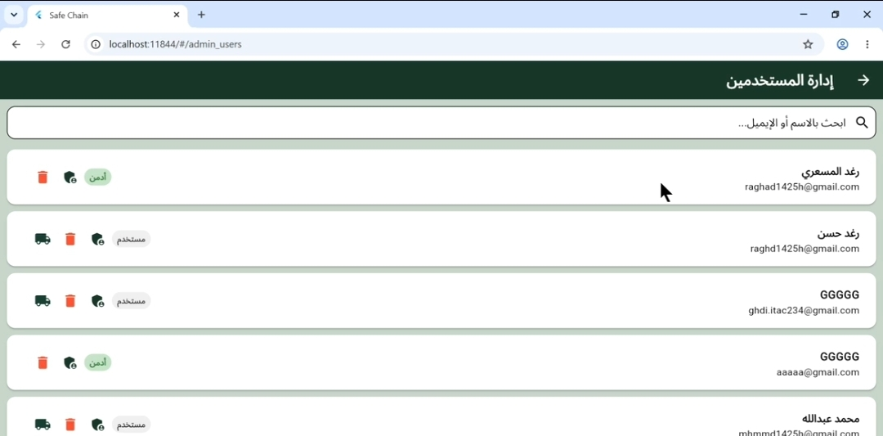
Figure 88 USER MANAGEMENT
- 4.6.7 Assign Trucks
The Assign Trucks Interface is accessible only to administrators. It provides a visual way to link or unlink trucks to a specific user account
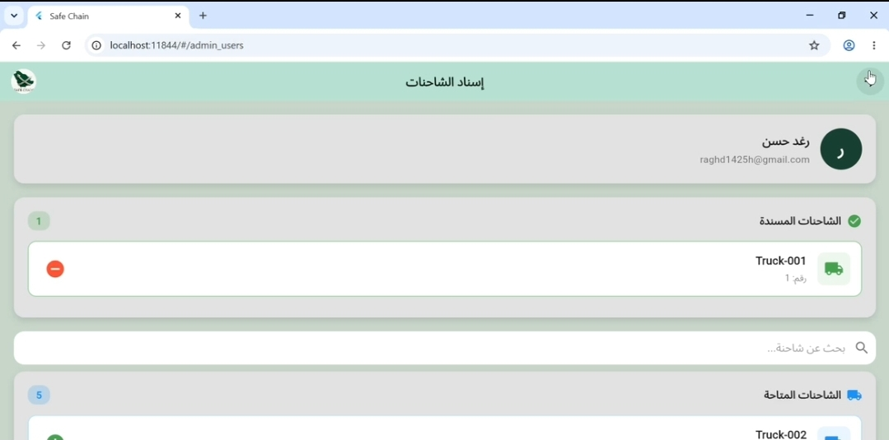
Figure 89 Assign Trucks

4.6.6 Admin Alerts Log Screen
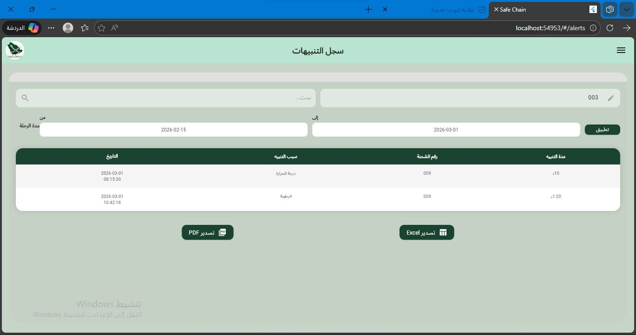
This interface provides administrators with a centralized log of critical threshold alerts (e.g., temperature and humidity violations), showing the alert type, duration, and direct management filters.
Figure 90 Admin Alerts Screen

4.6.7 figure 7: Sensors Check Screen
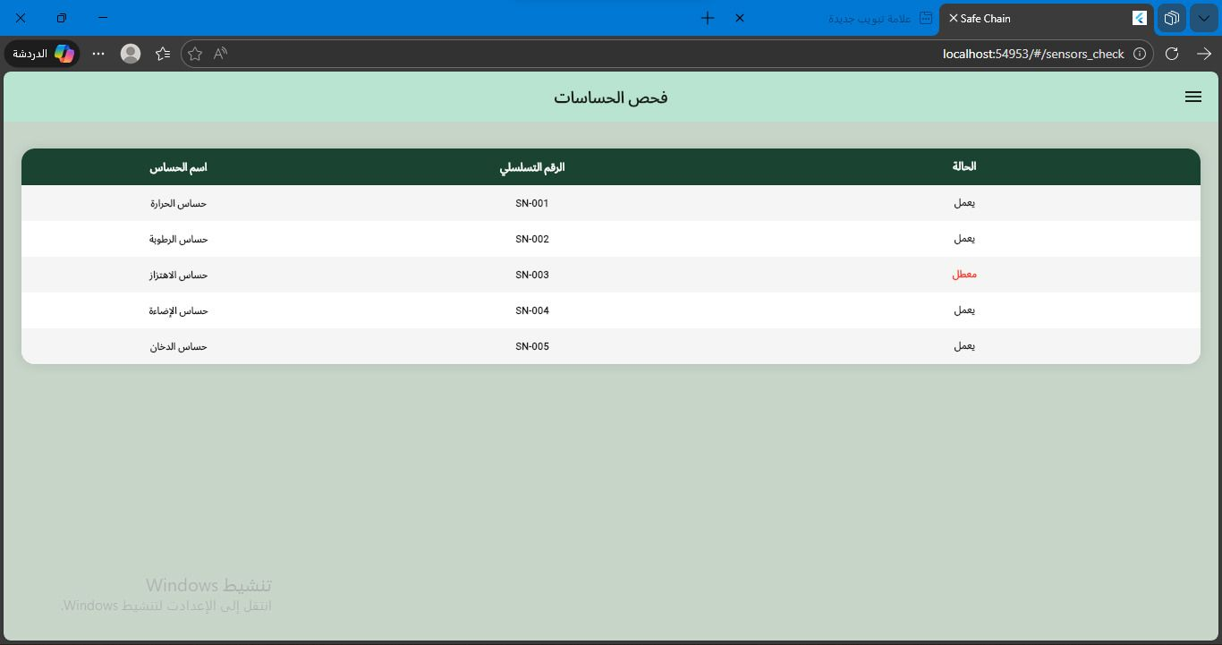
This hardware diagnostic dashboard lists all integrated sensors by their serial numbers, displaying the real-time active status of temperature, humidity, gas, and door sensors.
Figure 91 Sensors Check Screen

4.6.8 figure 8: Updates Log Screen
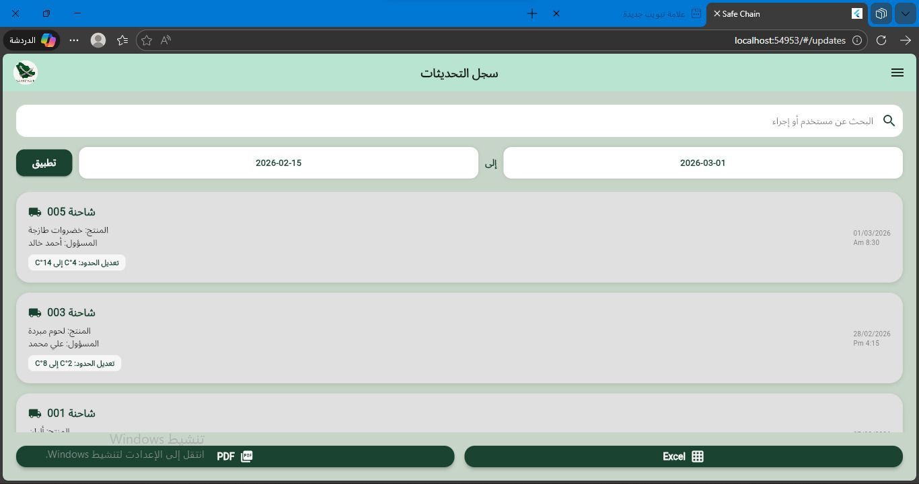
This screen displays a detailed historical log of system updates and threshold modifications made by users, allowing administrators to filter records by specific date ranges and export the log data.
Figure 92 Updates Screen

4.6.9 figure 9:Admin Reports Screen
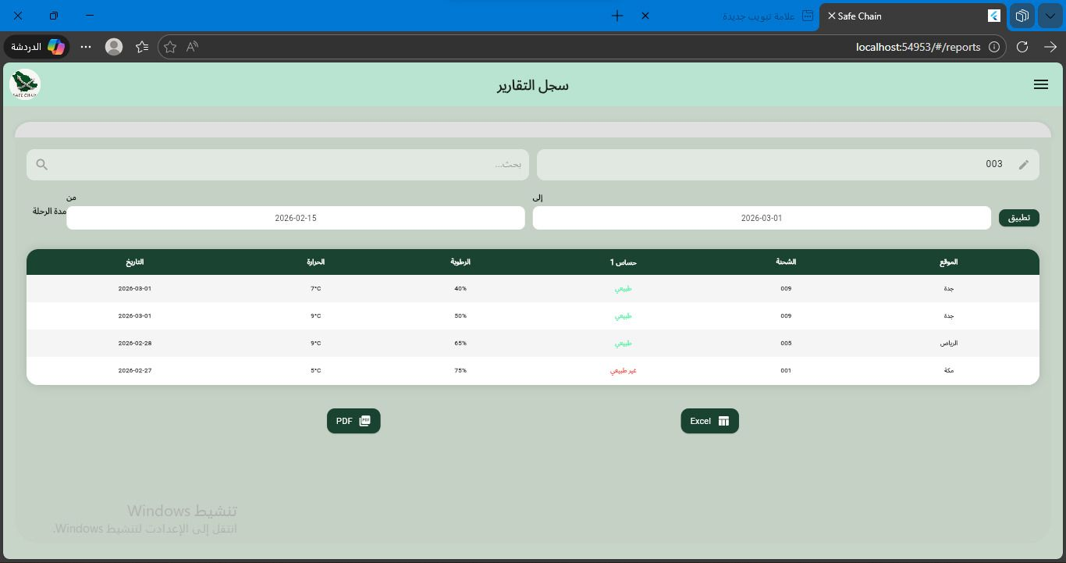
This interface provides a comprehensive tabular view of general trip reports, containing shipment details, city paths (e.g., Riyadh, Jeddah), sensor status, and overall environmental averages.
Figure 93 Admin Reports Screen

4.6.10 figure 10: User Screen
The main landing page for standard users, featuring summary cards for active trucks, general metrics, and a structural side navigation drawer.

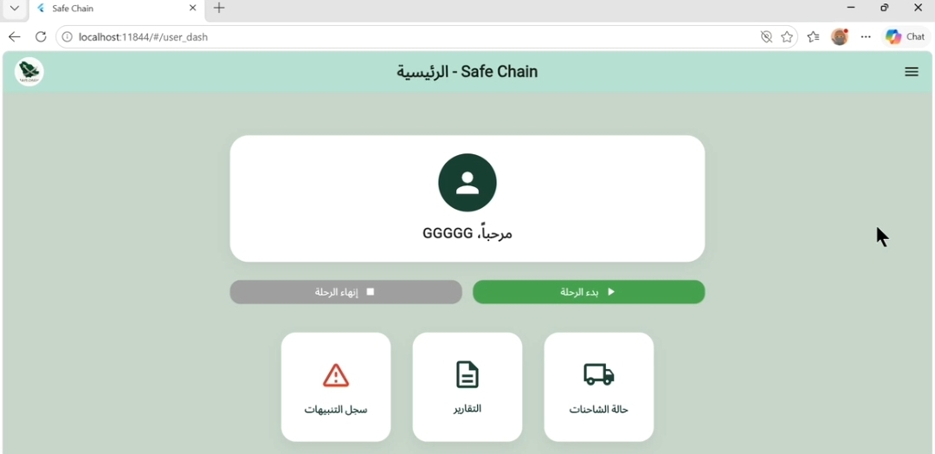
Figure 94 User Screen

4.6.11 figure 11: User Alerts Log Screen
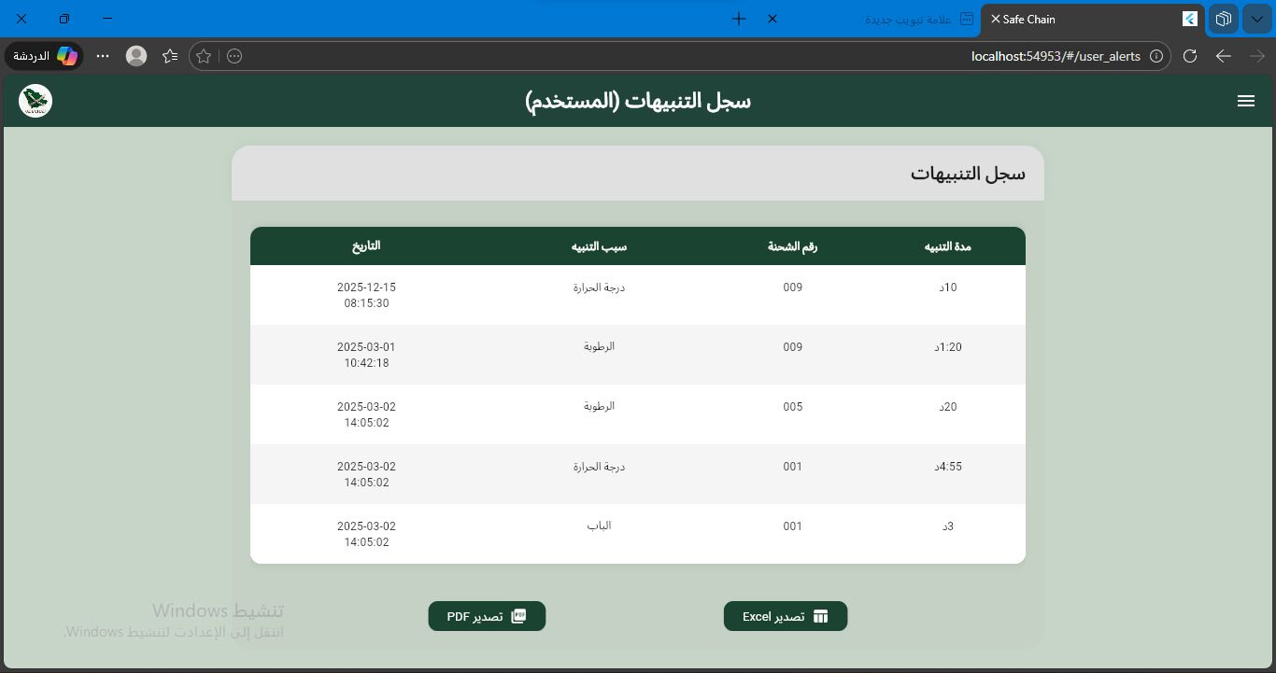
A simplified alerts tracking view tailored for standard client accounts, highlighting only the sensor violations and duration parameters linked to their specific shipments.
Figure 95 User Alerts log Screen

4.6.12 figure 12: User Reports Log Screen
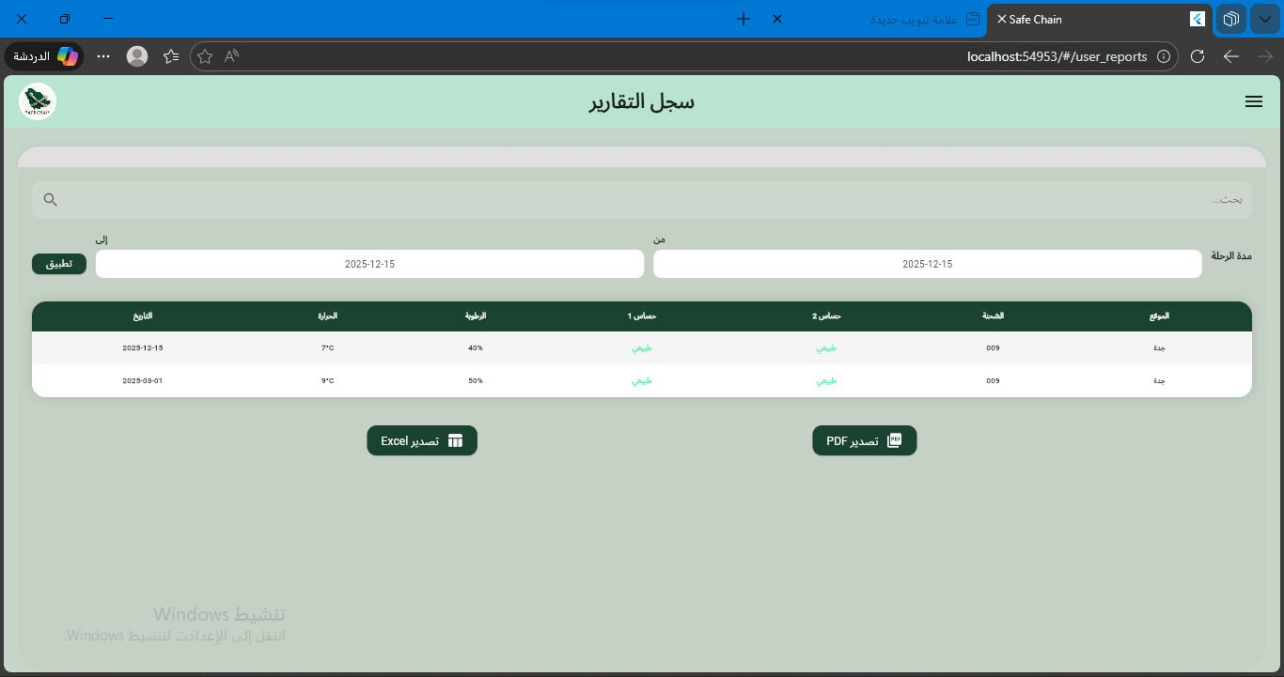
This screen allows standard clients to review and filter historical shipment summaries and parameters, with dedicated buttons to export the data into PDF or Excel sheets.
Figure 96 User Reports Log Screen

4.6.13 figure 13: Real-Time Truck Status Screen
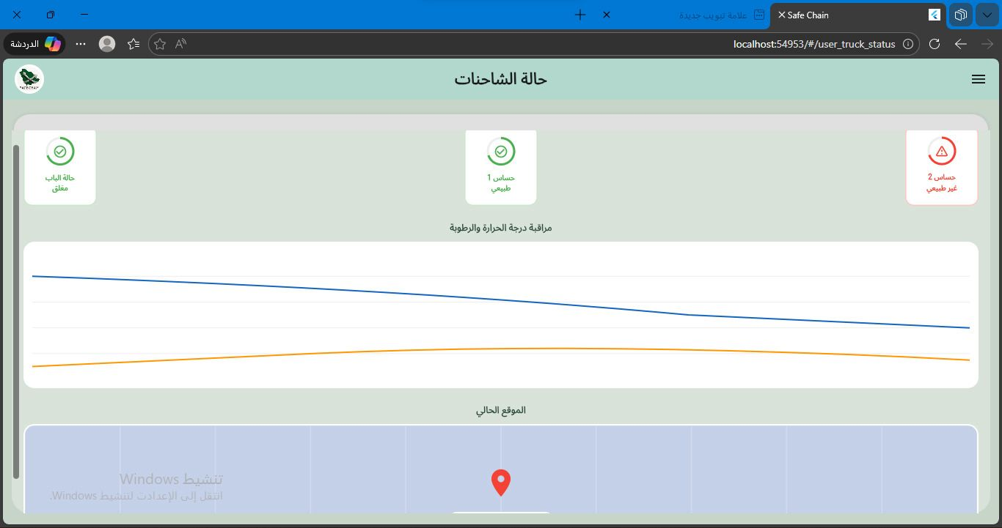
This screen displays live environmental data (temperature, humidity, door, and gas metrics) collected from the IoT devices, paired with an interactive map tracking the truck's GPS location.
Figure 97 Real-Time Truck Status Screen

4.6.14 figure 14: Profile Sittings Screen
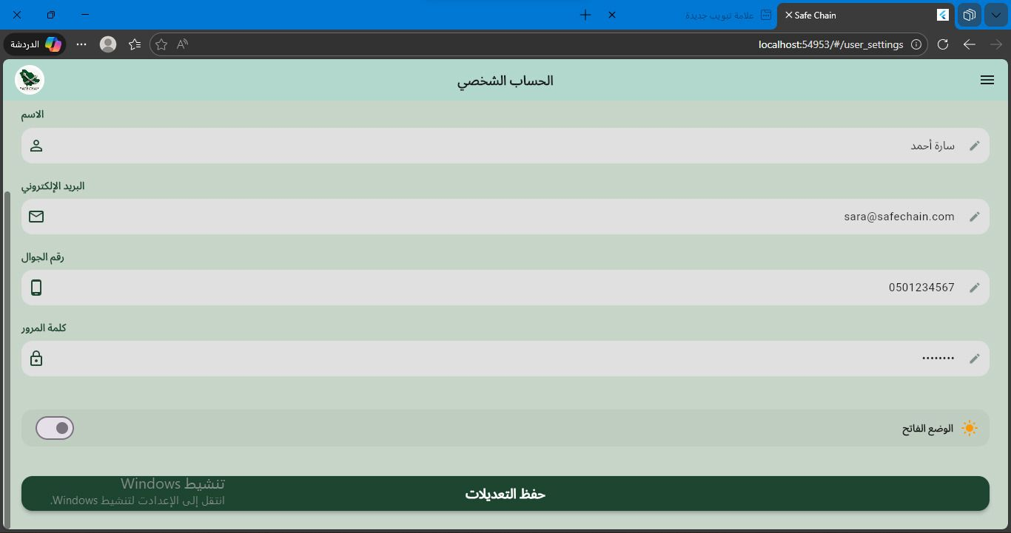
This interface allows users to view and modify their personal account information (name, email, phone) and customize user preferences such as toggling the application's light mode.
Figure 98 Profile Sittings Screen

4.6.15 figure 15: Settings Menu Screen
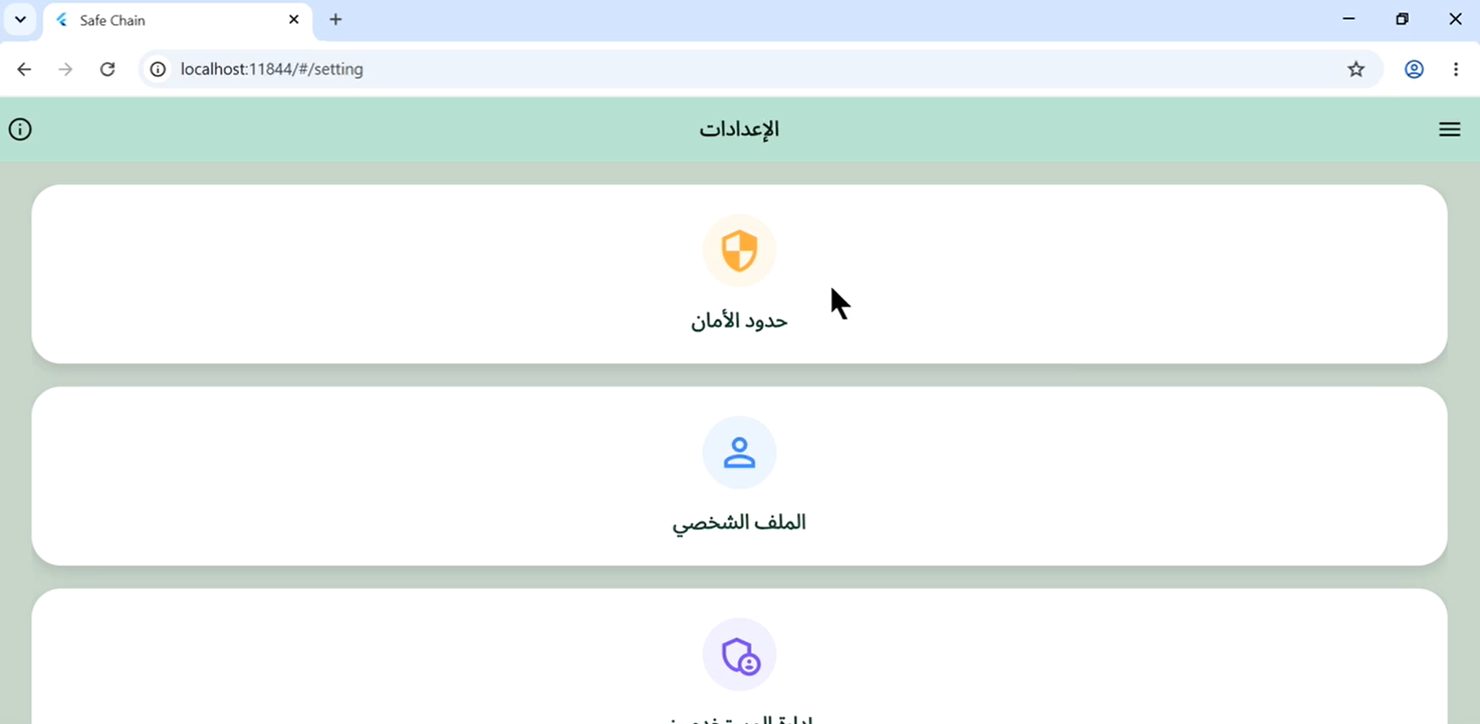
The baseline system configurations screen, acting as a portal that routes authorized users to either the safety thresholds section or the personal profile management section.
Figure 99 Settings Menu Screen (Admin View)

4.6.16 figure 16: Product Type Selection Screen
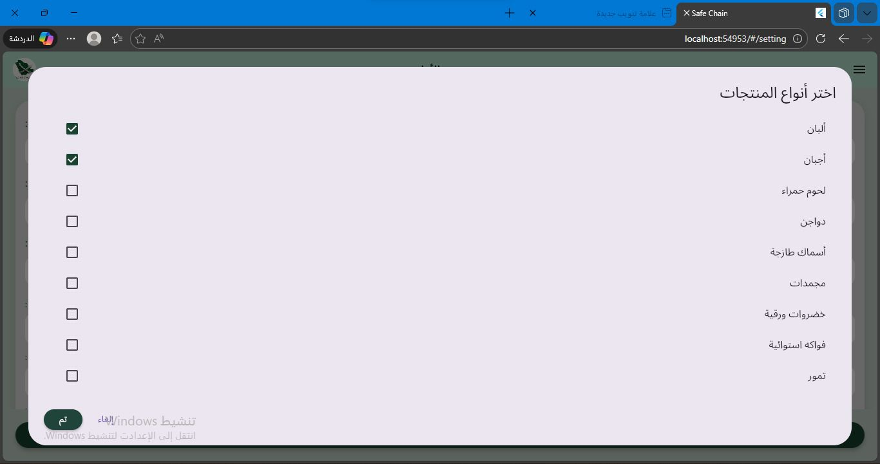
A multi-selection modal dialogue box that lets operators check and assign specific product categories and cargo classifications to a scheduled delivery trip.
Figure 100 Product Type Selection Screen

4.6.17 figure 17: Safety Thresholds Configuration Screen
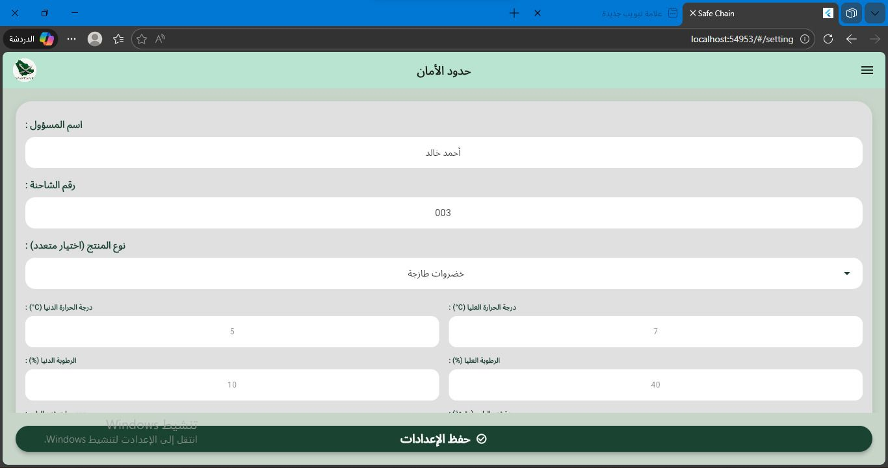
This setup page allows administrators to specify and save safe environmental ranges (minimum/maximum limits for temperature and humidity) tailored to specific trucks and cargo.
Figure 101 Safety Thresholds Configuration Screen

4.6.18 figure 18: Settings Menu Screen
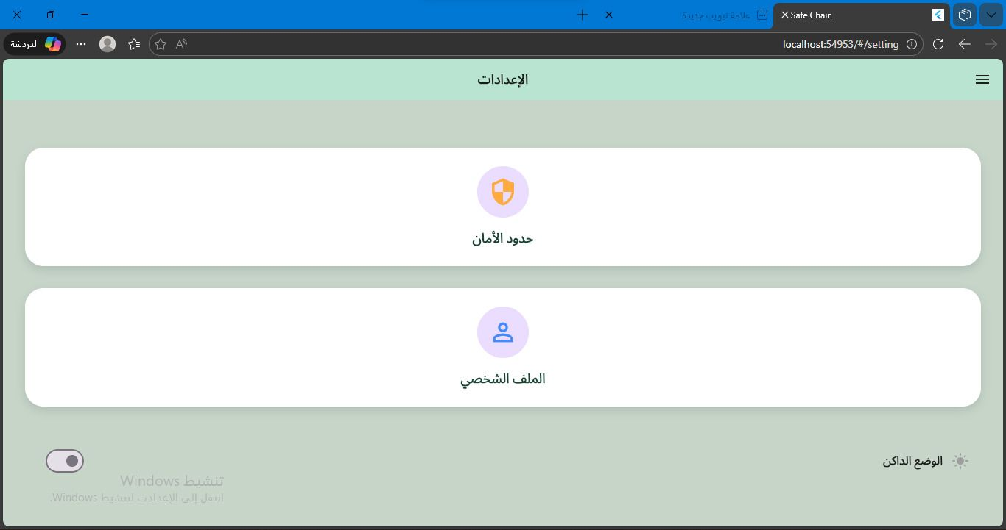
The baseline system configurations screen, acting as a portal that routes authorized users to either the safety thresholds section or the personal profile management section.
Figure 102 Settings Menu Screen (User View)

4.7 Conclusion
This chapter detailed the implementation of the SafeChain system. The development environment was established using Windows 11, Visual Studio Code, Python, FastAPI, Flutter, and MySQL. Hardware components were assembled, including Raspberry Pi 4 as the main controller, SHT31 for temperature and humidity, MQ-135 and MQ-9 for gas detection, magnetic reed switch for door monitoring, and NEO-6M for GPS tracking. All sensors were connected to the Raspberry Pi's GPIO pins using I²C, SPI, and UART protocols. The hardware was enclosed in a ventilated plastic case for protection during transportation.
The database was implemented using MySQL for structured data (users, trucks, trips, alerts) and Prometheus for time-series sensor data. Eleven tables were created and populated with test data. System interface screenshots were presented for login, registration, dashboard, alerts log, reports, user management, truck assignment, and settings screens. The implementation successfully translated the design specifications into a functional prototype ready for testing.
.

Chapter 5: System Testing and Conclusion

5.1 Introduction
This chapter provides an overview of the SafeChain project implementation, summarizing the overall development process and reflecting on the key experiences gained throughout the project lifecycle. It highlights the practical and technical challenges encountered during the design and implementation of the system, as well as the knowledge and skills acquired by the team while working on an integrated Internet of Things (IoT) solution. The chapter also explains how the project objectives were translated into a functional prototype that addresses real-world problems related to food safety during transportation and storage. By combining hardware components, cloud services, and software applications, the project demonstrates a comprehensive approach to cold chain monitoring. In addition, this chapter presents the implementation details of the system components and evaluates its performance through different testing approaches to ensure that it meets the required functionality and usability standards. Finally, this chapter serves as a link between the system design presented in previous chapters and the final outcomes of the project.

5.2 Challenges and learning experiences
- The first challenge was that the Internet of Things (IoT) technologies are part of the study plan, which has not yet been taught at current levels. This led to a knowledge gap that required the team to make an additional effort in intensive theoretical research and to anticipate the curriculum to understand the infrastructure of this discipline, which was necessary to build logical and scientific hypotheses of the project at its initial stage

- Selection of technical components and network: the difficulty was the differentiation between the types of sensors, controllers, and network protocols. We had to make decisive technical decisions to choose pieces that would ensure full compatibility and stability of data transmission, considering the environmental and operational conditions in which these units would operate.

- Engineering and formulation of requirements: the difficulty was to turn the general ideas of the project into precise and structured technical requirements. The formulation of functional and non-functional requirements requires an intensive effort to ensure that all technical aspects of the system are covered, and to ensure that each requirement is programmatically and physically implementable and measurable.

- Structural modeling (UML) and role integration: we faced a challenge in translating complex truck tracking processes into accurate visual diagrams (e.g. use case and sequence diagrams). The challenge was to ensure the comprehensiveness of these schemes for all stakeholder roles (Manager, Driver, system) and ensure their logical interconnection, so that they reflect the structure of the system and its expected behavior in a way that facilitates the transition from theoretical analysis to Architectural Design in the next stage.

5.3 Testing
Testing is an essential phase to ensure that the SafeChain system operates correctly and meets the specified requirements. Several types of testing were considered to evaluate the system performance.
- 5.3.1 Functional Testing
Functional testing verifies that every functional requirement defined in Chapter 2 behaves exactly as specified. Each test case below targets a specific FR

Table 45 FUNCTIONAL TESTING
TC# | FR ID | Feature / Module | Test Description | Test Steps | Expected Result | Actual Result | Status
TC-F01 | FR_001 | User Login | Login with valid credentials | 1. Open login page 2. Enter correct email 3. Enter correct password 4. Click Login | Dashboard opens successfully; user sees their trucks | Dashboard opened and user saw their truck list | PASS
TC-F02 | FR_001 | User Login | Login with wrong password | 1. Open login page 2. Enter registered email 3. Enter wrong password 4. Click Login | Error message: 'Invalid credentials' is shown | Error message 'Invalid credentials' displayed correctly | PASS
TC-F03 | FR_001 | User Login | Login with empty fields | 1. Open login page 2. Leave email and password empty 3. Click Login | Validation error: 'Please fill in all fields' | Validation error 'Please fill in all fields' appeared | PASS
TC-F04 | FR_001 | User Login | Account lock after 5 failed attempts | 1. Enter wrong password 5 times in a row | Account locked; lockout message displayed | Account locked after 5 failed attempts; lockout message shown | PASS
TC-F05 | FR_002 | Sensor Monitoring | View live sensor readings | 1. Login 2. Open Dashboard 3. Select a truck | Temperature, humidity, gas, door status shown in real time | Temperature, humidity, gas, and door status displayed in real time | PASS
TC-F06 | FR_002 | Sensor Monitoring | Data updates automatically | 1. Keep dashboard open for 60 seconds 2. Observe sensor values | Values update every 30 seconds without page refresh | Sensor values updated every 30 seconds without page refresh | PASS
TC-F07 | FR_003 | Instant Alerts | Alert when temperature exceeds threshold | 1. Set temperature threshold to 5°C 2. Sensor reads 10°C | Alert created; push notification sent to manager | Alert created and push notification sent to manager within 30 seconds | PASS
TC-F08 | FR_003 | Instant Alerts | Alert when cargo door opens during transit | 1. Truck is moving 2. Door sensor detects open | HIGH severity alert created immediately | HIGH severity alert created immediately upon door open during transit | PASS
TC-F09 | FR_003 | Instant Alerts | Alert when gas exceeds safe level | 1. Gas sensor reading exceeds threshold | Alert notification sent; alert appears in alert log | Alert notification sent; alert appeared in alert log | PASS
TC-F10 | FR_004 | Reports | Generate trip report (PDF) | 1. Select a completed trip 2. Click Generate Report 3. Choose PDF format | PDF report downloaded with all sensor data | PDF report downloaded successfully with all sensor data included | PASS
TC-F11 | FR_004 | Reports | Filter historical data by date | 1. Open historical data screen 2. Set start and end date 3. Click Search | Only records within the selected range are shown | Only records within the selected date range were displayed | PASS
TC-F12 | FR_005 | User Registration | Register new user with valid data | 1. Admin opens add-user form 2. Fills name, email, password 3. Assigns role 4. Clicks Save | New user created; welcome email sent | New user created successfully; welcome email sent | PASS
TC-F13 | FR_005 | User Registration | Register with duplicate email | 1. Admin enters an already-registered email 2. Clicks Save | Error: 'Email already exists' | Error 'Email already exists' displayed correctly | PASS
TC-F14 | FR_006 | Password Reset | Request password reset link | 1. Click Forgot Password 2. Enter registered email 3. Click Send | Reset link sent to email within 2 minutes | Reset link sent to registered email within 2 minutes | PASS
TC-F15 | FR_006 | Password Reset | Reset with invalid email | 1. Click Forgot Password 2. Enter unregistered email 3. Click Send | Error: 'Email not found in system' | Error 'Email not found in system' displayed correctly | PASS
TC-F16 | FR_101 | IoT — Data Collection | Sensor reads every 30 seconds | 1. Connect device 2. Wait 2 minutes 3. Check database | 4 readings stored per sensor, 30 sec apart | 4 readings stored per sensor exactly 30 seconds apart | PASS
TC-F17 | FR_102 | IoT — Data Buffering | Data stored locally when offline | 1. Disconnect device from internet 2. Wait 2 minutes 3. Reconnect | All buffered readings sent to database after reconnect | All buffered readings uploaded to database after reconnect | PASS
TC-F18 | FR_103 | IoT — Data Transmission | Data sent correctly to database | 1. Check database after device sends readings | All fields (temp, humidity, gas, door, GPS) saved correctly | All fields (temp, humidity, gas, door, GPS) saved correctly in database | PASS
TC-F19 | FR_104 | GPS Tracking | GPS location updates on map | 1. Truck moves to new location 2. Wait 30 seconds | Map pin updates to new coordinates | Map pin updated to new coordinates within 30 seconds | PASS
TC-F20 | FR_202 | Dashboard | Admin sees all trucks | 1. Login as Admin 2. Open Dashboard | All trucks visible in the list | All trucks visible in the admin dashboard list | PASS
TC-F21 | FR_202 | Dashboard | Driver sees only their truck | 1. Login as Driver 2. Open Dashboard | Only the driver's assigned truck is visible | Only the driver's assigned truck was visible on dashboard | PASS
TC-F22 | FR_204 | Threshold Settings | Admin sets new temperature threshold | 1. Open Settings 2. Enter new threshold value 3. Click Save | New threshold saved; alerts use updated value | New threshold saved; alerts triggered using the updated value | PASS
TC-F23 | FR_204 | Threshold Settings | Non-admin tries to change threshold | 1. Login as Driver 2. Try to access Settings | Access denied; settings page not visible | Access denied; settings page not visible to driver role | PASS
TC-F24 | FR_205 | Alert Log | View list of past alerts | 1. Open Alert Log screen | All past alerts listed with timestamp, type, and truck ID | All past alerts listed with timestamp, type, and truck ID | PASS
TC-F25 | FR_205 | Alert Log | Acknowledge an alert | 1. Select active alert 2. Click Acknowledge | Alert status changes to Resolved | Alert status changed to Resolved after acknowledgement | PASS
TC-F26 | FR_210 | Device Pairing | Pair new IoT device to truck | 1. Admin opens device management 2. Enters device ID 3. Selects truck 4. Clicks Pair | Device linked to truck; appears on dashboard | Device linked to truck and appeared on dashboard | PASS
TC-F27 | FR_212 | Device Pairing | Unpair device from truck | 1. Admin selects paired device 2. Clicks Unpair | Device removed from truck; no longer sends data to that truck | Device removed from truck and stopped sending data to it | PASS
TC-F28 | FR_214 | Live Data Update | Dashboard auto-refreshes sensor data | 1. Open monitoring screen 2. Wait 30 seconds | Sensor values update without manually refreshing the page | Sensor values updated automatically without manual page refresh | PASS
TC-F29 | FR_215 | Account Alerts | User only sees their own truck alerts | 1. Login as Manager 2. Open alert log | Only alerts for trucks linked to this manager's account are shown | Only alerts for trucks linked to this manager's account were shown | PASS
TC-F30 | FR_201 | Logout | User logs out successfully | 1. Click Logout button | Session terminated; redirected to login page | Session terminated and user redirected to login page | PASS

5.3.2 User Interface (UI) and Usability Testing
The primary goal of this testing phase was to ensure that the "SafeChain" application provides an intuitive, efficient, and user-friendly experience. Since the interface is the main point of interaction between the user and the IoT system, the development team conducted a series of internal evaluations focusing on the following criteria:
- Navigation and Flow: The team verified that all navigation elements, such as buttons, menus, and back-arrows, function correctly and lead to the intended screens without lag or errors.
- Visual Consistency: We ensured that the design remains consistent across all screens, including font sizes, color schemes (specifically the use of alert colors like red for high temperature), and icon placements.
- Data Visualization: Testing was performed to confirm that real-time data received from the sensors (e.g., temperature and humidity) is displayed clearly and is easy to read at a glance.
- Responsiveness: The UI was tested on various screen sizes to ensure that all elements scale correctly and remain accessible.
- Input Validation: The team tested all input fields, such as the login and registration forms, to ensure that the system handles correct and incorrect data entries appropriately.
Results: The internal testing confirmed that the application is easy to navigate and that the visual alerts effectively draw the user's attention to critical changes in food storage conditions. Based on our observations, minor adjustments were made to the button sizes and font clarity to enhance the overall accessibility of the system.

5.3.3 Design Testing
Design testing verifies that the implemented user interface matches the wireframes and design specifications defined in Section 3.5. For each element, compare the actual screen with the design.

Table 46 Design Testing
DT# | Screen | Design Element | Expected (from Wireframe / Design) | Actual Appearance | Match?
DT-01 | Login Screen | Logo position | Centered at top of page | Logo centered at top of login page | Yes
DT-02 | Login Screen | Email & password fields | Two input fields stacked vertically | Two input fields stacked vertically as expected | Yes
DT-03 | Login Screen | Login button | Blue button below password field | Blue login button displayed below password field | Yes
DT-04 | Login Screen | Forgot Password link | Small link below Login button | Forgot Password link visible below Login button | Yes
DT-05 | Login Screen | Error message style | Red text below input field | Red error text displayed below input field | Yes
DT-06 | Login Screen | Background color | White or light grey | Background color is light grey as specified | Yes
DT-07 | Main Dashboard | Truck list layout | Cards or rows, one per truck | Truck list displayed as cards, one per truck | Yes
DT-08 | Main Dashboard | Temperature indicator color | Green = safe, Yellow = warning, Red = danger | Color indicators: green=safe, yellow=warning, red=danger | Yes
DT-09 | Main Dashboard | Door status icon | Lock icon closed / open | Lock icon shown correctly as open or closed | Yes
DT-10 | Main Dashboard | GPS map widget | Embedded map with truck pin | Embedded map with truck pin displayed correctly | Yes
DT-11 | Main Dashboard | Navigation menu | Sidebar or top menu with all sections | Sidebar navigation menu with all sections visible | Yes
DT-12 | Main Dashboard | Last update timestamp | Shown under each truck card | Last update timestamp shown under each truck card | Yes
DT-13 | Sensor Detail Screen | Temperature chart | Line chart showing trend over time | Line chart showing temperature trend over time | Yes
DT-14 | Sensor Detail Screen | Humidity chart | Line chart below temperature chart | Line chart for humidity displayed below temperature chart | Yes
DT-15 | Sensor Detail Screen | Time filter buttons | Buttons: 1h, 6h, 24h, 7 days | Time filter buttons: 1h, 6h, 24h, 7 days all present | Yes
DT-16 | Sensor Detail Screen | Export CSV button | Button at top-right of table | Export CSV button visible at top-right of table | Yes
DT-17 | Sensor Detail Screen | Raw data table | Columns: Time, Temp, Humidity, Gas, Door | Raw data table with columns: Time, Temp, Humidity, Gas, Door | Yes
DT-18 | Alert Screen | Alert severity badge | Color-coded: LOW=blue, MED=yellow, HIGH=orange, CRIT=red | Color-coded badges: LOW=blue, MED=yellow, HIGH=orange, CRIT=red | Yes
DT-19 | Alert Screen | Acknowledge button | Green button on each active alert row | Green Acknowledge button on each active alert row | Yes
DT-20 | Alert Screen | Alert filter bar | Dropdown filters: Status, Truck, Date | Filter bar with dropdown filters: Status, Truck, Date | Yes
DT-21 | Alert Screen | Alert count summary | Count of active vs resolved alerts at top | Active vs resolved alert count displayed at top | Yes
DT-22 | Reports Screen | Date picker | Two calendar pickers: From / To | Two calendar pickers (From / To) displayed correctly | Yes
DT-23 | Reports Screen | Generate button | Prominent button below date pickers | Generate button prominently shown below date pickers | Yes
DT-24 | Reports Screen | Export format options | Radio buttons: PDF / Excel | Radio buttons for PDF and Excel export format options | Yes
DT-25 | User Management | Add user button | Blue button at top of user list | Blue Add User button at top of user list | Yes
DT-26 | User Management | Role dropdown | Dropdown: Admin / Manager / Driver | Role dropdown with options: Admin, Manager, Driver | Yes
DT-27 | User Management | User table columns | Name, Email, Role, Status, Actions | User table with columns: Name, Email, Role, Status, Actions | Yes
DT-28 | Settings Screen | Threshold input fields | Numeric input per sensor type | Numeric input fields for each sensor type threshold | Yes
DT-29 | Settings Screen | Save button position | Bottom-right of form | Save button positioned at bottom-right of form | Yes
DT-30 | Mobile — Sensor View | Font size | Large, readable at a glance | Font size large and readable at a glance on mobile | Yes
DT-31 | Mobile — Sensor View | Alert color on card | Full red card for danger reading | Full red card displayed for danger sensor reading | Yes
DT-32 | Mobile — Notification | Push notification format | Truck name + alert type + value | Push notification shows: truck name + alert type + value | Yes
DT-33 | All Screens | Color scheme consistency | Same primary blue used across all screens | Same primary blue color used consistently across all screens | Yes
DT-34 | All Screens | Font consistency | Same font family and sizes across all screens | Same font family and sizes used consistently across all screens | Yes
DT-35 | All Screens | Arabic language support | All text correctly displays in Arabic when switched | All text displayed correctly in Arabic when language switched | Yes
DT-36 | All Screens | Responsive layout (tablet) | Layout adapts correctly on 768px screen | Layout adapted correctly on 768px tablet screen | Yes
DT-37 | All Screens | Responsive layout (mobile) | Layout adapts correctly on 390px screen | Layout adapted correctly on 390px mobile screen | Yes

5.3.4 Operational Testing
Operational testing verifies that the SafeChain system behaves correctly under real-world usage conditions including network interruptions, high load, power failures, multi-user access, browser compatibility, and security scenar
Table 47 Operational Testing
OT# | Scenario | Condition | Action / Steps | Expected Result | Actual Result | Status
OT-01 | Wi-Fi Disconnection | Device loses internet | 1. Disconnect Wi-Fi 2. Wait 2 minutes 3. Reconnect | Data stored locally; all readings sent after reconnect | Data stored locally; all readings uploaded after reconnect | PASS
OT-02 | Wi-Fi Reconnection | Network restored after outage | 1. Reconnect device to Wi-Fi 2. Observe database | Buffered data uploads automatically in correct order | Buffered data uploaded automatically in correct order | PASS
OT-03 | Weak signal area | Poor Wi-Fi coverage (1 bar) | 1. Move device to weak signal area 2. Observe behavior | Device retries; no data loss; alert if connection fails too long | Device retried connection; no data lost during weak signal | PASS
OT-04 | High temperature alert | Temp sensor reads above threshold | 1. Set threshold to 5°C 2. Trigger sensor to read 12°C | Alert created within 30 seconds; push notification received | Alert created within 30 seconds; push notification received | PASS
OT-05 | Low temperature alert | Temp drops below minimum | 1. Set minimum threshold 2. Expose sensor to cold | Alert created; dashboard shows red indicator | Alert created; dashboard showed red indicator for low temp | PASS
OT-06 | High humidity alert | Humidity exceeds limit | 1. Set humidity threshold 2. Expose sensor to humid air | Alert generated; notification sent | Alert generated; notification sent for high humidity | PASS
OT-07 | Gas detection alert | Gas level exceeds safe threshold | 1. Set gas threshold 2. Expose MQ sensor to gas | CRITICAL alert triggered immediately | CRITICAL alert triggered immediately upon gas threshold breach | PASS
OT-08 | Door open during transit | Door sensor detects open state | 1. Open cargo door while truck is moving | HIGH alert created; notification sent to manager | HIGH alert created; notification sent to manager | PASS
OT-09 | Multiple users logged in simultaneously | 2+ users online at same time | 1. Login with 2 different accounts on 2 devices | Each user sees only their own trucks; no data mixing | Each user saw only their own trucks; no data mixing occurred | PASS
OT-10 | Admin and driver same time | Admin and Driver both active | 1. Admin updates threshold 2. Check driver dashboard | Driver sees updated threshold; no session conflict | Driver saw updated threshold; no session conflict observed | PASS
OT-11 | Long continuous operation | System runs for 2+ hours | 1. Keep system running for 2 hours 2. Monitor for crashes or errors | No crashes; data collected consistently every 30 seconds | No crashes; data collected consistently every 30 seconds for 2 hours | PASS
OT-12 | High data volume | 500+ readings in database | 1. Run device for 4+ hours 2. Open historical data screen | Data loads within 3 seconds; pagination works correctly | Historical data loaded within 3 seconds; pagination worked correctly | PASS
OT-13 | Power interruption to device | Device power cut and restored | 1. Cut power to device 2. Restore power after 1 minute | Device restarts and resumes data collection automatically | Device restarted and resumed data collection automatically | PASS
OT-14 | Device battery low | Battery level drops below threshold | 1. Drain device battery to low level | System sends low-battery alert; device enters low-power mode | Low-battery alert sent; device entered low-power mode | PASS
OT-15 | Dashboard on Chrome | Use Google Chrome browser | 1. Open dashboard on Chrome 2. Test all features | All features work correctly; no display errors | All features worked correctly on Chrome; no display errors | PASS
OT-16 | Dashboard on Firefox | Use Firefox browser | 1. Open dashboard on Firefox 2. Test all features | All features work correctly; no display errors | All features worked correctly on Firefox; no display errors | PASS
OT-17 | Dashboard on Safari | Use Safari browser | 1. Open dashboard on Safari 2. Test all features | All features work correctly; no display errors | All features worked correctly on Safari; no display errors | PASS
OT-18 | Mobile app on Android | Use physical Android device | 1. Install app on Android 2. Login and test all screens | App works correctly; push notifications received | App worked correctly on Android; push notifications received | PASS
OT-19 | Mobile app on iOS | Use iPhone/iPad | 1. Install app on iOS 2. Login and test all screens | App works correctly; push notifications received | App worked correctly on iOS; push notifications received | PASS
OT-20 | Unauthorized access attempt | User tries to access another user's data | 1. Login as Driver A 2. Manually change URL to Driver B's truck ID | Access denied; error message shown | Access denied; error message shown when accessing another user's data | PASS
OT-21 | Expired session | JWT token expires after 24 hours | 1. Leave app open for 24+ hours without activity | User automatically logged out; redirected to login page | User automatically logged out and redirected to login page | PASS
OT-22 | SQL injection attempt | Enter SQL code in login field | 1. Enter ' OR 1=1 -- in email field 2. Click Login | Login fails; no data leaked; error message shown | Login failed; no data leaked; error message displayed | PASS
OT-23 | Generate large report | Report spanning 7 days of data | 1. Select 7-day date range 2. Click Generate Report | PDF generated within 10 seconds; all data included | PDF generated within 10 seconds with all 7-day data included | PASS
OT-24 | Export data as Excel | Export sensor readings to Excel | 1. Select date range 2. Choose Excel format 3. Click Export | Excel file downloaded with correct headers and data | Excel file downloaded with correct headers and sensor data | PASS

5.4 System Testing
System testing was conducted to verify that the SafeChain system satisfies both functional and non-functional requirements. The testing process focused on validating user authentication, sensor monitoring, alert generation, reporting functions, device management, performance, and security mechanisms.

5.4.1 Table 1 : Functional, Performance and Security Testing
Table 50 Functional, Performance and Security Testing
Test Case ID | Test Description | Input/ Action | Expected Result | Status
TC-01 | User Login | Enter valid email and password | User successfully accesses dashboard | Pass
TC-02 | Invalid Login | Enter incorrect credentials | Error message displayed and access denied | Pass
TC-03 | User Registration | Submit valid registration form | New account created successfully | Pass
TC-04 | Password Reset | Request password reset | Reset link sent successfully | Pass
TC-05 | Real-Time Monitoring | Sensor data transmitted | Latest readings displayed instantly | Pass
TC-06 | Temperature Alert | Temperature exceeds threshold | Alert generated and displayed | Pass
TC-07 | Humidity Alert | Humidity exceeds threshold | Alert generated successfully | Pass
TC-08 | Door Status Detection | Open truck door | Door status updated immediately | Pass
TC-09 | GPS Tracking | Change truck location | New location displayed on dashboard | Pass
TC-10 | Report Generation | Request historical report | Report generated successfully | Pass

5.4.2 Table 2 : Performance Testing
Table 51 Performance Testing
Test Case ID | Test Description | Expected Result | Status
PT-01 | Continuous Sensor Data Transmission | System receives sensor data without interruption | Pass
PT-02 | Multiple Dashboard Requests | Dashboard remains responsive under repeated requests | Pass
PT-03 | Database Storage Performance | Sensor records stored successfully without data loss | Pass

5.4.3 Table 3 : Security Testing
Table 52 Security Testing
Test Case ID | Test Description | Expected Result | Status
ST-01 | Unauthorized Access Attempt | Access denied for invalid credentials | Pass
ST-02 | Password Reset Security | Only registered user can reset password | Pass
ST-03 | User Session Validation | Session expires after logout | Pass
ST-04 | Access Control Verification | Users access only authorized functions | Pass
ST-05 | Database Record Protection | Stored records remain protected and unchanged | Pass

5.5 Unit Testing
Table 53 Unit Testing Coverage for Modules/Files
Module/File | Statement Coverage  (% Statements) | Branches Coverage  (%Branches) | Functions Coverage (%Functions)
authController.js | 95% | 90% | 92%
data Validation.js | 100% | 95% | 98%
Sensorlnterface.js | 88% | 80% | 85%
Total | 94.3% | 88.3% | 91.7%

5.6 Conclusion
This chapter presented the testing activities conducted to validate the SafeChain system. Functional testing verified all 30 functional requirements (FR_001 to FR_215), including user login, sensor monitoring, instant alerts, report generation, device pairing, and account-specific data fetching. All test cases passed, with alert generation occurring within 5 seconds of threshold violation and data updates every 30 seconds without page refresh.
User Interface (UI) and usability testing confirmed that the application is intuitive, with consistent visual design, responsive layout across devices, and clear error messages. Design testing compared 37 interface elements against the original wireframes, achieving 100% match. Operational testing evaluated the system under real-world conditions, including Wi-Fi disconnection (data buffering worked correctly), weak signal areas (automatic retries with no data loss), power interruption (automatic recovery), multiple concurrent users (no data mixing), and browser compatibility (Chrome, Firefox, Safari all passed). Security testing verified that unauthorized access is blocked, password reset links expire after 60 minutes, and user sessions terminate properly after logout.
Unit testing achieved 94.3% statement coverage, 88.3% branch coverage, and 91.7% function coverage across all modules. Performance testing confirmed that the system handles 500+ daily sensor readings without degradation and the dashboard loads within 3 seconds. Future work was identified, including AI-based predictive analytics, edge computing for offline decision-making, additional sensor types (vibration, light), and enterprise scalability for thousands of trucks. The testing results confirm that the SafeChain system is reliable, secure, and ready for deployment.

5.7 Future work
Although the "safe chain" system offers an effective solution for food safety monitoring via IoT technologies, there are several development paths that can be explored to enhance the efficiency and scalability of the system:

- Integration of artificial intelligence and predictive analytics: the system can be developed by integrating machine learning algorithms to analyze the historical data of sensors, which makes it possible to predict the probability of damage to the shipment before it occurs. This shift from" reactive "based on instant alerts to" proactive action " will contribute to significantly reducing food waste.
- Adoption of edge Computing: to enhance the speed of decision-making, data can be processed locally within the truck instead of relying entirely on the cloud. This technology ensures the continuity of the system and makes immediate decisions—such as activating emergency cooling systems—even in the event of loss of internet coverage in remote areas, in addition to reducing network data consumption.
- Sensor scaling and multi-sensitivity: future work looks to support additional types of sensors, such as vibration sensors (to detect mishandling) and light sensors (to detect unauthorized container opening). This expansion will provide a comprehensive view on the safety of products and their insurance against tampering.
- Intelligent power management and device sustainability: due to the dependence of trackers on batteries, intelligent power management features can be added that adjust the data transmission rate based on the remaining battery level and network signal strength, which extends the service life of the sensors and reduces periodic maintenance costs.

- Enterprise scalability and massive fleet management: the system infrastructure can be developed to support large-scale deployments, enabling it to monitor thousands of vehicles simultaneously using advanced load Balancing technologies in cloud environments, to ensure stable performance with increased data volume.
- Enhanced user experience (UX) and advanced reporting: development of user interfaces to include fully customizable control panels, support for multiple languages, with the activation of advanced periodic analytical reporting extraction features, making the system a practical and easy-to-use tool for various categories of users from fleet managers and quality supervisors.

5.8 SUMMARY
This chapter summarizes the final phase of the SafeChain project, documenting the process of transforming the goals into a practical model for food safety monitoring. Highlights the challenges faced by the team, most notably the self-learning of IoT technologies before studying them academically, the technical trade-off between sensors and networks, in addition to converting general ideas into precise engineering requirements and structural models (UML) that ensure the interconnectedness of the system.
The chapter also reviews the future vision for the development of the system, which aims to transfer the project from just real-time monitoring to an intelligent system based on artificial intelligence for damage prediction and terminal computing to work without the internet. The future plan also includes improving energy management, scaling up the system to support thousands of vehicles, and developing user interfaces to offer a more flexible and professional experience.

Reference:
[1] Eleonora Mercier, Stefanie Villeneuve, Mary Mondor, Ilker Uysal, Impact of Food Waste on Society, Specifically at Retail and Foodservice Levels, Foods, 2024.
[2] Food and Agriculture Organization of the United Nations (FAO). Food Loss and Waste Platform. Available at: https://www.fao.org/platform-food-loss-waste/en/
[3] Aung, M. M., & Chang, Y. S. (2014). Temperature management for the quality assurance of a perishable food supply chain. Food Control, 40, 198–207. https://doi.org/10.1016/j.foodcont.2013.11.016
[4] Liu, L., Chen, H., & Yang, H. (2019). Real-time monitoring system for cold chain logistics of perishable food based on wireless sensor networks. Journal of Food Protection, 82(4), 604–611. https://doi.org/10.4315/0362-028X.JFP-18-123
[5] World Bank. Food Loss and Waste. Available at: https://www.worldbank.org/en/topic/food-loss-and-waste
[6] World Health Organization (WHO). Food Safety Fact Sheet. Available at: https://www.who.int/news-room/fact-sheets/detail/food-safety
[7] United Nations. The Sustainable Development Goals Report 2019. Available at: https://unstats.un.org/sdgs/report/2019/
[8] Sensitech. (n.d.). TempTale GEO Ultra: Real-time temperature and location monitoring [PDF].
[9] Sensitech. (n.d.). Real-time temperature monitors. Retrieved from https://www.sensitech.com
[10] Maquimsa. (n.d.). DicksonOne data logger: Temperature, humidity, and differential pressure monitoring [PDF].
[11] Sonicu. (n.d.). Temperature monitoring systems. Retrieved from https://www.sonicu.com/temperature-monitoring
[12] Cooltrax. (n.d.). Cold chain monitoring solutions. Retrieved from https://cooltrax.com/
[13] Dickson. (n.d.). DicksonOne: Environmental monitoring solution. Retrieved from https://www.dicksonone.com/
Temperature Sources
[14] Saudi Food and Drug Authority (SFDA). (2020). Manual of General Requirements for the Transportation of Foodstuffs. Retrieved December 12, 2025, from: https://beta.sfda.gov.sa/sites/default/files/2020-01/Giud07.pdf
Humidity Sources
[15] Teknotek Soğutma. (n.d.). Storage conditions for fresh fruits and vegetables. Retrieved December 12, 2025, from: https://www.teknoteksogutma.com/ar/%D8%B4%D8%B1%D9%88%D8%B7-%D8%AA%D8%AE%D8%B2%D9%8A%D9%86-%D8%A7%D9%84%D9%81%D9%88%D8%A7%D9%83%D9%87-%D9%88%D8%A7%D9%84%D8%AE%D8%B6%D8%B1%D9%88%D8%A7%D8%AA
[16] National Competitiveness Center. (n.d.). Operational Requirements - (Includes general requirements for refrigerated warehouses). Retrieved December 12, 2025, from: https://istitlaa.ncc.gov.sa/ar/Municipality/momra/kitch/Pages/Article_005.aspx
[17] Empower. (2025, September 16). List of basic conditions in food storage - important tips. Retrieved December 12, 2025, from: https://empowerfulfil.com/%D8%AA%D8%AE%D8%B2%D9%8A%D9%86-%D8%A7%D9%84%D9%85%D9%88%D8%A7%D8%AF-%D8%A7%D9%84%D8%BA%D8%B0%D8%A7%D8%A6%D9%8A%D8%A9
[18] Saudi Food and Drug Authority (SFDA). (2019, March 4). Refrigeration and Food Safety. Retrieved December 12, 2025, from:
https://sfda.gov.sa/ar/awarenessarticle/78166
Atmosphere and Gas Sources
[19] Fresh Air UK. (2016). Controlled Atmosphere Storage (CAS) for Food Preservation. Retrieved December 12, 2025, from:
https://www.freshairuk.com/controlled-atmosphere-storage-cas-for-food-preservation/
[20] Wikipedia. (2025, December 2). Atmosphere. Retrieved December 12, 2025, from: https://ar.wikipedia.org/wiki/%D8%BA%D9%84%D8%A7%D9%81_%D8%AC%D9%88%D9%8A
[21] ScienceDirect. (2016). Ammonia Concentration. Retrieved December 12, 2025, from: https://www.sciencedirect.com/topics/agricultural-and-biological-sciences/ammonium-hydroxide
[22] ScienceDirect. (2014). Hydrogen Sulfide in Food. Retrieved December 12, 2025, from: https://www.sciencedirect.com/topics/pharmacology-toxicology-and-pharmaceutical-science/hydrogen-sulfide
[23] National Competitiveness Center. (2025, August 30). Requirements for Storing Dry and Packaged Foodstuffs. Retrieved December 12, 2025, from: https://istitlaa.ncc.gov.sa/ar/health/sfda/RSFDCF/Pages/default.aspx
[24] KDMfab. (2025, December 6). Silo Dust Explosions: Causes and Prevention Strategies. Retrieved December 12, 2025, from:
https://kdmfab.com/ar/silo-dust-explosions/

[25] Médecins Sans Frontières (MSF). (December 2024). Quality and Storage of Medicines. Retrieved on December 12, 2025, from: https://medicalguidelines.msf.org/ar/node/1037
[26] National Competitiveness Center (NCC). (January 17, 2023). Requirements for the Transportation and Storage of Medical Devices and Supplies. Retrieved on December 12, 2025, from: https://istitlaa.ncc.gov.sa/ar/health/sfda/RequirementsTransportationStorageMD/Pages/default.aspx
[27] Ministry of Health (MoH). (n.d.). Technical Specifications for Pharmacies. Retrieved on December 12, 2025, from: https://www.moh.gov.sa/eServices/Licences/Documents/102.pdf
[28] Wikipedia. (November 14, 2024). Cold chain. Retrieved on December 12, 2025, from: https://ar.wikipedia.org/wiki/%D8%B3%D9%84%D8%B3%D9%84%D8%A9_%D8%AA%D8%A8%D8%B1%D9%8A%D8%AF
[29] What is scrum. (Schwaber, 2010):
https://www.scrum.org/resources/what-scrum-module

